

DDOS ATTACK DETECTION AND MITIGATION (REAL-TIME DDOS DETECTION AND ADAPTIVE MITIGATION FRAMEWORK USING MACHINE LEARNING)
SentinelFlow: Real-time DDoS detection with a Random Forest and adaptive, self-recovering mitigation
A project report submitted in partial fulfilment of the requirements for the award of the degree of
BACHELOR OF TECHNOLOGY
in
COMPUTER SCIENCE AND ENGINEERING
Submitted by
MALLELA PALLAVI | 23K91A05E3
KATTOJU DURGABHAVANI | 24K95A0514
NIMMALA RAKSHITHA | 23K91A05H3
PRODHATOOR SHASHI PREETHAM | 23K91A05K0
Batch C15 (CSE-C)
Under the esteemed guidance of
V MEENAKSHI
[DESIGNATION]
DEPARTMENT OF COMPUTER SCIENCE AND ENGINEERING
[COLLEGE NAME]
[COLLEGE ADDRESS]
Academic year [ACADEMIC YEAR]

CERTIFICATE
This is to certify that the project report entitled "DDoS Attack Detection and Mitigation (Real-Time DDoS Detection and Adaptive Mitigation Framework Using Machine Learning)" is a bonafide record of the work carried out by MALLELA PALLAVI (23K91A05E3), KATTOJU DURGABHAVANI (24K95A0514), NIMMALA RAKSHITHA (23K91A05H3), PRODHATOOR SHASHI PREETHAM (23K91A05K0), in partial fulfilment of the requirements for the award of the degree of Bachelor of Technology in Computer Science and Engineering, during the academic year [ACADEMIC YEAR], under my supervision.

Project Guide | Head of the Department | Principal
V Meenakshi | [HOD NAME] | [PRINCIPAL NAME]
[DESIGNATION] | Department of Computer Science and Engineering | [COLLEGE NAME]

External Examiner: [NAME AND SIGNATURE]
Place: [PLACE]
Date: [DATE]

DECLARATION
We hereby declare that the project report entitled "DDoS Attack Detection and Mitigation (Real-Time DDoS Detection and Adaptive Mitigation Framework Using Machine Learning)", submitted to the Department of Computer Science and Engineering, [COLLEGE NAME], in partial fulfilment of the requirements for the award of the degree of Bachelor of Technology in Computer Science and Engineering, is a record of original work carried out by us under the guidance of V Meenakshi, [DESIGNATION]. The results embodied in this report have not been submitted to any other university or institution for the award of any degree or diploma.

MALLELA PALLAVI 23K91A05E3
KATTOJU DURGABHAVANI 24K95A0514
NIMMALA RAKSHITHA 23K91A05H3
PRODHATOOR SHASHI PREETHAM 23K91A05K0

Place: [PLACE]
Date: [DATE]

ACKNOWLEDGEMENT
We express our sincere gratitude to our project guide, V Meenakshi, [DESIGNATION], for valuable guidance, encouragement and constructive suggestions throughout this project.
We thank [HOD NAME], Head of the Department of Computer Science and Engineering, for providing the facilities and support needed to complete this work, and [PRINCIPAL NAME], Principal, [COLLEGE NAME], for the encouragement given to us.
We thank the project coordinators and all faculty and staff members of the department for their help, and our families and friends for their constant support.
We also acknowledge the authors of the base paper and of the related work cited in this report, the Canadian Institute for Cybersecurity for the CICIDS2017 dataset used in the real-data evaluation, and the maintainers of the open-source software used in this project (Python, Flask, scikit-learn, pandas, NumPy, Scapy, psutil, SQLite, React, Vite, Recharts, matplotlib, pytest and Playwright).

MALLELA PALLAVI
KATTOJU DURGABHAVANI
NIMMALA RAKSHITHA
PRODHATOOR SHASHI PREETHAM

ABSTRACT
Distributed denial-of-service (DDoS) attacks flood a service with traffic from many sources and leave legitimate users without access. Detection that is not followed by action leaves the service down, while wrongly blocking legitimate sources is itself a denial of service. This project builds SentinelFlow, a working real-time detection and adaptive mitigation system: Scapy (or a built-in simulator) feeds rolling traffic windows that are reduced to ten flow features and classified by a 200-tree Random Forest; an explainable rule layer scores how distributed the traffic is across sources and destinations (the carpet-bombing signature) and assigns a Low, Medium, High or Critical severity with its contributing factors; High and Critical windows quarantine the three busiest sources for a limited time, after which they recover automatically. A Flask service with twelve JSON endpoints, a SQLite history and a nine-page React console present the result. The work follows the resource-aware ensemble framework of Trigui et al. (IEEE Access, 2026) and adds the closed detection-to-mitigation loop that paper leaves as future work.
Measured honestly, the shipped model was trained on a labelled synthetic fallback because CICIDS2017 was unreachable when the product was built: it scores 99.71 % accuracy on its own held-out split, but only 71.8 % accuracy (63.4 % recall, 17.2 % false-positive rate) on 225,745 real CICIDS2017 DDoS-day flows. Retrained on those real flows with the same features and hyper-parameters, the forest reaches 99.94 % accuracy over five seeds (99.74 % on a chronological block split), comparable with the 100 % reported by the base paper on different datasets. The severity layer cuts false positives on benign windows from 13.6 % to 0.27 % at 5-second windows, but window length matters: the model was calibrated on 10-second windows. 95 automated tests and 25 smoke checks pass; live capture could not be run end to end here because Npcap is not installed, and mitigation is an application-level quarantine that never changes the operating-system firewall.
Keywords: DDoS detection, network security, Random Forest, CICIDS2017, Scapy packet capture, adaptive mitigation, carpet-bombing, Flask security dashboard.

TABLE OF CONTENTS
CERTIFICATE i
DECLARATION ii
ACKNOWLEDGEMENT iii
ABSTRACT iv
TABLE OF CONTENTS v
LIST OF FIGURES viii
LIST OF TABLES x
LIST OF ABBREVIATIONS xi
1. INTRODUCTION 1
1.1 Domain and Background 1
1.2 Motivation 2
1.3 Problem Statement 3
1.4 Need for the Proposed System 3
1.5 Overview of the Proposed Solution 3
1.6 Objectives 4
1.7 Scope 4
1.8 Contributions 5
1.9 Limitations and Assumptions 5
1.10 Organisation of the Report 6
2. LITERATURE SURVEY 7
2.1 Overview 7
2.2 Base Paper Analysis 8
2.3 Related Work by Theme 10
2.4 Datasets and Algorithms Used in the Surveyed Work 11
2.5 Strengths and Limitations of Existing Approaches 12
2.6 Research Gap 12
3. FEASIBILITY STUDY 13
3.1 Introduction 13
3.2 Technical Feasibility 13
3.3 Economic Feasibility 14
3.4 Operational Feasibility 14
3.5 Schedule Feasibility 15
3.6 Risk Analysis 15
3.7 Advantages and Constraints 15
4. SYSTEM REQUIREMENTS AND ANALYSIS 16
4.1 Existing System and its Limitations 16
4.2 Proposed System and its Advantages 16
4.3 Functional Requirements 16
4.4 Non-Functional Requirements 17
4.5 Hardware Requirements 18
4.6 Software Requirements 18
4.7 User Roles 18
4.8 Data Requirements 18
4.9 Interface Requirements 19
4.10 Use Cases 19
4.11 Existing and Proposed Systems Compared 20
4.12 Constraints and Assumptions 20
5. SYSTEM DESIGN 21
5.1 Design Goals and Architecture 21
5.2 High-Level Workflow 23
5.3 Data Flow Diagrams 23
5.4 Class, Sequence and Use-Case Design 25
5.5 Data Design 27
5.6 Core Algorithm Design 28
5.7 Module Design 30
5.8 API Design 31
5.9 User Interface Design 31
5.10 Design Trade-offs and Known Weaknesses 32
6. METHODOLOGY AND SOFTWARE IMPLEMENTATION 33
6.1 Overall Methodology 33
6.2 Dataset 34
6.3 Preprocessing 34
6.4 Algorithm Choice and Justification 35
6.5 Mathematical Formulation 37
6.6 Model Architecture and Training 38
6.7 Application Architecture 39
6.8 API Design 41
6.9 Front-End Implementation 41
6.10 Security and Error Handling 41
6.11 Installation and Execution 42
7. SYSTEM TESTING 43
7.1 Testing strategy 43
7.2 Unit testing 43
7.3 Integration testing 44
7.4 Functional testing 45
7.5 Security testing 45
7.6 Validation and edge cases 47
7.7 Performance testing 47
7.8 User acceptance 49
7.9 Limits of the testing done 50
8. RESULTS AND OUTPUT SCREENS 51
8.1 What was measured and how 51
8.2 The shipped model on its own test split 51
8.3 Real-data check on CICIDS2017 52
8.4 The product's training recipe on real flows 56
8.5 The window pipeline: model, risk and severity together 57
8.6 Mitigation behaviour in the running system 58
8.7 Comparison with the base paper 59
8.8 Sample input and output 60
8.9 Output screens 60
8.10 Success and failure analysis 63
8.11 Limitations of the results 64
8.12 Objectives against outcomes 65
9. CONCLUSION 66
9.1 Summary of the work 66
9.2 Objectives achieved and not achieved 66
9.3 Key findings 67
9.4 Practical applications 68
9.5 Known limitations 69
10. FUTURE SCOPE 69
10.1 Improvements to the existing system 69
10.2 Additional features 70
10.3 Scalability and deployment 70
10.4 Further research 71
REFERENCES 72
APPENDIX A: IMPORTANT CODE 74
A.1 The per-window pipeline (`app.py`) 74
A.2 Severity assessment (`security/severity.py`) 74
A.3 Distributed-risk score (`security/distributed_analysis.py`) 76
A.4 Mitigation policy and quarantine (`security/mitigation.py`) 76
A.5 Packet aggregation into the ten features (`monitoring/traffic_aggregator.py`) 77
A.6 Feature validation (`ml/features.py`) 77
A.7 Window augmentation and model fit (`ml/train_model.py`) 78
APPENDIX B: INSTALLATION AND USER GUIDE 79
B.1 Requirements 79
B.2 One-click start 79
B.3 Manual start 79
B.4 Using the console 79
B.5 Retraining on real CICIDS2017 files 80
B.6 Checks 80
B.7 Troubleshooting 80
APPENDIX C: ADDITIONAL SCREENS 81

LIST OF FIGURES
Figure 1: System architecture of SentinelFlow: browser tier, Flask API, pipeline modules and local files. 2
Figure 2: System architecture of SentinelFlow: browser tier, Flask API, pipeline modules and local files. 22
Figure 3: High-level workflow: offline training once, then a repeating capture, aggregate, classify, assess and act cycle. 23
Figure 4: Level 0 data flow diagram: SentinelFlow and its four external entities. 23
Figure 5: Level 1 data flow diagram: seven processes and four data stores. 24
Figure 6: Level 2 data flow diagram: processes 3.0 (risk and severity) and 4.0 (mitigation) expanded. 25
Figure 7: UML class diagram of the classes and module-level interfaces present in the code. 25
Figure 8: Sequence diagram: one monitoring window in Simulation Mode, from pressing Start to a stored detection. 26
Figure 9: Use-case diagram: what the administrator and the external actors can do. 27
Figure 10: Entity-relationship diagram of the SQLite database: four tables and no declared foreign keys. 27
Figure 11: Flowchart of process_window(), the algorithm every window passes through. 28
Figure 12: Classifier comparison on real flows: accuracy, F1 and false-positive rate (left) and training time (right). 36
Figure 13: Where the time goes in one window, and the cost of the saved n_jobs=-1. 48
Figure 14: Median and 95th-percentile latency of the GET endpoints. 49
Figure 15: Confusion matrix of the shipped model (results/confusion_matrix.png). 52
Figure 16: ROC curve of the shipped model (results/roc_curve.png). 52
Figure 17: Feature importance of the shipped forest (results/feature_importance.png). 52
Figure 18: Accuracy, recall and false-positive rate: the shipped model on its own synthetic split, on real flows, and a forest retrained on real flows. 53
Figure 19: Confusion matrices: shipped model on its synthetic test, shipped model on real flows, retrained forest on real flows. 53
Figure 20: Classifier comparison on real flows: accuracy, F1, false-positive rate and training time. 54
Figure 21: Feature importance of the shipped forest and of the forest retrained on real flows. 55
Figure 22: Feature-group ablation on real flows. 56
Figure 23: Attack recall and false-positive rate on 10 s simulator windows for three training sets. 56
Figure 24: False-positive rate of the forest's label and of High/Critical severity, and the recall of High/Critical, at three window lengths. 57
Figure 25: Share of windows at each severity level for each simulated traffic style (5 s windows). 58
Figure 26: Landing page, light theme. A status card read from the API shows 140 attack windows, 68 benign windows, F1 99.71 % and ROC-AUC 99.99 %; these last two are the synthetic-split figures, shown here without a synthetic caveat. 61
Figure 27: Landing page, dark theme: 142 attack and 71 benign windows scored so far, same F1 and ROC-AUC. The counters update live from /api/detections. 61
Figure 28: Sign-in page. Email and password fields, the demo account (demo@sentinelflow.com, Demo@1234) and a Fill demo credentials button; the gate is browser-side only. 61
Figure 29: Overview page. The amber banner says simulation mode; the red capture-problem banner reports the real error (winpcap not installed). Cards: Benign, severity Low (risk 0.1557), model confidence 73.5 %, 274 packets/s, 3 sources / 4 destinations, 23 active mitigations; session 207 windows done. 61
Figure 30: Detections page, newest first, 100 rows with filters. Windows #232, #230, #226 and #224 are labelled Attack at 59-63 % confidence with only 3 sources, 4 destinations and 83-156 packets/s: benign-looking windows flagged by the forest at 2 s, held at Medium (rate limit advised). #227 (24 sources, 1 destination, 2,985 packets/s, 100 %) is Critical with a quarantine. 62
Figure 31: Threat-detail drawer for window #233: Benign at 52.5 % confidence, severity Low (score 4.2), 175 packets/s, 121,600 bytes/s, 3 sources, 4 destinations, distributed risk 0.14 with its four components, the first severity factor and the recommendation 'Continue routine monitoring'. 62
Figure 32: Analytics page: 237 windows scored, 155 Attack (65.4 %), 82 Benign, 99 High or Critical; donut chart, severity bar chart and the start of the packet-rate timeline. The simulator intends 35 % attack windows, so the 65.4 % reflects the short-window false alarms of Section 8.5. 62
Figure 33: Network health page, psutil counters sampled every 5 s: CPU 46.8 %, memory 98.1 % (the machine was heavily loaded), 1.8 GB received in 1,989,327 packets, 301 MB sent in 942,409 packets, with CPU/memory and throughput charts. 62
Figure 34: Mitigation page: 18 active quarantines, 100 recorded actions, quarantine length 40 s (doubled for Critical). Each card shows the address, seconds left of 80 s, a progress bar and the reason, for example 172.16.28.168, 21 s left, 'Attack window (simulation) [Critical]'. 63
Figure 35: Model page: banner 'SYNTHETIC TRAINING DATA' with the warning that the numbers describe the synthetic fallback; accuracy 99.71 %, precision 99.96 %, recall 99.46 %, F1 99.71 %, ROC-AUC 99.99 %, 4,800 test samples, confusion matrix 2,399 / 1 / 13 / 2,387 and the feature-importance bars. 63
Figure 36: Settings page: monitoring window 10 s (2-120), quarantine 40 s (5-3600, doubled for Critical), saved confirmation, dark-mode switch, and a session panel (signed in as the demo user, interface simulation, 224 windows completed, demo-gate note). 63
Figure 37: Command palette opened over the Overview page with the query 'tack': the matching detections (Windows #250, #245, #242, #238 and #235 Attack at Medium, #247 and #240 Critical with quarantine), with keyboard hints. 63
Figure 38: Accuracy, recall and false-positive rate: shipped model on synthetic data and on real flows, and the forest retrained on real flows. 68
Figure 39: False-positive rate on benign windows and attack recall at 2, 5 and 10 s windows. 68
Figure 40: Original dashboard: live detection table (simulation, real inference). 81
Figure 41: Original dashboard: Threat Detail of a Critical window with its factors and recommendation. 81
Figure 42: Original dashboard: Mitigation Center with active quarantines (seconds left) and history. 82
Figure 43: Original dashboard: Model Performance with the dataset-provenance note, confusion matrix, ROC curve and feature importance. 82
Figure 44: Original dashboard: header with the Simulation Mode pill, interface selector and Start live, Start simulation and Stop buttons. 82

LIST OF TABLES
Table 1: Abbreviations used in this report xi
Table 2: Project objectives and where they are addressed 4
Table 3: Summary of the surveyed works 7
Table 4: Strengths and limitations of the main approach families 12
Table 5: Technology choices and the evidence that they are feasible 13
Table 6: Cost items 14
Table 7: Planned sprints from the batch backlog 15
Table 8: Risks, their handling and what actually happened 15
Table 9: Limitations of the existing approaches 16
Table 10: Functional requirements and their verification 17
Table 11: Non-functional requirements and measured status 17
Table 12: Software used 18
Table 13: The ten-feature schema shared by training and inference 19
Table 14: REST interface 19
Table 15: Principal use cases 19
Table 16: Existing approaches and SentinelFlow 20
Table 17: Data dictionary of the four tables 28
Table 18: Severity points (security/severity.py) 29
Table 19: Modules of SentinelFlow (line counts measured) 30
Table 20: Routes of app.py 31
Table 21: Console screens and the data each reads 31
Table 22: The ten features, their definition and the importance each forest gives them 35
Table 23: Classifiers on the real CICIDS2017 DDoS-day flows (same split) 36
Table 24: Training configuration (ml/train_model.py, config/config.py) 38
Table 25: Experiments run for this report (scripts/run_experiments.py, scripts/measure_api.py) 39
Table 26: Traffic styles produced by the simulator (monitoring/simulator.py) 40
Table 27: Security and error-handling measures, with what each was checked by 41
Table 28: Error paths of live capture and what the user sees 42
Table 29: Test levels, tools and results. 43
Table 30: Unit and component tests, by file. 44
Table 31: Malformed-input and abuse probes (scripts/measure_api.py). 45
Table 32: Edge cases and how SentinelFlow behaved. 47
Table 33: Per-window processing time in milliseconds (600 windows; host CPU at 100 % from other jobs). 47
Table 34: REST API latency over HTTP on 127.0.0.1 (milliseconds). 48
Table 35: Objectives against what was verified by testing. 49
Table 36: Shipped model on its own held-out split (synthetic fallback data plus simulator windows). 51
Table 37: Real CICIDS2017 Friday-DDoS flows: shipped model versus a forest retrained on real flows. 53
Table 38: Classifiers on real CICIDS2017 flows (same split, seed 42; training and prediction times on a CPU-saturated host). 54
Table 39: Feature-group ablation: Random Forest on real flows (seed 42). 55
Table 40: Shipped model through the pipeline at three window lengths (4,000 simulated windows each). 57
Table 41: Severity by traffic style, 5 s windows (counts of windows). 58
Table 42: Base paper and SentinelFlow, side by side (datasets and protocols differ). 59
Table 43: The six objectives of the batch against what was achieved. 65
Table 44: Batch objectives against the outcome 66
Table 45: Screens and how to use them 79
Table 46: Common problems 80

LIST OF ABBREVIATIONS
Table 1: Abbreviations used in this report
Abbreviation | Expansion
API | Application Programming Interface
AUC | Area Under the ROC Curve
CICIDS2017 | Canadian Institute for Cybersecurity Intrusion Detection System dataset 2017
CPU | Central Processing Unit
CSV | Comma-Separated Values
DDoS | Distributed Denial of Service
DFD | Data Flow Diagram
DoS | Denial of Service
ER | Entity-Relationship
FN | False Negative
FP | False Positive
FPR | False-Positive Rate
HTTP | Hypertext Transfer Protocol
ICMP | Internet Control Message Protocol
IDS | Intrusion Detection System
IP | Internet Protocol
JSON | JavaScript Object Notation
kNN | k-Nearest Neighbours
LLM | Large Language Model
ML | Machine Learning
Npcap | Packet-capture driver for Windows
RAG | Retrieval-Augmented Generation
REST | Representational State Transfer
RF | Random Forest
ROC | Receiver Operating Characteristic
SDN | Software-Defined Networking
SPA | Single-Page Application
SQL | Structured Query Language
SVM | Support Vector Machine
TCP | Transmission Control Protocol
TN | True Negative
TP | True Positive
UDP | User Datagram Protocol
UI | User Interface
UML | Unified Modeling Language

1. INTRODUCTION

1.1 Domain and Background
A distributed denial-of-service (DDoS) attack makes a network service unavailable by flooding it with traffic from many sources at once. Because the traffic comes from many compromised or rented machines, it cannot be stopped by blocking a single address, and the taxonomy of Mirkovic and Reiher [11] already distinguished the many ways in which such floods can be built and defended against. The base paper of this project describes DDoS as one of the most prevalent and destructive threats to network operators and points to incidents with multi-terabit floods and low-rate, stealthy patterns that evade conventional detection [1].
Two developments make the problem harder for the owner of a small network. First, a growing number of connected devices gives attackers more machines to recruit. Second, newer attack styles do not aim at one victim: a carpet-bombing attack spreads traffic over many destinations in the same network, so that each individual flow looks small and legitimate while the sum degrades the whole network [6]. A detector that only watches the busiest flow or the busiest destination can miss it.
The usual defence has two halves. Detection decides that traffic is hostile; mitigation then acts on that decision, for example by rate limiting or blocking the offending sources. This project builds both halves in one working product, SentinelFlow, that runs on an ordinary computer: a classifier trained on labelled flow data decides, window by window, whether traffic is benign or an attack, an explainable rule layer assesses how distributed the traffic is and how severe the situation is, and a mitigation manager quarantines the worst sources for a limited time and lets them recover.
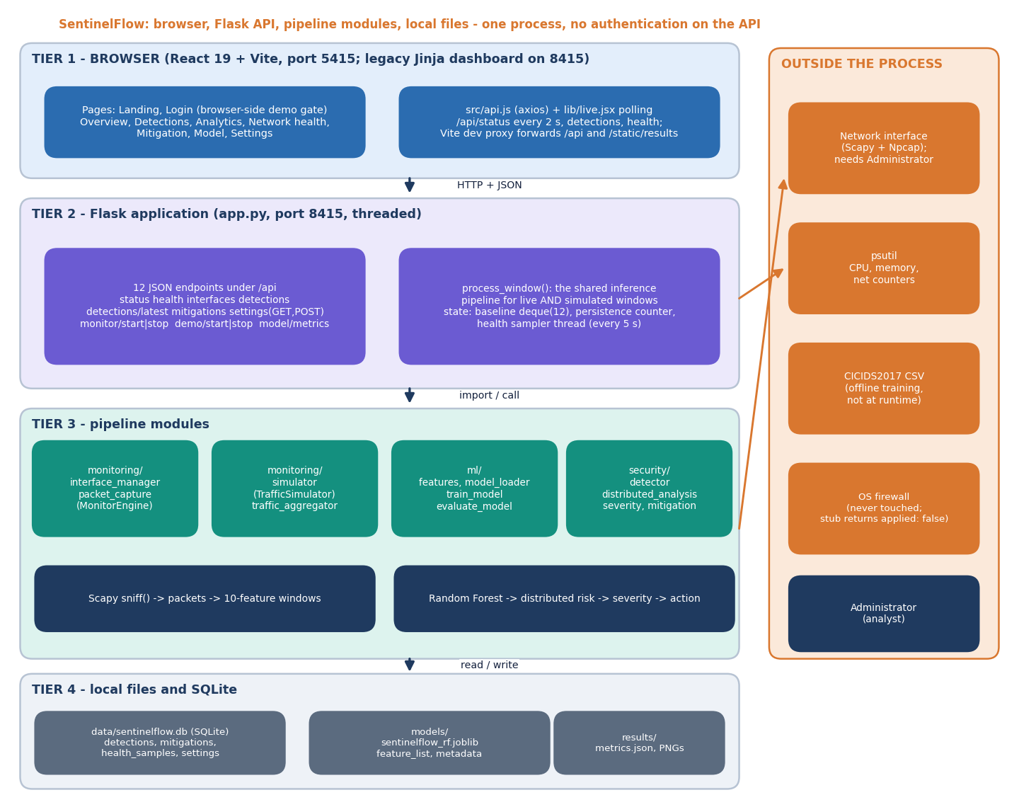
Figure 1: System architecture of SentinelFlow: browser tier, Flask API, pipeline modules and local files.
The figure above gives the overall picture. The browser tier is a React console; the Flask application owns the shared inference function; the pipeline modules capture or simulate packets, classify, assess and act; SQLite and a few files hold the state. Chapter 5 explains each tier.

1.2 Motivation
The motivation comes from three observations in the batch survey and the base paper.
• Signature-based defences miss new or modified patterns. A classifier that learns from flow features can generalise to variants that no signature describes, provided the training data is representative.
• Detection without action leaves the service down. The batch survey names the gap as closing the loop from real-time detection to automatic, adaptive mitigation with measured response latency. The base paper itself lists sidecar operation, throttling or blackholing of suspicious flows and live testbeds as future work [1].
• A false positive is itself a denial of service. Quarantining a legitimate source because the detector was wrong harms exactly the users the system is supposed to protect, so the false-positive rate has to be measured at the point where an action is taken, not only at the classifier.
A fourth, practical motivation emerged while documenting the work: reported accuracies of 99 to 100 % are common in the literature [1], [16], [18], but they come from offline evaluations on one dataset at a time, and the audit of CICIDS2017 by Engelen et al. [9] and the critique of Sommer and Paxson [10] both warn that such numbers do not guarantee real-world performance. A student project that reports its own numbers has to show where its model stands on real data, and that is done in Chapter 8.

1.3 Problem Statement
The batch problem statement lists four weaknesses of current practice:
• Signature-based defences cannot detect novel or modified attack patterns.
• Detection without mitigation leaves the service unavailable while the attack continues.
• Blocking legitimate users through false positives is itself a denial of service.
• Attack traffic must be classified fast enough to act before resources are exhausted.
The need that follows is stated in the batch document as: a framework that detects DDoS traffic in real time and applies adaptive mitigation without blocking legitimate users.

1.4 Need for the Proposed System
Existing open-source intrusion detection tools are built for network engineers: they need a dedicated sensor, rule sets and expertise. Research prototypes, including the base paper, evaluate a classifier on a stored dataset and stop there. A small organisation, a laboratory or a student team needs something between the two: a self-contained program that watches a network interface, tells an administrator in plain words why a window of traffic is considered an attack, takes a limited and reversible action, and keeps a history that can be inspected afterwards. Such a program also has to be safe to demonstrate, which is why SentinelFlow includes a Simulation Mode that exercises the whole pipeline without sending or capturing a single real packet.

1.5 Overview of the Proposed Solution
SentinelFlow treats time as a sequence of monitoring windows (ten seconds by default, two to 120 seconds allowed). For every finished window the system performs the same six steps, whether the packets came from the network card or from the simulator:
1. Aggregate. Packets are reduced to ten features (packet and byte counts, per-second rates and average packet sizes, each for the received and the sent direction) plus context that the classifier does not see: the number of distinct sources and destinations, the protocol mix and the busiest addresses.
2. Classify. A 200-tree Random Forest returns Benign or Attack and a confidence.
3. Assess distribution. A weighted rule score between 0 and 1 expresses how widely the traffic is spread over sources and destinations, how high the packet rate is and how far it deviates from the average of the last twelve windows.
4. Grade severity. A transparent score combines the label, the confidence, the packet rate, the distribution score, the spread and the number of consecutive suspicious windows into Low, Medium, High or Critical, and records every factor that contributed.
5. Act. High and Critical windows quarantine the three busiest sources that are not protected local addresses for 40 seconds (80 for Critical); Medium recommends rate limiting; Low only keeps monitoring. Quarantines expire by themselves and are then marked as recovered.
6. Record and show. The detection, with its full explanation, and each quarantine are stored in SQLite and appear on the console, which polls the API every two seconds.
The same ten-feature schema is used for training: columns of a CICIDS2017 flow record are mapped to it (forward packets and bytes become sent, backward become received, rates are counts divided by the flow duration). That sharing is what allows a classifier trained on flow rows to be applied to live windows, and it is also the source of the flow-to-window scale problem measured in Chapter 8.

1.6 Objectives
The six objectives of the batch are reproduced in Table 1.1 together with the chapter that reports how far each was reached.
Table 2: Project objectives and where they are addressed
No. | Objective | Addressed in
1 | Acquire a benchmark intrusion dataset and extract network flow features | Chapters 6 and 8
2 | Capture live traffic and compute the same features in real time | Chapters 6 and 7
3 | Train a classifier to distinguish DDoS traffic from legitimate traffic | Chapters 6 and 8
4 | Implement adaptive mitigation that rate-limits or blocks identified attack sources | Chapters 5, 6 and 8
5 | Build a dashboard showing live traffic, detection events and mitigation actions | Chapters 5 and 8
6 | Evaluate detection accuracy, false positive rate and time from detection to mitigation | Chapters 7 and 8

1.7 Scope
In scope. Binary classification of traffic windows as benign or attack with a Random Forest on ten flow features; capture with Scapy and a safe software simulator; an explainable distributed-risk and severity layer; temporary application-level quarantine with automatic recovery; a SQLite history of detections, mitigations and host health; a REST API with twelve endpoints; a nine-page React console; offline training from CICIDS2017 CSV files; automated tests; and a measured evaluation on synthetic and real data.
Out of scope. Changing the operating-system firewall or any router or switch; software-defined-network controller integration; multi-class attack identification; encrypted-traffic payload analysis; user registration, password reset, role-based access and report export (listed as user stories US-101 to US-103 and US-119 in the batch backlog but not built); and any claim about performance under a real production attack.

1.8 Contributions
1. A working closed loop from traffic window to stored detection to temporary quarantine to automatic recovery, on a commodity host, with the decision latency measured (Chapter 8).
2. A transparent distributed-risk score (source diversity, destination diversity, packet-rate pressure and deviation from a rolling baseline) aimed at carpet-bombing patterns. Measured on its own it is a precise but weak detector (recall 9 to 32 % at the 0.7 threshold, no false positives), so it is used as one input of the severity score.
3. An explainable severity engine that lists its contributing factors. At 5-second windows it reduces the false-positive rate on benign windows from 13.6 % (Random Forest label alone) to 0.27 % (High or Critical severity).
4. A Simulation Mode that drives the identical inference pipeline without network access, always labelled as simulated in the interface.
5. A shared ten-feature schema for flow rows and monitoring windows, and a measured finding about it: the forest shipped with the product was trained on synthetic data and scores 71.8 % accuracy on 225,745 real CICIDS2017 DDoS-day flows, while the same forest retrained on those flows reaches 99.94 % (five seeds).

1.9 Limitations and Assumptions
The limitations are stated here once and measured in detail in Chapters 7 and 8.
• The shipped model was trained on a labelled synthetic fallback because CICIDS2017 could not be downloaded when the product was built; its 99.71 % accuracy is measured on a held-out split of that synthetic data.
• Mitigation is an application-level denylist. apply_os_firewall_block() is a stub that returns applied: false; no packet is dropped by the operating system, and rate limiting is only recommended.
• Live capture needs Npcap and Administrator rights. Npcap is not installed on the machine used for this report, so only the error path of live capture was exercised; Simulation Mode drives the same pipeline.
• The model was calibrated on 10-second windows. At shorter windows the Random Forest label alone raises many false alarms (46.0 % at 2 s and 13.6 % at 5 s on benign windows).
• The REST API has no authentication; the console login is a browser-side demonstration gate. Both servers bind to 127.0.0.1.
The work rests on four assumptions: the forward direction of a CICIDS2017 flow corresponds to sent traffic and the backward direction to received traffic; local interface addresses define inbound and outbound orientation for live windows; a quarantine of 40 seconds (doubled for Critical) is long enough to demonstrate recovery; and a ten-second window is long enough to aggregate meaningful rates yet short enough to react.

1.10 Organisation of the Report
Chapter 2 surveys the base paper and related work and states the research gap. Chapter 3 studies the technical, economic, operational and schedule feasibility. Chapter 4 analyses the existing and proposed systems and lists the requirements. Chapter 5 presents the design: architecture, workflow, data flow diagrams, UML diagrams, database and user interface. Chapter 6 describes the methodology and implementation: data, preprocessing, algorithm, formulation, API, security and installation. Chapter 7 reports testing and its limits, and Chapter 8 the results with every output screen, the comparison with the base paper and objectives against outcomes. Chapter 9 concludes, Chapter 10 gives the future scope, and the report ends with the references and three appendices (important code, installation and user guide, additional screens).

2. LITERATURE SURVEY

2.1 Overview
The batch literature survey (5.LITERATURE SURVEY.docx) lists five works: the base paper and four recent articles on DDoS detection and mitigation. This chapter reads them together with the works the base paper itself cites, two further papers found in the batch folder, and the dataset papers on which every result in this field depends. Of the five survey items, only the base paper [1] was available in full. For the PeerJ article [3] only the abstract was available, and for the remaining three [2], [4] and [5] only the bibliographic record could be verified. Their results are therefore never quoted in this report; they are listed so that the survey is complete and honest about what was read.
The works fall into five groups: threshold and statistical detection, supervised machine learning, ensembles with feature selection (the base paper's family), deep, reinforcement and language-model approaches, and studies of the data itself. Table 2.1 summarises the works whose content was read.
Table 3: Summary of the surveyed works
Work | Year | Approach | Finding / limitation
Trigui et al. [1] (base paper) | 2026 | RF + Banzhaf feature selection; seven classifiers; four hard-voting ensembles; SDN | 100 % on SDN flows and CIC-DDoS2023; SVM/kNN ensembles slow; no live mitigation
Swileh et al. [6] | 2026 | Carpet-bombing DDoS in SDN: RAG + FAISS + LLM, no supervised training; Mininet + Ryu | Accuracy 99.94 % (Gemma-4-31B-IT), about 2 s per request; needs an LLM service
Raghavendran, Robinson [3] | 2026 | WISNE-SDN IoT controller; KNN, XGBoost, Naive Bayes on a testbed dataset | 97 % (KNN), 100 % (XGB) from the abstract; testbed data, detection only
Jadric, Mladenovic [4] | 2025 | Double deep Q-networks for DDoS detection and mitigation (title only) | Batch survey item; abstract not available, results not quoted
Alashhab et al. [14] | 2024 | Ensemble online machine learning for DDoS detection and mitigation in SDN | Cited by the base paper; record verified, results not quoted
Rahman [7] | 2025 | Logistic regression, decision tree, SVM on a CIC dataset sample | SVM 0.971, decision tree 0.827, logistic regression 0.593; detection only
Zaman et al. [15] | 2025 | Decision-tree algorithms for DDoS detection in SDN | Cited by the base paper; record verified, results not quoted
Alduailij et al. [16] | 2022 | Mutual information + RF feature importance; ensemble voting | 99 % on CICIDS2017 and CIC-DDoS2019 (as reported in the base paper)
Becerra-Suarez et al. [18] | 2024 | Tree learners and deep networks with data processing | 99.97 % accuracy, 99.98 % F1 (as reported in the base paper)
Areef, Vijayasri [2] | 2026 | DDoS detection and mitigation (title only) | Batch survey item; abstract not available, results not quoted
IJARCCE item [5] | 2025 | AI-driven DDoS detection and mitigation in SDN (title only) | Batch survey item; abstract not available, results not quoted
Engelen et al. [9] | 2021 | Audit of CICIDS2017: labelling and flow-construction problems | Warns that CICIDS2017 results need care; relevant to every claim made on this dataset

2.2 Base Paper Analysis
Reference. M. M. Trigui, M. S. Islam, M. D. Gambo, M. S. Alam and T. Helmy, "Resource-aware ensemble framework for DDoS detection in SDN via novel game-theoretic feature selection," IEEE Access, vol. 14, pp. 1666-1676, 2026, doi: 10.1109/ACCESS.2025.3618519. The paper was received on 12 August 2025, accepted on 26 September 2025 and published on 7 October 2025. The batch record (3.BASE PAPER.docx) names it as the base paper of this project.

2.2.1 Problem and motivation
The paper starts from the observation that in software-defined networking (SDN) the central controller is both the source of visibility and a single point of failure: flooding it can destabilise the whole network. Detection therefore has to be accurate, general enough for low-rate and zero-day attacks, and light enough to run next to the controller without degrading it. The authors criticise earlier work on three grounds: models are evaluated on the dataset they were trained on, outdated datasets are used, and almost no paper reports memory, latency or model size.

2.2.2 Method
The contribution is a hybrid feature-selection method and a set of voting ensembles.
• RF-BPI feature selection. Random Forest feature importance is combined with a Banzhaf Power Index from cooperative game theory. The index of a feature is the average marginal contribution of that feature over all subsets of the other features; because that is exponential, the paper estimates it by flipping the value of one feature in a sample of test rows and recording the share of rows whose predicted label changes, then normalises the scores. Features with negligible scores are dropped.
• Classifiers. XGBoost, Random Forest, Gradient Boosting, SVM, k-nearest neighbours, AdaBoost and Gaussian Naive Bayes are trained individually; eleven classifiers are compared in the paper's accuracy figures, and tree-based models perform best.
• Ensembles. Four hard-voting ensembles (clf1 to clf4) are built from the best base learners; clf4 deliberately mixes complex (XGBoost, SVM) and simple (Naive Bayes) models for diversity.
• Resource profiling. Training time (wall clock), inference time on the whole test set, peak memory (memory_profiler) and model size on disk (joblib) are recorded alongside accuracy, precision, recall and F1.

2.2.3 Data and results
Two datasets are used: an SDN flow dataset with 104,345 records and 23 features, and a subset of CIC-DDoS2023 with 1,754,109 rows and 47 features. All four ensembles reach 100 % accuracy, precision, recall and F1 on both. The differences lie in cost: the ensembles that contain an SVM (clf3 and clf4) needed more than 4,000 seconds to train on the SDN data, the ensemble with k-nearest neighbours (clf2) needed more than 150 seconds to classify the SDN test set, while clf1 stayed light in training time, inference time and size (below 1 MB on CIC-DDoS2023 for clf1 and clf3). On CIC-DDoS2023 all models trained in under 15 seconds. The paper concludes that clf1 is the deployment-ready choice and compares its accuracy with prior work, for instance 99 % on CICIDS2017 and CIC-DDoS2019 for the ensemble of Alduailij et al. [16] and 99.97 % accuracy with 99.98 % F1 for Becerra-Suarez et al. [18] (both as reported in the base paper).

2.2.4 Strengths
• Two datasets, one of them recent, and a stated attempt at cross-environment validation.
• Resource profiling is part of the evaluation, which is rare and directly relevant to deployment next to a controller.
• The feature-selection idea is interpretable: a feature is kept because flipping it changes decisions, not only because it splits trees well.

2.2.5 Limitations and what it leaves open
• Perfect scores on everything. Accuracy of 100 % on four ensembles and two datasets suggests that the tasks are nearly separable or that the evaluation is easy; the paper itself notes that confusion rises with the number of classes in a multi-class setting.
• Offline only. Both datasets are stored files. The paper proposes a sidecar that would throttle or blackhole suspicious flows but does not build or test it; it names live testbeds and production traces as future work.
• Detection only. There is no mitigation component, no severity grading and no measure of the time from detection to action.
• Binary labels. Multi-class detection, online learning and federated deployment are future work.
SentinelFlow starts exactly at these gaps: it builds the capture-to-action loop on a commodity host and measures it, while accepting the base paper's own warning that high offline accuracy is not enough. It does not reproduce the Banzhaf selection or the voting ensembles; Chapter 8 instead compares single classifiers on real flows.

2.3 Related Work by Theme

2.3.1 Threshold, statistical and early SDN detection
Early SDN detectors watched flow-level statistics such as packet rates, destination entropy and connection counts collected from OpenFlow switches. Braga et al. [23] proposed a lightweight detector for NOX/OpenFlow that feeds flow statistics to a self-organising map. Such methods catch volumetric floods but, as the base paper observes, are poorly suited to low-rate or stealthy variants and depend on manual tuning. The survey of Su et al. [17] and the taxonomy of Mirkovic and Reiher [11] organise this space of detection and mitigation technologies and are the best starting points for a reader new to the field.

2.3.2 Supervised machine learning
Most recent work trains a classifier on labelled flow features. Rahman [7] compares logistic regression, a decision tree and an SVM on a CIC dataset sample and reports accuracies of 0.593, 0.827 and 0.971 respectively, with the SVM the best. Zaman et al. [15] study decision-tree algorithms for DDoS detection in SDN, and Raghavendran and Robinson [3] evaluate KNN, XGBoost and Naive Bayes on a testbed dataset from a WISNE-SDN IoT controller, with accuracies of 97 % for KNN and 100 % for XGBoost according to the abstract. Sahoo et al. [20] tune an SVM with an evolutionary algorithm for SDN DDoS detection, and Varghese and Muniyal [21] propose an IDS framework for SDN. The common pattern is high accuracy on a single stored dataset and detection without action.

2.3.3 Ensembles and feature selection
Alduailij et al. [16] select features with mutual information and Random Forest importance and combine classifiers by voting; Hossain and Islam [19] use hybrid feature selection with an ensemble to reduce false positives; Becerra-Suarez et al. [18] combine tree learners and deep networks with careful data processing. Alashhab et al. [14] go furthest towards the project's goal by using an ensemble online model for both detection and mitigation in SDN, although their record could only be verified bibliographically here. The base paper belongs to this family and adds the Banzhaf-based selection and resource profiling.

2.3.4 Deep, reinforcement and language-model approaches
Jadric and Mladenovic [4] apply double deep Q-networks to detection and mitigation, which treats mitigation as a learned policy; only the title could be verified. Swileh et al. [6] target carpet-bombing attacks in SDN with a retrieval-augmented framework: interface-level traffic features are turned into embeddings, similar past traffic is retrieved with FAISS and a large language model infers whether the traffic is an attack, without supervised training. Their best configuration (Gemma-4-31B-IT) reports 99.94 % accuracy with about two seconds per request on a Mininet and Ryu testbed with hping3-generated attack traffic. It is the closest published work to this project in intent (carpet bombing, detection and mitigation) and the most different in method: it needs an LLM service and about two seconds per decision, whereas SentinelFlow uses a 2.7 MB forest on the local machine.

2.3.5 Programmable data planes and applied software
Musumeci et al. [22] move part of the detection into a P4 programmable switch to reduce controller load, at the price of specialised hardware. Akroma and Mohamed [24] analyse DDoS attacks and develop software for detection and mitigation with machine learning. The batch survey also lists [2] and [5] under similar titles; neither could be read.

2.3.6 Studies of the data and of the method
Two papers do not propose a detector but affect how every detector's numbers should be read. Engelen et al. [9] audited CICIDS2017 and documented labelling and flow-construction problems, which is why the result of this project on that dataset is reported with caveats. Sommer and Paxson [10] explained why machine learning for intrusion detection is harder than in other fields, with a closed-world assumption that rarely holds, high cost of errors and difficulty of evaluation. Both support the decision to measure the shipped model on data it was not built from.

2.4 Datasets and Algorithms Used in the Surveyed Work
Datasets. The base paper uses an SDN flow dataset (104,345 records, 23 features) and CIC-DDoS2023 (1,754,109 rows, 47 features in the subset). Alduailij et al. and Becerra-Suarez et al. use CICIDS2017 and CIC-DDoS2019 (as reported in the base paper). CICIDS2017 [8] was produced by the Canadian Institute for Cybersecurity from five days of labelled traffic (Monday to Friday) and is distributed as CSV files of flow records computed with CICFlowMeter, each with 78 features and a label. The Friday-afternoon file used in this project's real-data evaluation has 225,745 rows (97,718 benign and 128,027 labelled DDoS) and 79 columns. The Swileh et al. work builds its own Mininet dataset [6], and Raghavendran and Robinson a testbed dataset [3].
Algorithms. Random Forest [12] averages many decision trees grown on bootstrap samples with random feature subsets; it handles non-linear interactions, needs no feature scaling and exposes feature importance, which is why the base paper and this project both use it. Gradient boosting and XGBoost build trees sequentially on the errors of earlier trees. SVMs separate classes with a maximum-margin hyperplane and become expensive on large data, as the base paper's clf3 and clf4 show. k-nearest neighbours is simple but its inference cost grows with the training set (clf2). Naive Bayes is the cheapest and assumes independent features. The ensembles combine these by hard voting.

2.5 Strengths and Limitations of Existing Approaches
Table 4: Strengths and limitations of the main approach families
Family | Strengths | Limitations
Threshold and statistical | Cheap, easy to explain, catches large volumetric floods | Manual tuning; misses low-rate and spread-out attacks
Single supervised classifier | High accuracy on benchmark flows; fast inference for trees | Accuracy measured on one dataset; no action after detection
Ensembles with feature selection | More stable decisions; smaller feature space; resource profile in the base paper | SVM and kNN members are slow; still offline
Deep and reinforcement learning | Can learn a mitigation policy; temporal patterns | Heavy training; limited interpretability; specialised infrastructure
Retrieval + LLM | No retraining; works on carpet bombing; natural-language explanations | About two seconds per request; depends on an external model
P4 / in-network detection | Offloads the controller | Needs programmable hardware

Across the families the strengths are accuracy on stored data and, in the better papers, an awareness of resource cost. The shared weaknesses are the dependence on one dataset at a time, the absence of a measured detection-to-action loop, and the absence of an account of what a false positive costs the user who is wrongly blocked.

2.6 Research Gap
The batch survey states the gap as: the surveyed work applies ensemble detection within software-defined networks, and the gap is closing the loop from real-time detection to automatic adaptive mitigation with measured response latency. Reading the sources above refines it into three parts:
1. The surveyed work applies ensemble detection within software-defined networks; closing the loop from real-time detection to automatic, adaptive mitigation with measured response latency is the gap named in the batch survey.
2. Reported accuracies of 99-100 % come from offline evaluations on one dataset at a time; few works run a live (or live-like) capture-to-action loop on a commodity host.
3. False-positive cost is rarely measured at the level where it hurts (a legitimate source quarantined), and carpet-bombing traffic that spreads across many destinations is seldom scored with a distributed-traffic signal.

3. FEASIBILITY STUDY

3.1 Introduction
Before the design was fixed, the project was examined for technical, economic, operational and schedule feasibility. This chapter records that examination with the evidence gathered while building and measuring SentinelFlow: what was available, what it cost, who would run it and how the work was planned.

3.2 Technical Feasibility
The product needs five capabilities: packet capture or a substitute, feature computation, a trained classifier, a web service with storage, and a browser interface. Each is available in free, widely used libraries, and each was shown to work on the development machine (an Intel Core i5-12500 with 6 cores and 12 threads, 15.7 GB of memory, Windows 11 Pro, no GPU).
Table 5: Technology choices and the evidence that they are feasible
Capability | Choice (version used) | Evidence
Packet capture | Scapy 2.8.0 [25], Npcap on Windows | Capture code written; Npcap absent on the test machine, so only the error path ran. Simulator substitutes.
Host health | psutil 7.2.2 [27] | CPU, memory and network counters sampled every 5 s and stored.
Classifier | scikit-learn 1.9.1 [13], Random Forest [12] | Shipped forest trained in 22.2 s; real-flow forest in about 7 s; model file 2.74 MB.
Data handling | pandas 3.1.0, NumPy 2.4.6, joblib 1.6.0 | 225,745 real flows read, cleaned and mapped in a single pass.
Web service | Python 3.11.9, Flask 3.1.3 [26] | Twelve JSON endpoints; median response 3.0 to 35.7 ms over HTTP on 127.0.0.1.
Storage | SQLite (Python standard library) | Four tables; no server to install.
Interface | React 19, Vite 8, Tailwind 4, Recharts 3 | Nine pages built; twelve screens captured with data.
Tests | pytest 9.1.1, requests | 95 automated tests and 25 smoke checks pass.

Capacity was checked against the simulator, whose windows are the heaviest the pipeline sees in this project: over 600 windows the mean was 1,969 packets and the largest 8,966; aggregating such a window took a median of 1.0 ms. Real traffic on a busy link would contain far more packets per window, so the capture path is the part whose capacity could not be established without a live test.
The main technical risk was data: CICIDS2017 could not be downloaded when the product was first built, so the training script falls back to a labelled synthetic dataset and says so in the metadata, the API and the console. The documentation run later obtained one real CICIDS2017 file (the Friday-afternoon DDoS capture, 225,745 flows) from a public mirror, which showed that the fallback is feasible to run but not representative (Chapter 8). The second risk was packet capture on Windows, which needs Npcap and Administrator rights; the Simulation Mode removes the dependency for demonstration. The feasibility of the core idea, a classifier on ten flow features, is supported by the real-data result of 99.94 % accuracy after retraining.

3.3 Economic Feasibility
The project was carried out with no expenditure on licences, cloud services or special hardware. Every library is open source: Flask, scikit-learn, pandas, psutil and Vite are under permissive licences, React is under the MIT licence and Scapy under the GNU GPL version 2. CICIDS2017 is distributed for research by the Canadian Institute for Cybersecurity (its licence field on the mirror used reads simply 'other', and the dataset paper has to be cited [8]). The computer used was an ordinary desktop; the heaviest job, training the 200-tree forest on the real flows, took seconds. No GPU, database server or message broker is needed.
Table 6: Cost items
Item | Cost | Note
Software licences | None | All libraries open source
Cloud or hosting | None | Runs on localhost; optional Docker image
Hardware | Existing computer | No GPU; model file 2.74 MB
Dataset | None | Public CICIDS2017 files; paper must be cited
Human effort | Team time | The only real cost; not priced here because no timesheet exists

For an organisation that wanted to adopt a product like this, the recurring costs would be administrator time to retrain the model on its own traffic and, for live capture, a machine placed where it can see the traffic. Those costs were not measured and are not estimated here.

3.4 Operational Feasibility
The intended operator is a network administrator or analyst, not a developer. Starting the product is one step: run.bat creates a virtual environment, installs the dependencies, trains the model if none exists and starts the API on port 8415 and the console on port 5415. The console explains itself: a coloured banner says whether the data is live or simulated, every detection lists the factors behind its severity, and the Model page warns when the training data was synthetic. Quarantines are temporary (40 seconds by default, 80 for Critical) and expire without intervention, so a wrong decision corrects itself and no firewall rule has to be cleaned up afterwards, because none is ever written.
Operating the product live requires Administrator rights and Npcap on Windows, which a small organisation can supply but a student laboratory sometimes cannot; Simulation Mode covers that case. Maintenance consists of retraining when the traffic profile changes: copying CICIDS2017 or locally labelled captures into data/raw and running python ml/train_model.py.

3.5 Schedule Feasibility
The batch backlog (19.USER_STORIES.xlsx) divides the work into 23 user stories of 116 story points in five sprints. The file is an import sheet and carries every story with the status 'To Do'; it is a plan, not a record of what was done. Table 3.3 shows the plan; Chapter 8 reports which objectives were reached.
Table 7: Planned sprints from the batch backlog
Sprint | Stories | Points | Content
1 | US-101 to US-106 | 26 | Login, password reset, roles, flow submission and validation, repository setup
2 | US-107 to US-110, US-114 | 32 | Approach evaluation, benchmark dataset, live capture with the same features, classifier training, output review
3 | US-111 to US-113, US-115 to US-117 | 39 | Adaptive mitigation, live-traffic dashboard, accuracy evaluation, retry and logging, tuning, API
4 | US-118 to US-121 | 14 | Results dashboard, report export, history and search, notifications
5 | US-122, US-123 | 5 | Evaluation metrics, deployment and user documentation

The schedule was feasible for the core of the project (sprints 2 and 3: data, capture, classifier, mitigation, dashboard, API) and for the history, search and documentation items. The items of sprint 1 that concern accounts (registration, password reset, role-based access) and the export and notification items of sprint 4 were not built; the console has a demonstration login only. This is stated again in Section 4.7.

3.6 Risk Analysis
Table 8: Risks, their handling and what actually happened
Risk | Handling in the design | Outcome
Benchmark dataset unavailable | Labelled synthetic fallback, provenance recorded in metadata | Happened: the shipped model is synthetic-trained; real-data check added in documentation
Packet capture not permitted or Npcap missing | Capture errors surfaced in the UI; Simulation Mode | Happened on the test machine; error path tested, simulator used
Legitimate source quarantined by mistake | Protected local addresses, short expiring quarantine, severity layer before action | False-positive rate at acting level 0.27 % (5 s windows) in simulation
Detector too slow for the window | Per-window decision in one call; measure latency | Median 217 ms on a CPU-saturated host; forest saved with n_jobs=-1 costs about ten times more per window
Optimistic metrics | Report held-out, real and pipeline-level numbers separately | Gap found and reported (Chapter 8)
Scope growth (accounts, export, notifications) | Backlog prioritised; core loop first | Accounts, export and notifications left out

3.7 Advantages and Constraints
Advantages. The product is self-contained (one process, one SQLite file), explainable (every severity lists its factors), safe to demonstrate (Simulation Mode), cheap to run, and reversible in its action (temporary quarantine, no firewall changes). Its model is small and quick to retrain, and its behaviour is covered by automated tests.
Constraints. The result depends on the quality and representativeness of the training data; the monitoring window must match the one the model was calibrated on; live capture needs privileges; and the mitigation is advisory at the network level because nothing outside the application is changed. These constraints shape the requirements in Chapter 4.

4. SYSTEM REQUIREMENTS AND ANALYSIS

4.1 Existing System and its Limitations
In practice an administrator has three kinds of tools. Signature-based intrusion detection systems compare traffic with known patterns; they are precise for known attacks but, as the batch problem statement says, cannot detect novel or modified patterns. Threshold rules on packet rate or connection count are cheap but need manual tuning and miss attacks that spread over many destinations. Research prototypes, including the base paper, train a classifier on stored flows and report accuracy, but stop at detection.
Table 9: Limitations of the existing approaches
Approach | What it does | Limitation for this problem
Signature IDS | Matches known patterns | Misses new or modified attacks
Threshold rules | Alarm when rate or count exceeds a limit | Manual tuning; blind to spread-out traffic; many false alarms in busy periods
Offline classifier (base paper and similar) | Labels stored flows with high accuracy | No live loop, no mitigation, no severity, no latency measurement
Retrieval + LLM | Classifies traffic by retrieving similar cases | About two seconds per request and an external model service

4.2 Proposed System and its Advantages
SentinelFlow aggregates traffic into rolling windows, classifies each window, grades its severity with a visible explanation, acts on High and Critical windows with a temporary quarantine, lets the quarantine lapse, and stores everything for review. Its advantages over the existing approaches are the closed loop, the explanation attached to every decision, the carpet-bombing-aware distributed-risk signal, a safe simulation mode and a measured false-positive rate at the point of action.

4.3 Functional Requirements
Table 4.3 lists the functional requirements, the code that implements each and how it was verified. 'Tests' refers to the pytest suite in tests/ (95 tests) and 'smoke' to scripts/smoke_test.py (25 backend checks); both pass.
Table 10: Functional requirements and their verification
ID | Requirement | Implemented in | Verification
FR-1 | Capture packets on a chosen interface in rolling windows | monitoring/packet_capture.py | Error path tested (no Npcap); live capture not verified here
FR-2 | Run a safe simulator through the same pipeline | monitoring/simulator.py | Tests (bounds, callback, start/stop); smoke; 25 probes
FR-3 | Aggregate packets into ten features plus context | monitoring/traffic_aggregator.py | 5 aggregator tests
FR-4 | Validate every feature vector before prediction | ml/features.py | Tests for missing, non-numeric, NaN, infinite, negative values
FR-5 | Classify a window as Benign or Attack with a confidence | ml/model_loader.py, security/detector.py | Tests: output shape, flood window is Attack, missing model reported
FR-6 | Score distributed-traffic risk from 0 to 1 | security/distributed_analysis.py | 4 tests (levels, component sum, carpet-bombing wording)
FR-7 | Grade severity Low to Critical and list the factors | security/severity.py | 4 tests (cap, Critical case, persistence)
FR-8 | Quarantine the top three non-protected sources on High or Critical; recommend rate limiting on Medium | security/mitigation.py | Tests for durations, doubling, protected addresses, duplicates
FR-9 | Expire quarantines automatically and mark them recovered | security/mitigation.py, database/db.py | Expiry test with a controlled clock
FR-10 | Store detections, mitigations, host health and settings | database/db.py | 7 database tests; schema test
FR-11 | Expose status, history, settings, control and model metrics through a REST API | app.py | 32 API tests; smoke; 25 probes
FR-12 | Validate settings (window 2 to 120 s, quarantine 5 to 3600 s) | app.py | Out-of-range and malformed-value tests and probes
FR-13 | Show overview, detections, analytics, health, mitigation, model and settings in a console | frontend/src/pages | Console pages captured with data (Chapter 8)
FR-14 | Show model metrics together with the data provenance | app.py, Model page | API test for provenance; screenshot of the warning
FR-15 | Train and persist the model from CICIDS2017 CSV files or the fallback | ml/train_model.py | Run when the product was built; real-flow experiments reuse its pieces

4.4 Non-Functional Requirements
Table 11: Non-functional requirements and measured status
Quality | Requirement | Status
Responsiveness | The API answers dashboard polling without visible delay | Median 3.0 to 35.7 ms per endpoint over HTTP (127.0.0.1)
Decision latency | The decision for a window is made within a fraction of the window | Median 217 ms, 95th percentile 489 ms from finished features to decision, on a host kept at 100 % CPU by other jobs
Accuracy | High accuracy and a low false-positive rate on real traffic | Not met by the shipped model on real flows (71.8 %); met after retraining (99.94 %)
Explainability | Every severity shows its contributing factors | Met (factor list stored with each detection)
Safety | No change to the operating-system firewall; reversible actions | Met by design: firewall function is a stub; quarantines expire
Reliability | Errors reported, not hidden; invalid input rejected | 25 of 25 malformed-input probes behaved as intended; backend healthy afterwards
Security | Local-only service | Servers bind to 127.0.0.1; no API authentication; interface name not length-checked
Portability | Windows and Linux; optional Docker | Windows 11 tested; Docker files present but not run for this report
Maintainability | Tests and a single feature schema shared by training and inference | 95 tests; ml/features.py is the single schema

4.5 Hardware Requirements
The product was developed and measured on an Intel Core i5-12500 (6 cores, 12 threads) with 15.7 GB of memory and Windows 11 Pro. No GPU is used. The shipped model is 2.74 MB and loads in a fraction of a second. A network interface is needed only for live capture; Simulation Mode needs none. Minimum hardware was not determined by experiment and no lower bound is claimed; peak memory use was not measured.

4.6 Software Requirements
Table 12: Software used
Component | Version used | Role
Python | 3.11.9 (3.11 or 3.12 recommended) | Back end, training, tests
Flask | 3.1.3 | REST API and legacy dashboard
scikit-learn / joblib | 1.9.1 / 1.6.0 | Random Forest and model persistence
pandas / NumPy / SciPy | 3.1.0 / 2.4.6 / 1.17.1 | Data handling
Scapy / Npcap | 2.8.0 / required on Windows for live capture | Packet capture
psutil | 7.2.2 | Host health and local addresses
matplotlib | 3.11.2 | Result plots
pytest / requests | 9.1.1 / 2.34.2 | Tests and smoke checks
Node.js with React / Vite / Tailwind / Recharts | React 19.3, Vite 8.3, Tailwind 4.3, Recharts 3.10 | Console
SQLite | Bundled with Python | Storage
Browser | Chrome, Edge or Firefox | Console

A note on versions: the model was pickled with scikit-learn 1.9.0 and loaded with 1.9.1, which produces a warning but works; pinning the library version would remove it.

4.7 User Roles
The product has a single role, the administrator or analyst, who can start and stop sessions, change settings and read everything. The batch backlog also asks for registration, password reset and a separate privileged role for a security-operations analyst (US-101 to US-103). These were not implemented: the React console has a browser-side demonstration login (a fixed demo account stored in the browser) that only gates the pages, and the REST API has no authentication. Because both servers listen on 127.0.0.1 only, the exposure is limited to the local machine, but the product should not be put on a network interface as it stands.

4.8 Data Requirements
For training the product needs labelled flow records with, at least, forward and backward packet counts, forward and backward byte totals and the flow duration, which is what CICIDS2017 CSV files provide. The documentation run used one such file with 225,745 rows. For operation it needs no external data: windows are built from packets, and the store is created on first start. The persistent data are the four SQLite tables (detections, mitigations, health samples, settings), the model files and the result files written by training.
Table 13: The ten-feature schema shared by training and inference
Feature | Meaning | From a CICIDS2017 flow | From a live window
received_packets, received_bytes | Count and bytes of received traffic | Backward packets and bytes | Packets whose destination is a local address (or neither end is local)
received_packets_per_second, received_bytes_per_second | Received rates | Counts divided by flow duration | Counts divided by window length
average_received_packet_size | Bytes per received packet (0 if none) | Bytes / packets | Bytes / packets
sent_packets, sent_bytes | Count and bytes of sent traffic | Forward packets and bytes | Packets whose source is local and destination is not
sent_packets_per_second, sent_bytes_per_second | Sent rates | Counts divided by flow duration | Counts divided by window length
average_sent_packet_size | Bytes per sent packet (0 if none) | Bytes / packets | Bytes / packets

The schema is the single contract between training and inference. Alongside the ten features the aggregator computes context that the classifier never sees (distinct sources and destinations, protocol shares, the busiest addresses), which the distributed-risk and mitigation steps use.

4.9 Interface Requirements
Table 14: REST interface
Method | Path | Purpose
GET | /api/status | Mode, interface, window, windows completed, latest detection, active quarantines, capture error
GET | /api/health | Current and recent CPU, memory and network counters
GET | /api/interfaces | Capture interfaces with addresses and state
GET | /api/detections?limit=n | Stored detections (1 to 500) with counts by prediction and severity
GET | /api/detections/latest | Most recent detection
GET | /api/mitigations | Active quarantines and history
GET, POST | /api/settings | Read or change window and quarantine length
POST | /api/monitor/start, /api/monitor/stop | Start or stop live capture
POST | /api/demo/start, /api/demo/stop | Start or stop Simulation Mode
GET | /api/model/metrics | Metrics, feature importance, confusion matrix and provenance

The human interface is the React console on port 5415 (the original server-rendered dashboard remains on 8415). The packet interface is Scapy on the chosen network adapter. The only external file interface is the CSV reader of the training script.

4.10 Use Cases
Table 15: Principal use cases
No. | Use case | Actor | Main flow
UC-1 | Start Simulation Mode | Administrator | Press Start simulation; windows are scored and shown
UC-2 | Start live capture | Administrator | Choose interface and window, press Start live; the session reports a capture error if the driver is missing
UC-3 | Investigate a detection | Administrator | Open Detections, select a row, read the factors and the recommendation
UC-4 | Watch quarantines | Administrator | Open Mitigation, see countdowns and history
UC-5 | Adjust settings | Administrator | Change window or quarantine length; invalid values are refused
UC-6 | Check the model | Administrator | Open Model; read metrics and the synthetic-data warning
UC-7 | Retrain the model | Developer | Place CSV files in data/raw and run the training script

The use-case diagram in Chapter 5 shows these cases with their actors.

4.11 Existing and Proposed Systems Compared
Table 16: Existing approaches and SentinelFlow
Aspect | Existing (offline classifier, base paper) | SentinelFlow
Input | Stored flow datasets | Live packets or simulated windows, plus offline flow files for training
Decision | Label per flow | Label per window plus distributed risk and severity
Action | None (future work) | Temporary quarantine with automatic recovery, rate-limit advice
Explanation | Feature importance | Per-decision factor list
Resource profile | Training time, inference time, memory, model size | Model size, decision latency (median 217 ms under load), API latency
Reported accuracy | 100 % on SDN and CIC-DDoS2023 | 99.71 % synthetic (shipped); 71.8 % shipped on real flows; 99.94 % retrained on real flows

4.12 Constraints and Assumptions
• Window length: the model assumes ten-second windows; other lengths change the rates the model sees.
• Orientation: forward flow direction is treated as sent and backward as received; live orientation follows local interface addresses.
• Privilege: live capture needs Administrator rights and Npcap on Windows.
• Safety: no operating-system firewall rule is ever written; the quarantine is a decision inside the application.
• Data: the real-data evaluation covers one attack type (the DDoS day of CICIDS2017) and a random split of flows; the dataset has known labelling problems.
• Scope: a single administrator role, local access only, binary classification.

5. SYSTEM DESIGN
This chapter describes how SentinelFlow is built: the architecture and workflow, the data flow, the class, sequence and use-case design, the data design, the core algorithm, the module and API design and the user interface. Every diagram was drawn from the code in app.py, monitoring/, ml/, security/, database/ and frontend/src/; the complete set, each with a longer explanation, is also collected in the Block Diagrams document.
Three facts about the design are stated at the outset because they shape everything below. SentinelFlow is a single Python process with no message queue and no separate worker: the capture thread, the simulator thread, the health sampler and the Flask request threads share one set of in-memory objects. Its mitigation is application-level: a quarantine is an entry in a table inside the process, and the operating-system firewall is never touched. And its REST API has no authentication; the product relies on binding to 127.0.0.1. The design follows the detection half of the base paper [1] (a tree-based classifier on flow features) and adds the loop that paper lists as future work: severity assessment, mitigation, recovery and history.

5.1 Design Goals and Architecture
Five goals shaped the design. First, close the loop from a captured window to an action and back to a recovered state, so that detection is never the last step. Second, be explainable: every decision carries the factors that produced it, because a quarantined address must be justifiable to an administrator. Third, be safe by default: no attack traffic is generated, the firewall is not changed, local and loopback addresses are never quarantined, and quarantines expire by themselves. Fourth, run on a laptop without special hardware: the classifier is a Random Forest on ten numbers per window, and Simulation Mode needs neither Npcap nor Administrator rights. Fifth, use one pipeline for live and simulated traffic, so that the demonstration exercises the same code as a real capture.
Figure 2: System architecture of SentinelFlow: browser tier, Flask API, pipeline modules and local files.
The architecture has four tiers. The browser tier is a React 19 single-page application served by Vite on port 5415; it polls the API every two seconds and holds no business logic. The Flask application listens on 127.0.0.1:8415, exposes twelve JSON endpoints and owns process_window(), the one function through which every window passes. The pipeline modules are plain Python packages: monitoring/ produces windows, ml/ defines the feature schema and loads the model, and security/ turns a prediction into a risk score, a severity and an action. State lives in a SQLite file and in the joblib, JSON and PNG artefacts written by training. Beyond the process boundary are the network interface (reached through Scapy), psutil for host counters and, at training time only, the CICIDS2017 files.

5.2 High-Level Workflow
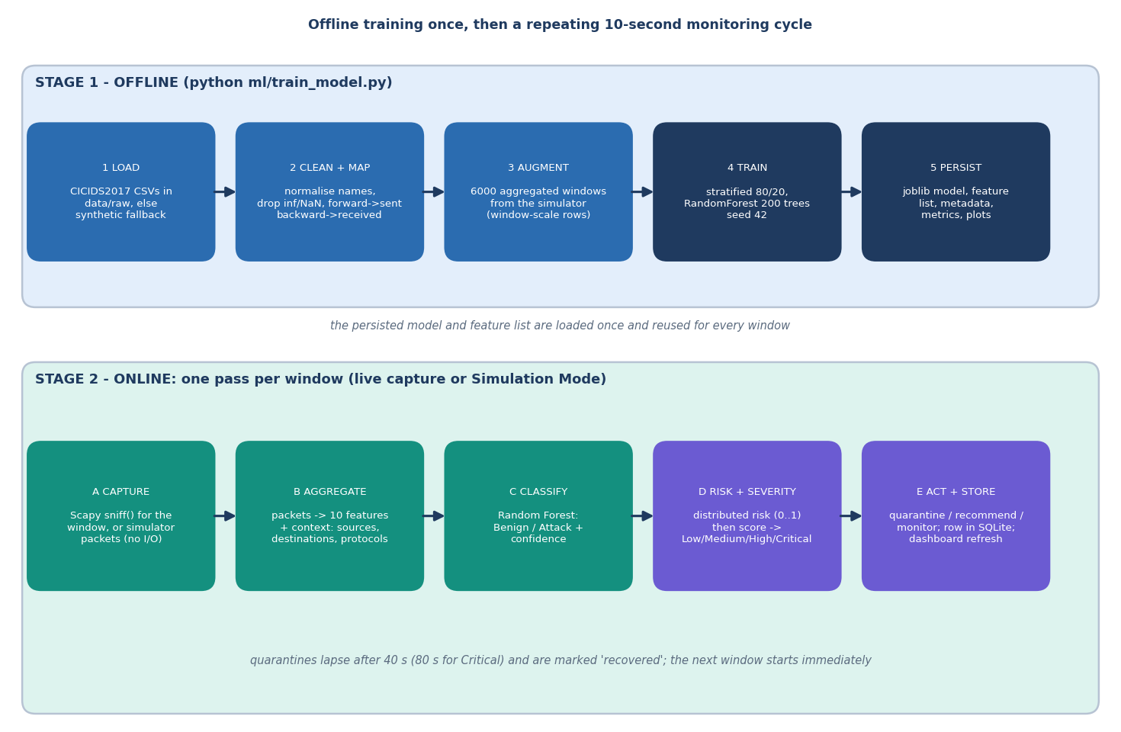
Figure 3: High-level workflow: offline training once, then a repeating capture, aggregate, classify, assess and act cycle.
The workflow has two time scales. Training is a command-line program, python ml/train_model.py, which took 22.2 seconds for the shipped model; it writes the model, the feature list, the metadata and the evaluation plots. Monitoring is a loop that repeats once per window. In live mode the window is the capture time of a Scapy sniff() call (ten seconds by default, two to 120 allowed); in Simulation Mode the simulator builds a packet list in memory and waits for the window length. Everything after the packet list is identical: aggregate, classify, assess, act, store.

5.3 Data Flow Diagrams

5.3.1 Level 0: context
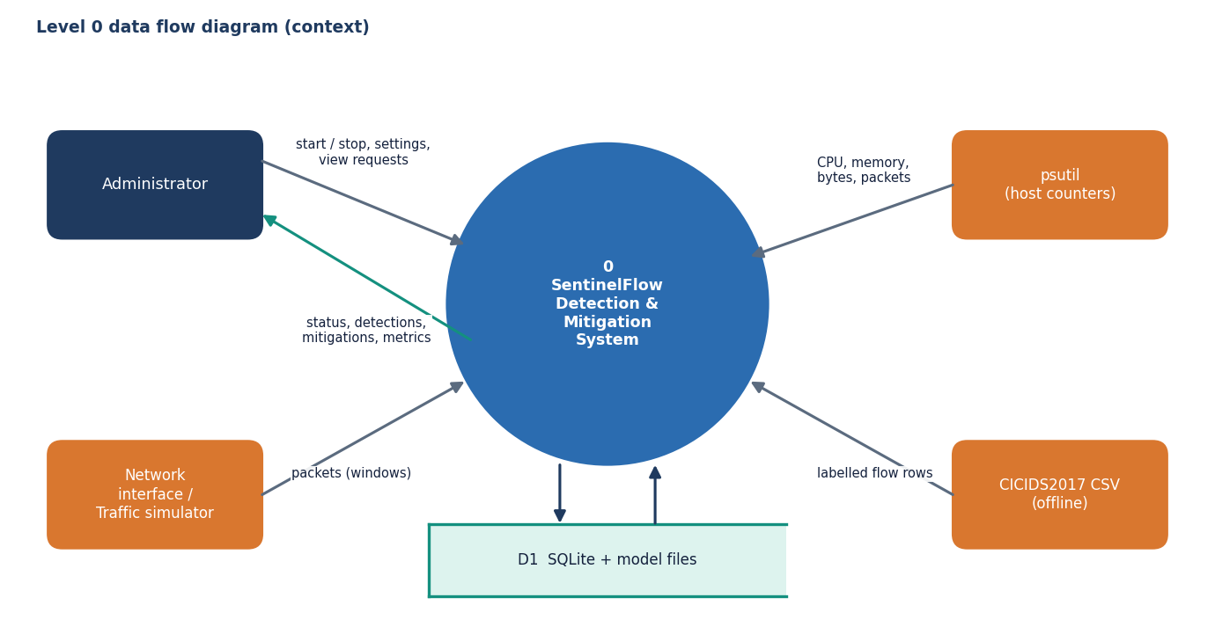
Figure 4: Level 0 data flow diagram: SentinelFlow and its four external entities.
At level 0 the system has four neighbours. The administrator controls sessions and reads results; the network interface or the simulator supplies packets; psutil supplies host counters for the health screen; the CICIDS2017 files supply labelled flow rows to the offline training script. A single store, D1, stands for the SQLite database and the model files.

5.3.2 Level 1: seven processes
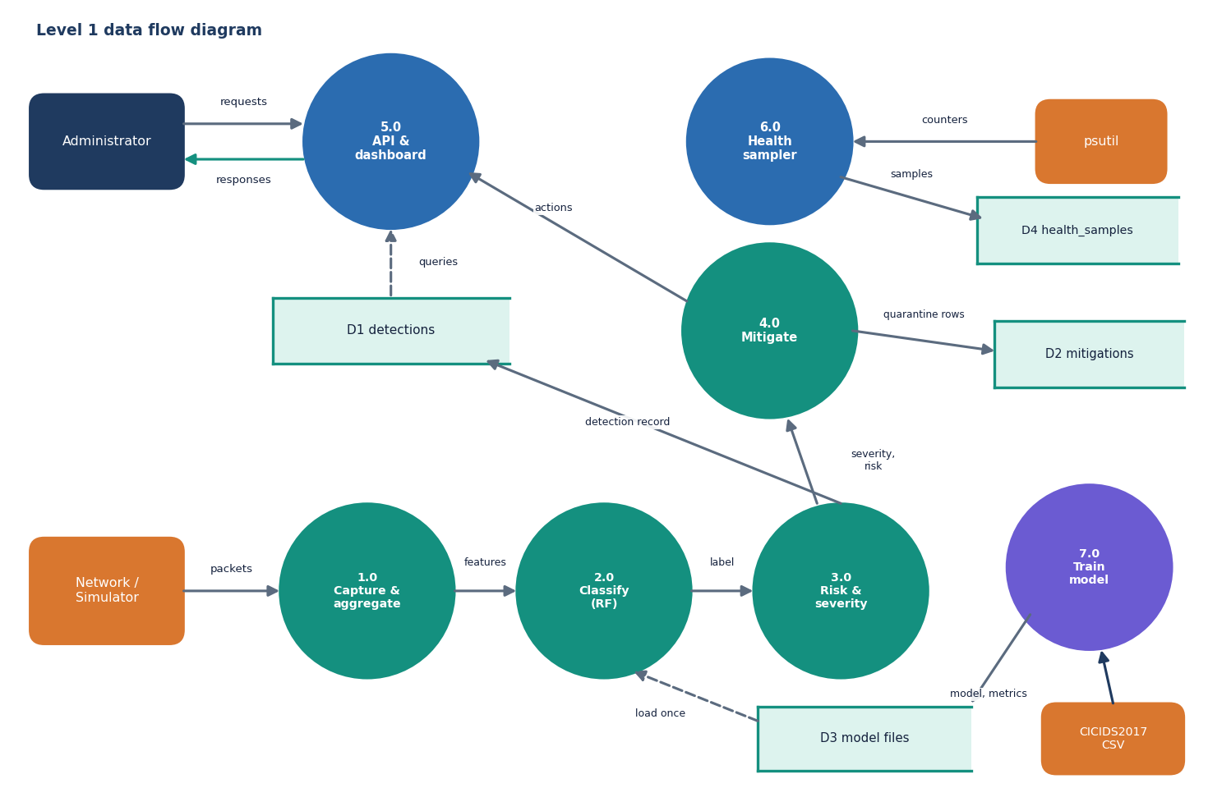
Figure 5: Level 1 data flow diagram: seven processes and four data stores.
Processes 1.0 to 4.0 run once per window. Process 2.0 loads the model files from D3 once and reuses them. Process 5.0, the API and dashboard, only reads: it answers the administrator's polls from D1 and D2. Process 6.0 is independent of traffic: a background thread samples CPU, memory and network counters every five seconds into D4. Process 7.0 is the offline trainer and is the only process that writes D3.

5.3.3 Level 2: risk, severity and mitigation
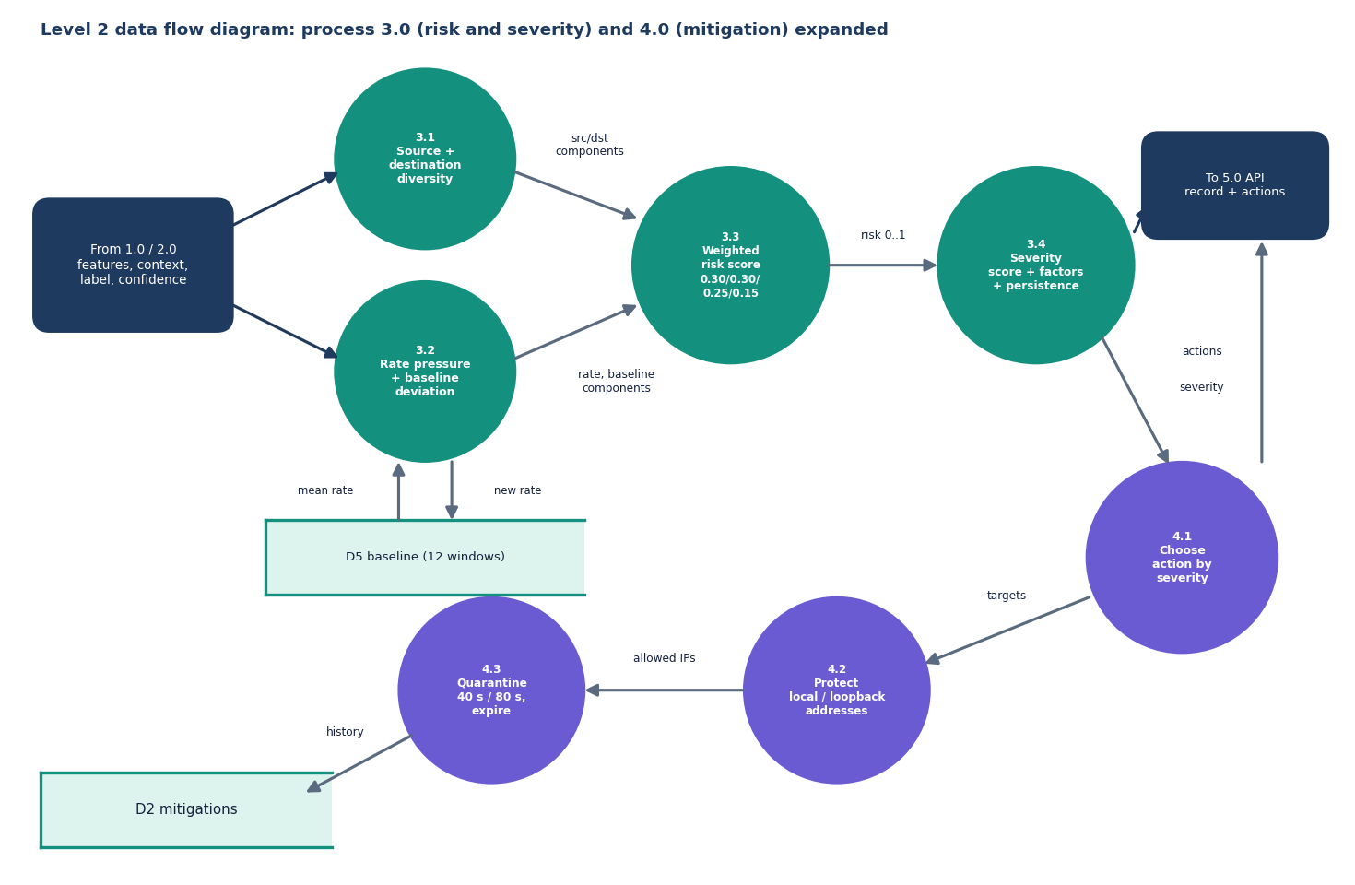
Figure 6: Level 2 data flow diagram: processes 3.0 (risk and severity) and 4.0 (mitigation) expanded.
Process 3.0 combines four measurable components into a distributed-risk score and then adds the forest's label, its confidence, the packet rate, the spread and the persistence of suspicious windows into a severity score, keeping a list of the factors that contributed. Process 4.0 maps the severity to an action. Only High and Critical produce quarantines; the targets are the three busiest sources, minus the protected addresses. The rolling baseline D5 holds the packet rates of the last twelve windows and feeds the deviation component of the next window.

5.4 Class, Sequence and Use-Case Design

5.4.1 Class diagram
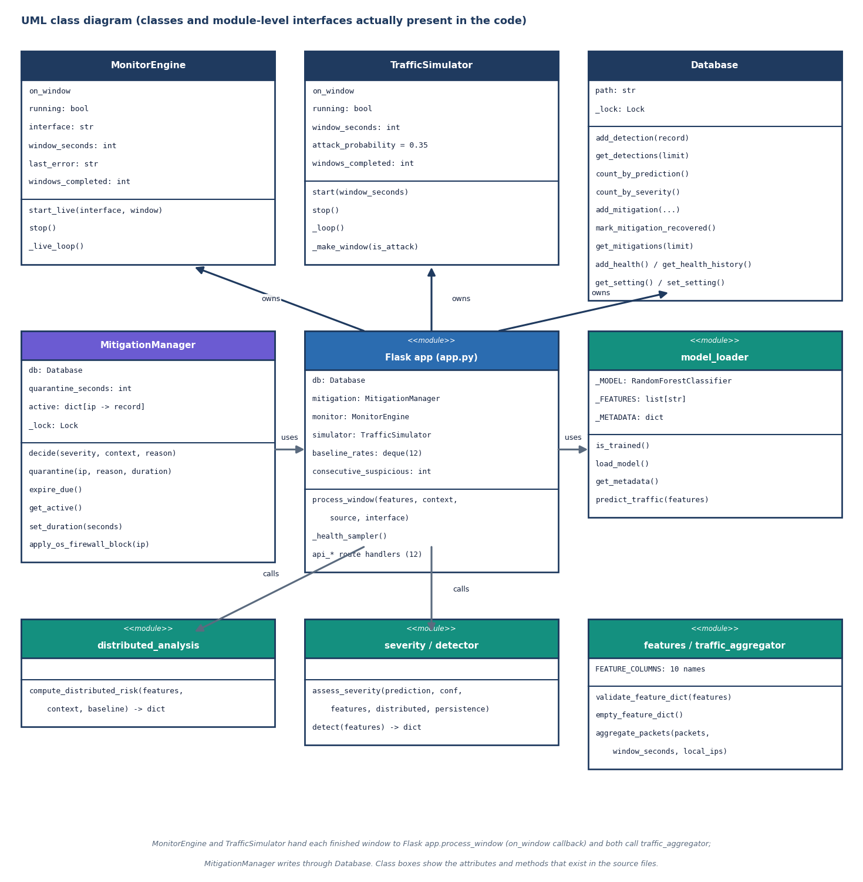
Figure 7: UML class diagram of the classes and module-level interfaces present in the code.
The design deliberately has few classes. MonitorEngine and TrafficSimulator are the two window producers and share one callback signature, on_window(features, context, source, interface). Database serialises every SQLite call behind a lock because Flask runs threaded. MitigationManager keeps the active quarantines in a dictionary keyed by address and writes history through Database. Everything else is a module of functions, which keeps the risk, severity and aggregation rules easy to test: the test-suite calls them directly with hand-made inputs.

5.4.2 Sequence diagram
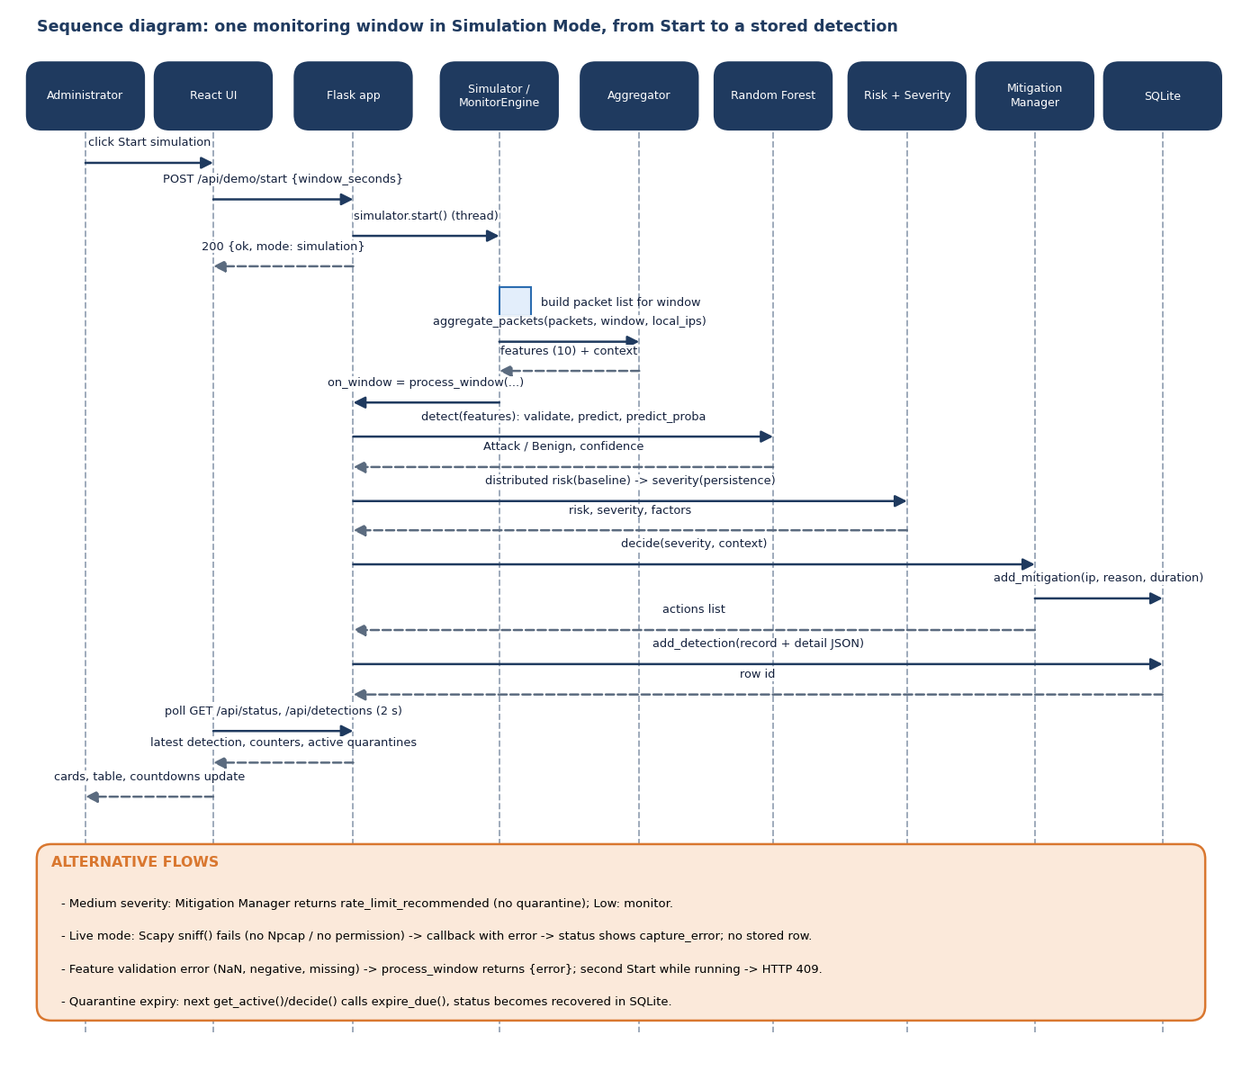
Figure 8: Sequence diagram: one monitoring window in Simulation Mode, from pressing Start to a stored detection.
The sequence shows why the console never waits for a detection: the Start request returns as soon as the simulator thread exists, and the console learns about new windows by polling. The alternative flows listed under the diagram are the ones covered by tests: a failing live capture, a validation error, a second Start (HTTP 409) and quarantine expiry.

5.4.3 Use-case diagram
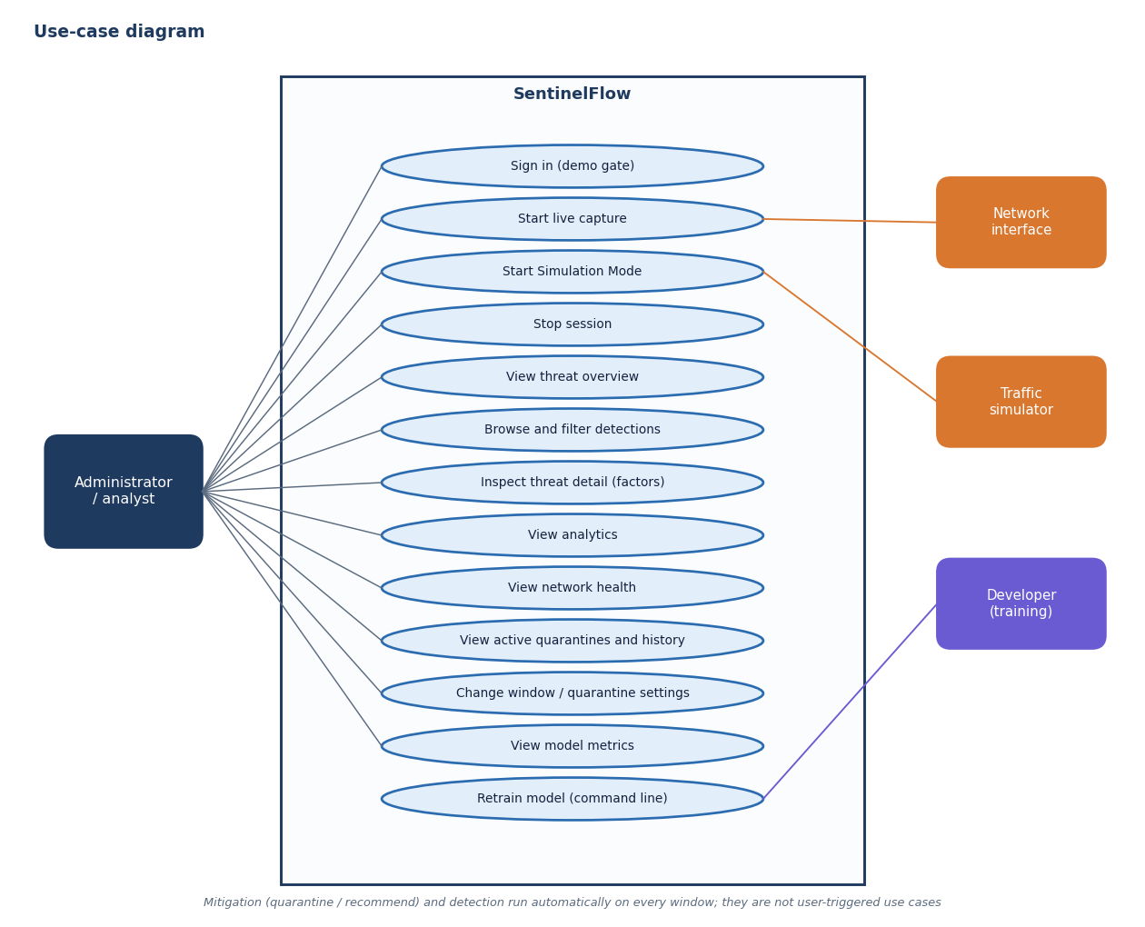
Figure 9: Use-case diagram: what the administrator and the external actors can do.
The administrator is the only human actor. Detection and mitigation are not use cases because nobody triggers them: they run on every window. Retraining the model is a developer use case performed from the command line, not from the console.

5.5 Data Design
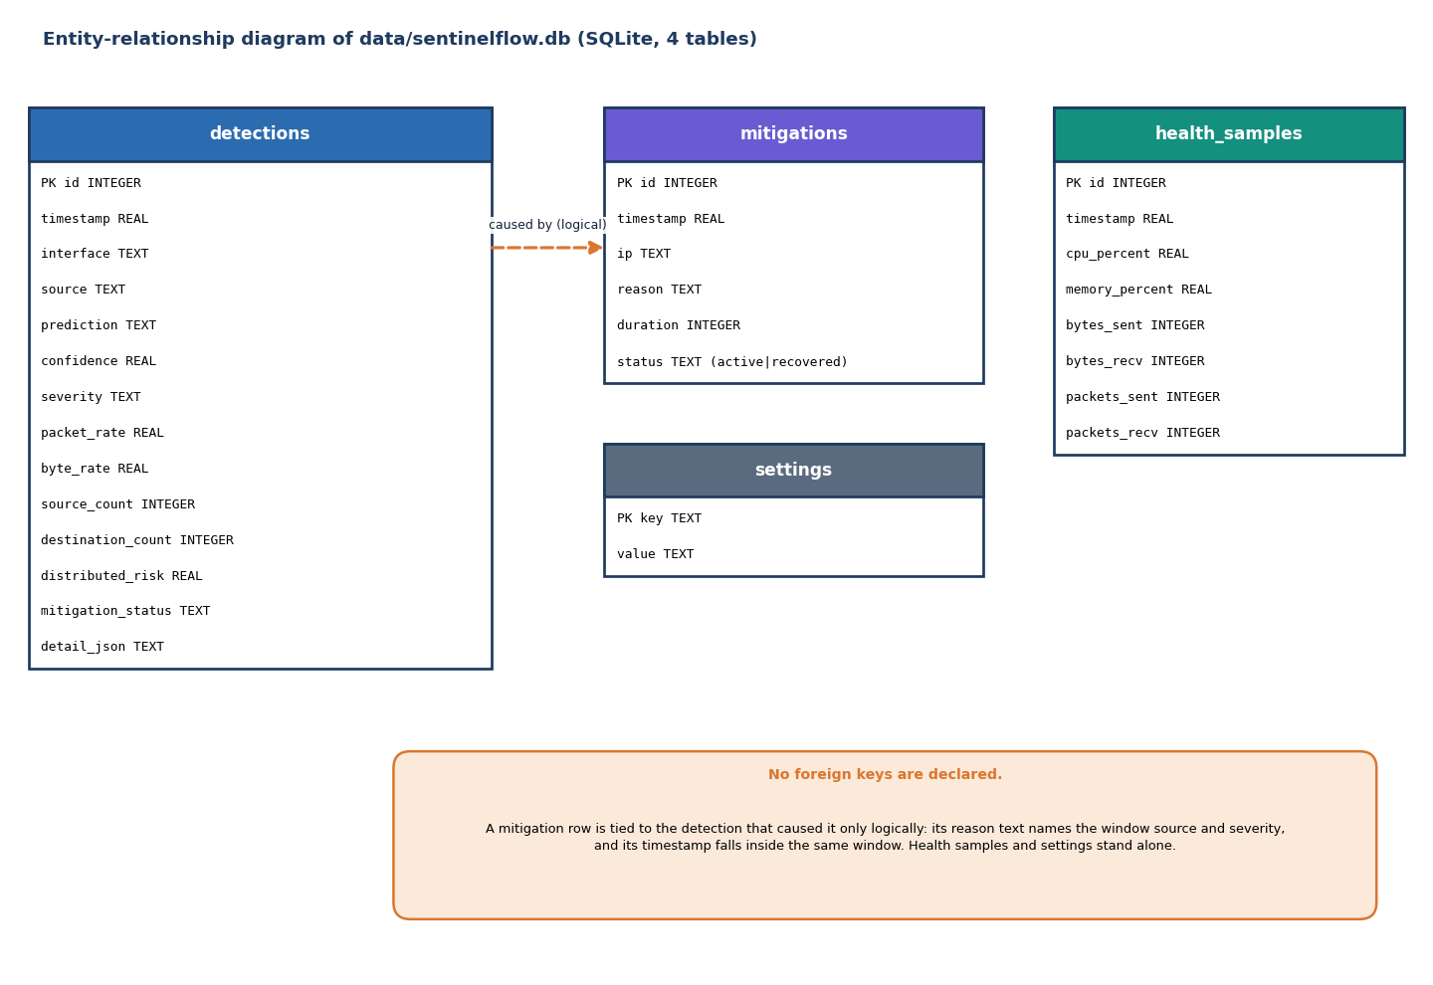
Figure 10: Entity-relationship diagram of the SQLite database: four tables and no declared foreign keys.
The database is one SQLite file, data/sentinelflow.db, created on first start by Database.__init__. Four tables are used; the data dictionary below describes them. There are no foreign keys: a quarantine row names the address, the reason text (which contains the window source and the severity) and the time, not the id of the detection that caused it. The full per-window detail (the ten features, the context, the risk components, the severity factors and the actions) is stored as one JSON text in detections.detail_json, so the Threat Detail screen can explain a past window exactly as it was scored.
Table 17: Data dictionary of the four tables
Table | Columns | Purpose and notes
detections | id (PK), timestamp, interface, source, prediction, confidence, severity, packet_rate, byte_rate, source_count, destination_count, distributed_risk, mitigation_status, detail_json | One row per scored window. prediction is Benign or Attack; severity is Low, Medium, High or Critical; source is live or simulation.
mitigations | id (PK), timestamp, ip, reason, duration, status | One row per quarantine. status is active until expiry, then recovered (updated by address and reason).
health_samples | id (PK), timestamp, cpu_percent, memory_percent, bytes_sent, bytes_recv, packets_sent, packets_recv | psutil sample every five seconds; the Network health screen reads the last 30.
settings | key (PK), value | Key-value table with get and set methods; the API currently keeps the window and quarantine settings in memory, so this table is unused.

Three further stores are files: models/sentinelflow_rf.joblib with feature_list.json and metadata.json (written by training, read once by model_loader), and results/ with metrics.json, confusion_matrix.json, feature_importance.json, classification_report.txt and three PNG plots (read by /api/model/metrics and /static/results/<file>). data/processed/test_features.csv keeps the held-out test rows.

5.6 Core Algorithm Design

5.6.1 The per-window algorithm
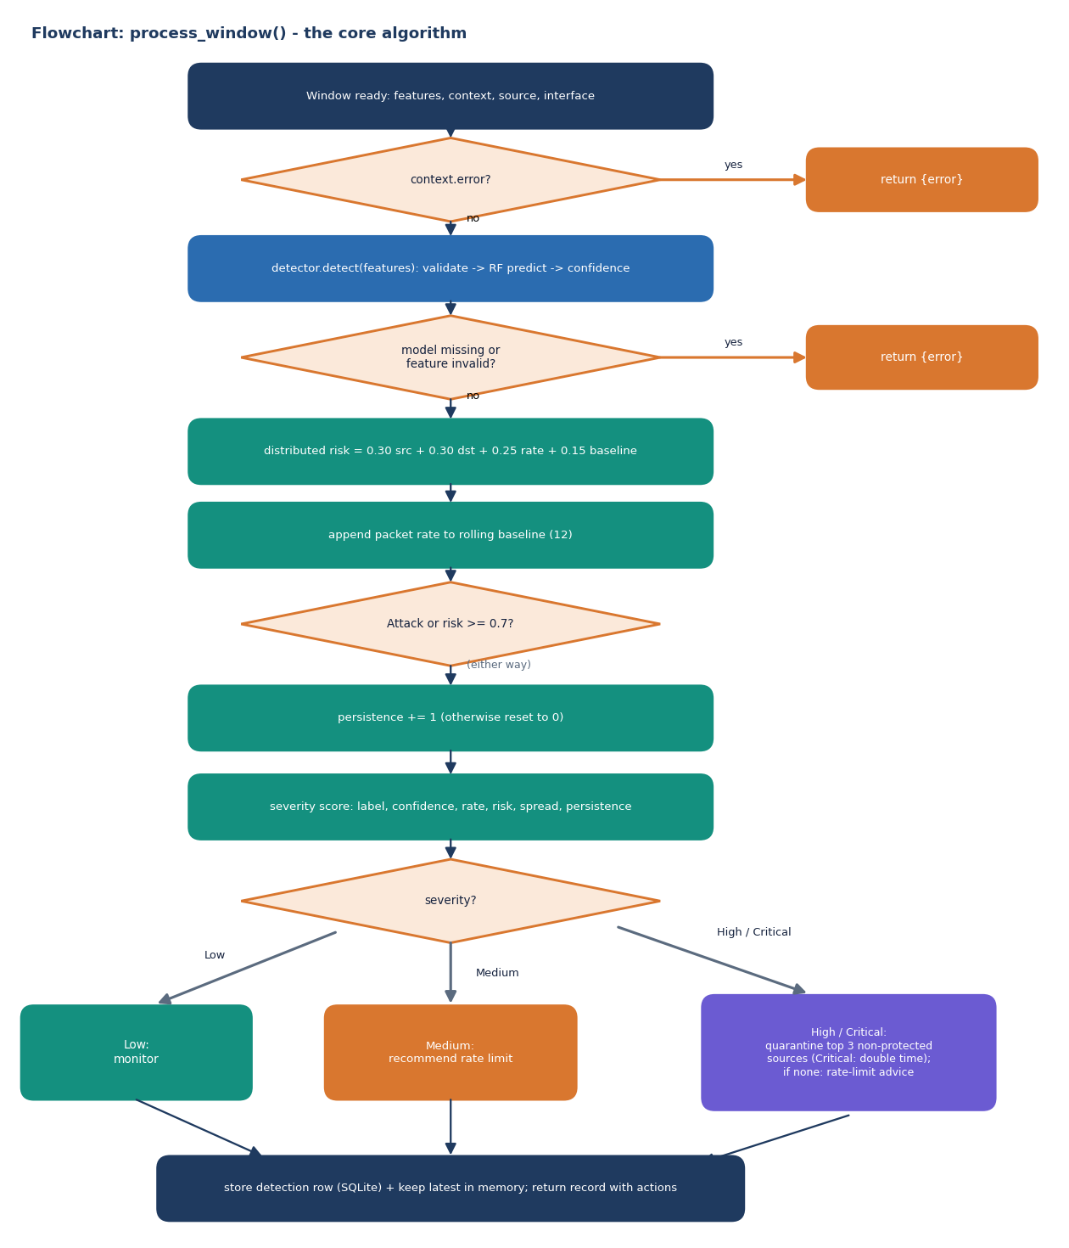
Figure 11: Flowchart of process_window(), the algorithm every window passes through.
process_window() is the heart of the application. It is deliberately a straight line with two early exits. The first exit handles a capture failure reported by the live engine (the context carries an error key); the second handles a missing model or invalid features, which ml.features.validate_feature_dict rejects when a value is missing, non-numeric, NaN, infinite or negative. After that the steps are fixed: distributed risk, baseline update, persistence update, severity, action, storage.

5.6.2 Distributed-risk and severity design
The distributed-risk layer exists because of carpet-bombing: traffic spread over many destinations can look modest at every single destination while the aggregate is large. Its four components are source diversity (distinct sources divided by 30, capped at 1), destination diversity (distinct destinations divided by 15, capped at 1), rate pressure (packets per second divided by 1,500, capped at 1) and baseline deviation (how far the packet rate is above the mean of the last twelve windows, scaled to 0 to 1 over a fourfold rise). The weights are 0.30, 0.30, 0.25 and 0.15. Scores below 0.4 are Low, below 0.7 Medium and otherwise High, and the sentence that goes with the score names the pattern: concentrated, spread across many sources, spread across many destinations (possible carpet bombing) or both.
Severity adds up points from independent evidence, so that no single signal decides. The label contributes most, the others refine it, and a benign label is capped so that a benign window can never rise above Medium.
Table 18: Severity points (security/severity.py)
Evidence | Condition | Points
Forest label | Attack / Benign | +30 / +8 x confidence
Model confidence | >= 0.90 / >= 0.75 | +15 / +8
Packet rate | >= 3,000 / >= 1,200 / >= 400 packets per second | +20 / +12 / +5
Distributed risk | >= 0.70 / >= 0.40 | +20 / +10
Spread | >= 25 sources or >= 12 destinations | +8
Persistence | >= 3 consecutive suspicious windows / exactly 2 | +10 / +5
Cap and levels | Benign capped at 45; Critical >= 70, High >= 50, Medium >= 28, otherwise Low | -

5.6.3 Mitigation policy
The policy is a table, not a model. Low keeps monitoring. Medium records a rate-limit recommendation for the interface. High quarantines the three busiest sources of the window for the configured time (40 seconds by default); Critical does the same for twice as long. Addresses that are unknown, loopback (127.0.0.1, ::1), the simulator's local host 192.168.1.20 or any address of a local interface are protected and never quarantined; when all top sources are protected the action degrades to a rate-limit recommendation. A source that is already quarantined is not quarantined again until the entry expires, and every call first expires due entries and marks them recovered in the history. The design choice that matters is what a quarantine is: an entry in MitigationManager.active and a row in mitigations. It is shown on the Mitigation screen and counted in the status, but no packet is dropped; an optional operating-system integration exists only as a stub, apply_os_firewall_block(), which returns applied: false.

5.7 Module Design
The table below lists every source module with its size and responsibility, so that the chapters that follow can refer to a module by name.
Table 19: Modules of SentinelFlow (line counts measured)
Module | Lines | Responsibility and key functions
app.py | 389 | Flask app; process_window, _health_sampler, 12 JSON routes, / page and /static/results/<file>; JSON 404 and 500 handlers
config/config.py | 33 | Host and port from .env (defaults 127.0.0.1:5000, set to 8415), window 10 s, baseline 12, quarantine 40 s, paths, seed 42, test size 0.2
ml/features.py | 62 | FEATURE_COLUMNS (ten names, fixed order), validate_feature_dict, empty_feature_dict
ml/preprocessing.py | 144 | normalize_columns, clean_dataframe, normalize_label_value, extract_label_series, map_to_common_schema (forward to sent, backward to received)
ml/train_model.py | 389 | Dataset lookup, synthetic fallback, window augmentation, 80/20 split, Random Forest, metrics, plots, artefacts
ml/model_loader.py | 87 | is_trained, load_model, get_metadata, predict_traffic (label, confidence)
ml/evaluate_model.py | 54 | Reloads the stored model and re-scores data/processed/test_features.csv
monitoring/interface_manager.py | 60 | list_interfaces (psutil + Scapy), local_ip_set
monitoring/packet_capture.py | 121 | MonitorEngine: rolling Scapy sniff() windows, error classification (permission, interface, Npcap)
monitoring/simulator.py | 98 | TrafficSimulator: benign, flood, carpet and slow windows, no network I/O
monitoring/traffic_aggregator.py | 83 | aggregate_packets: ten features plus context (sources, destinations, protocol shares, top sources)
security/detector.py | 9 | detect: refuses to run without a trained model
security/distributed_analysis.py | 73 | compute_distributed_risk
security/severity.py | 78 | assess_severity
security/mitigation.py | 115 | MitigationManager: decide, quarantine, expire_due, get_active, set_duration
database/db.py | 204 | Database: four tables, locked SQLite access

The front end adds about 3,100 lines of JSX and JavaScript in frontend/src/: ten page components, a small UI kit (table, charts, controls, command palette, activity log), an api.js axios client, a polling provider (lib/live.jsx), a demo-login provider (lib/auth.jsx) and a theme provider.

5.8 API Design
The API is JSON over HTTP on 127.0.0.1:8415. Errors are JSON objects with an error key and a meaningful status: 400 for invalid input, 404 for unknown routes, 409 when a session is already running, 500 for failures. The table below lists the twelve endpoints and the two additional routes.
Table 20: Routes of app.py
Method | Path | Purpose | Notable behaviour
GET | /api/status | Mode, window, windows completed, latest detection, active mitigations | mode is stopped, live or simulation; capture_error carries the last capture failure
GET | /api/health | Current host sample, last 30 recent, last 30 from SQLite | -
GET | /api/interfaces | Interface names, addresses, up/down | 500 if discovery fails
GET | /api/detections?limit= | Stored detections with counts by prediction and severity | limit clamped to 1-500; non-integer gives 400
GET | /api/detections/latest | Most recent detection | Falls back to SQLite; message when none
GET | /api/mitigations | Active quarantines with seconds left, history (100), quarantine length | Expires due entries first
GET / POST | /api/settings | Window (2-120 s), quarantine (5-3600 s), interface | Out-of-range or non-numeric gives 400; malformed JSON is tolerated
POST | /api/monitor/start | Start live capture on an interface | 409 if a session runs; capture failure is reported through status
POST | /api/monitor/stop | Stop live capture | Idempotent
POST | /api/demo/start | Start Simulation Mode (window 2-120 s, default 5) | 409 if a session runs
POST | /api/demo/stop | Stop simulation | Idempotent
GET | /api/model/metrics | metrics.json, feature importance, confusion matrix | trained: false and a message when no model exists
GET | / | Original server-rendered dashboard | Jinja template
GET | /static/results/<file> | Evaluation PNGs from results/ | send_from_directory; path traversal returns 404

5.9 User Interface Design
The console is a React single-page application in a dark, monospace-accented style with a light theme on a toggle. The landing page explains the pipeline and shows live counters from /api/status; the demo login gate leads to the console, which has a sidebar with seven screens (Overview, Detections, Analytics, Network health, Mitigation, Model, Settings), a top bar with a search box, a mode pill and a theme toggle, and a command palette (opened with /) with g-then-letter shortcuts.
Table 21: Console screens and the data each reads
Screen | Content | Source
Overview | Session control (interface, window, Start live, Start simulation, Stop); six cards: threat status, severity with risk, model confidence, packets per second, sources and destinations, active mitigations; packet-rate sparkline; latest windows | /api/status, /api/detections, /api/interfaces
Detections | Filterable, sortable table of every scored window; click opens the Threat Detail drawer with measured traffic, risk components, severity factors and the recommendation | /api/detections
Analytics | Benign-versus-attack donut, severity distribution, packet-rate and confidence timeline | /api/detections
Network health | CPU, memory, bytes and packets in and out with time series | /api/health
Mitigation | Active quarantines with countdown bars, history, quarantine length | /api/mitigations
Model | Accuracy, precision, recall, F1, ROC-AUC, confusion matrix, feature importance, plots, and a synthetic-data warning | /api/model/metrics
Settings | Window and quarantine length, with server-side validation messages | /api/settings

Three design choices are worth stating. Simulation Mode is always labelled: a pill in the top bar and a banner on the Overview screen say that nothing shown is live traffic. Failures are shown, not hidden: when live capture cannot start, the real reason from Scapy appears in a banner (the Overview capture in Chapter 8 shows the Npcap message). The Model screen warns when the training data were synthetic, which is the case for the shipped model. The output screens are shown and discussed in Chapter 8.

5.10 Design Trade-offs and Known Weaknesses
• One process, shared memory. Simple and fast, but the quarantine table and the baseline are lost on restart (history survives in SQLite) and the design does not scale beyond one host.
• Application-level mitigation. Safe and demonstrable on any machine, but it does not stop a single packet; turning it into enforcement needs a firewall or SDN rule installer and a very careful allow-list.
• Rules around a classifier. The risk and severity weights are hand-set and not learned; they are transparent, and Chapter 8 measures what they achieve, but they were not tuned on real attack captures.
• Window length is a hidden parameter. The forest was calibrated on 10-second windows; at 2 and 5 seconds its label alone raises 46 % and 14 % false alarms on benign windows, and the severity layer is what keeps the quarantine rate low (6.8 % and 0.27 %).
• No authentication on the API. Acceptable for a localhost-only prototype; the demo login is a browser-side gate and protects nothing.
• Saved forest uses all cores. The model was stored with n_jobs=-1, which makes single-window inference about ten times slower than a single thread (Chapter 7).

6. METHODOLOGY AND SOFTWARE IMPLEMENTATION
This chapter explains how SentinelFlow is built and how it was evaluated: the overall method, the data, the preprocessing, the choice of algorithm, the formulas, the training configuration, the application, its security and its installation. Every number in it comes from results/metrics.json or from the experiments in results/experiments/, run on the product's own modules.

6.1 Overall Methodology
The method has an offline half and an online half that share one feature schema. Offline, labelled network flows are cleaned, mapped to ten window-style features, and used to train a Random Forest; the model, its feature list and its evaluation are written to disk. Online, a stream of packets is cut into fixed windows, each window is reduced to the same ten features plus some context, and the stored forest classifies it. A rule layer then measures how distributed the traffic is, a severity engine combines all evidence into one of four levels with a list of reasons, and a policy table turns the level into an action. The ten features are the contract between the halves: ml/features.py defines them once, training and inference import them from there, and every prediction validates names, order and value ranges.
1. Acquire and map flows (offline): read CICIDS2017-style CSV rows or build the synthetic fallback; normalise column names; drop infinite and missing values; map forward packets and bytes to sent and backward ones to received; derive rates and averages.
2. Add window-scale rows (offline): generate 6,000 packet-level windows with the simulator generator and aggregate them through the real monitoring code, so that the forest also sees feature values of window size.
3. Train and evaluate (offline): stratified 80/20 split, Random Forest with 200 trees, balanced class weights and seed 42; write metrics, confusion matrix, ROC curve and feature importance.
4. Capture and aggregate (online): Scapy sniff() for one window (or simulator packets); count packets and bytes by direction; compute rates and averages; collect distinct sources, destinations, protocol shares and the top sources.
5. Classify: validate the ten values, run the forest, return Attack or Benign with the probability of the predicted class.
6. Assess: compute the distributed-risk score against a twelve-window baseline, update the persistence counter, compute the severity score and its factor list.
7. Act and record: quarantine, recommend or monitor; store the detection with its full detail; let quarantines expire and mark them recovered.

6.2 Dataset

6.2.1 The shipped training data
The product's training script looks for CICIDS2017 CSV files in data/raw/ and, if it finds none and the download attempts fail, builds a labelled synthetic fallback and records that fact in the metadata. That is what happened when the product was built, so the shipped model (trained on 24,000 rows) is synthetic-trained: 9,000 benign and 9,000 attack synthetic flows with the raw CICIDS2017 columns Flow Duration, Total Fwd Packets, Total Backward Packets and the two Total Length columns, plus 3,000 benign and 3,000 attack aggregated windows. Synthetic benign flows have a log-normal duration (median 0.4 s) and 1 to 39 packets per direction; synthetic attack flows are flood-like (200 to 2,499 forward packets, almost no reply), carpet-like (80 to 599) or slow (30 to 199 forward packets with longer duration). The metrics the application displays (99.71 % accuracy on 4,800 held-out rows) describe this synthetic mixture and are labelled so on the Model screen.

6.2.2 The real data used for the real-data check
To measure what the synthetic training cost, the real Friday-Afternoon-DDoS file of CICIDS2017 [8] was obtained from a public Hugging Face mirror (c01dsnap/CIC-IDS2017, the MachineLearningCSV release; the dataset card carries the licence field other and asks users to cite the dataset paper). It holds 225,745 labelled flows: 97,718 benign and 128,027 DDoS. It was mapped to the ten features with the product's own map_to_common_schema, so the experiment tests exactly the code path that a real training run would use. The file is 77 MB and is not stored in the repository. Two cautions apply: the file contains one attack family (the DDoS day), and CICIDS2017 is known to contain labelling and flow-construction problems [9], so even a high score on it is a statement about this file, not about networks in general.

6.3 Preprocessing
Preprocessing is in ml/preprocessing.py. Column names are lower-cased, trimmed and snake-cased so that Flow Duration and Flow Duration match; infinite values become missing and rows that are entirely empty are dropped. Labels are normalised: BENIGN, normal and 0 mean benign, everything else attack. The mapping to the schema is: sent packets and bytes from the forward columns, received from the backward columns, rates as counts divided by the flow duration in seconds (duration floored at one microsecond and capped at 3,600 s), and averages as bytes divided by packets, zero when there are no packets. Remaining missing values become zero. The training script subsamples to 120,000 rows if a very large dataset is supplied. No scaling is applied: tree ensembles do not need it, and leaving the units alone keeps the features equal to what the live aggregator produces.
At run time the aggregator (monitoring/traffic_aggregator.py) does the same mapping from packets. A packet whose source is a local interface address and whose destination is not local counts as sent; every other packet counts as received (destined to this host, loopback, or merely observed in transit). Each window also yields context that the model does not see: distinct sources and destinations, packets per source and destination, protocol shares and the five busiest sources and destinations.
Table 22: The ten features, their definition and the importance each forest gives them
Feature | Definition | Shipped forest | Forest on real flows
received_packets | packets in the received direction | 0.176 | 0.059
received_bytes | bytes in the received direction | 0.097 | 0.081
received_packets_per_second | received packets / window seconds | 0.016 | 0.044
received_bytes_per_second | received bytes / window seconds | 0.010 | 0.018
average_received_packet_size | received bytes / received packets (0 if none) | 0.054 | 0.144
sent_packets | packets in the sent direction | 0.209 | 0.188
sent_bytes | bytes in the sent direction | 0.110 | 0.183
sent_packets_per_second | sent packets / window seconds | 0.142 | 0.017
sent_bytes_per_second | sent bytes / window seconds | 0.078 | 0.041
average_sent_packet_size | sent bytes / sent packets (0 if none) | 0.107 | 0.226

Two observations follow from the table. The shipped forest spreads its weight over packet counts, rates and sizes in both directions, which fits a synthetic world in which attacks are defined by volume. The forest trained on real flows leans on the average packet sizes and on the sent-direction counts: in the DDoS day, the attack flows differ from benign flows mostly in how many packets and bytes the initiator sends and how large they are, and received-direction rates add little. Both forests ignore any field that is not among the ten (flags, inter-arrival times, ports, flow duration beyond the rates), which is a deliberate simplification: the same ten numbers can be computed from a ten-second window of raw packets, and many CICIDS2017 fields cannot.

6.4 Algorithm Choice and Justification
The base paper evaluates seven classifiers and four voting ensembles with a Banzhaf-index feature selection and reports 100 % on both of its datasets, with clear resource differences: its SVM-containing ensembles needed over 4,000 s to train on the SDN data and its kNN ensemble over 150 s to classify the SDN test set [1]. SentinelFlow keeps one classifier, the Random Forest [12], for four reasons. (1) The base paper itself finds tree-based learners strongest and the lightest ensemble the best fit for real-time use. (2) A forest handles features of very different scales and heavy-tailed distributions (packet counts from 1 to thousands) without scaling. (3) It gives a probability and a feature-importance ranking, both of which the console shows. (4) It is quick to train and small enough to ship (2.74 MB). Feature selection was not implemented: with only ten features there is little to select, and the ablation below shows that the five sent features alone carry almost all the signal.
The choice was checked, not assumed. Five classifiers were trained on the same real split (seed 42, 20 % test) after the product was built; the comparison is Table below and Figure below.
Table 23: Classifiers on the real CICIDS2017 DDoS-day flows (same split)
Classifier | Accuracy | F1 | False-positive rate | Training time (s)
DecisionTree | 99.94 % | 99.95 % | 0.06 % | 0.59
RandomForest(200) | 99.94 % | 99.95 % | 0.05 % | 6.77
HistGradientBoosting | 99.95 % | 99.95 % | 0.04 % | 0.81
GaussianNB | 72.91 % | 80.71 % | 62.56 % | 0.04
LogisticRegression(scaled) | 98.59 % | 98.77 % | 3.10 % | 0.42

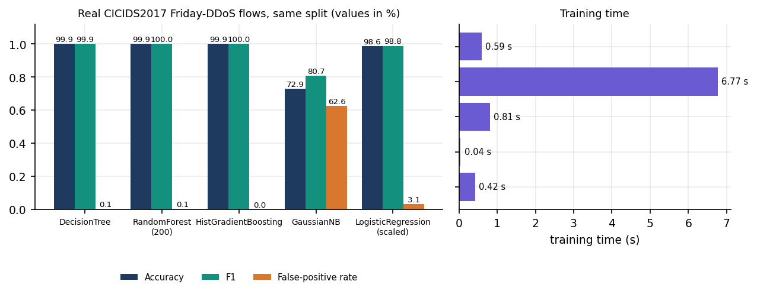
Figure 12: Classifier comparison on real flows: accuracy, F1 and false-positive rate (left) and training time (right).
Three tree-based learners are indistinguishable at about 99.9 % on this file; Gaussian Naive Bayes fails (its independence assumption does not suit correlated counts) and scaled logistic regression is clearly worse. The smaller 2025 study of Rahman reports the same ordering on a CIC sample, with SVM at 0.971, a decision tree at 0.827 and logistic regression at 0.593 [7]; the absolute values differ because the data and features differ. A single decision tree or histogram gradient boosting would have done as well on this file and trained faster; the forest was kept because it was already integrated, because averaging 200 trees makes the confidence value smoother, and because nothing measured here argues against it. That is a judgement, and it is stated as one.

6.5 Mathematical Formulation

6.5.1 Random Forest
The forest is an average of T = 200 decision trees, each grown on a bootstrap sample with random feature subsets at each split. Each tree splits to reduce Gini impurity; the forest's probability of the attack class is the mean of the trees' leaf probabilities and the label is the more probable class:
G(S) = 1 − Σ_c p_c², ΔG = G(S) − (|S_L|/|S|)·G(S_L) − (|S_R|/|S|)·G(S_R) (1)
P(attack | x) = (1/T) Σ_t P_t(attack | x), ŷ = Attack if P(attack | x) ≥ 0.5 (2)
class_weight=balanced weights class c by n / (2·n_c), so that the rarer class is not under-fitted; the confidence shown for a window is the probability of the predicted class. Feature importance is the mean decrease in impurity attributed to each feature, normalised to sum to one.

6.5.2 Window aggregation
For a window of W seconds with packet set Π, local address set L, and packet length ℓ(p):
sent = {p ∈ Π : src(p) ∈ L, dst(p) ∉ L}, received = Π \ sent (3)
packets_x = |x|, bytes_x = Σ_{p∈x} ℓ(p), packets_per_second_x = packets_x / W, bytes_per_second_x = bytes_x / W, average_size_x = bytes_x / packets_x (4)
The same ten quantities (counts, bytes, rates, average sizes for each direction) are obtained from a CICIDS2017 flow by taking forward counts as sent, backward counts as received and the flow duration in place of W.

6.5.3 Distributed-risk score
With n_src and n_dst the numbers of distinct sources and destinations, r the total packet rate (received plus sent packets per second) and r̄ the mean rate of the previous windows in the baseline (up to twelve):
R = 0.30·min(n_src/30, 1) + 0.30·min(n_dst/15, 1) + 0.25·min(r/1500, 1) + 0.15·b (5)
b = min( max(r/r̄ − 1, 0) / 4, 1 ) if r̄ > 1; otherwise b = 0 for r < 300 and b = 0.4 for r ≥ 300 (6)
R < 0.4 is Low, 0.4 ≤ R < 0.7 Medium and R ≥ 0.7 High. The weights are chosen by hand; they are a transparent rule, not a fitted model.

6.5.4 Persistence and severity
c_t = c_(t−1) + 1 if (ŷ_t = Attack or R_t ≥ 0.7), otherwise c_t = 0 (7)
S = 30·[Attack] + 8·conf·[Benign] + pts(conf) + pts(r) + pts(R) + 8·[n_src ≥ 25 or n_dst ≥ 12] + pts(c); S ← min(S, 45) if Benign (8)
where pts(conf) is 15 for conf ≥ 0.90 and 8 for conf ≥ 0.75, pts(r) is 20, 12 or 5 for r ≥ 3,000, 1,200 or 400, pts(R) is 20 for R ≥ 0.7 and 10 for R ≥ 0.4, and pts(c) is 10 for c ≥ 3 and 5 for c = 2. The level is Critical for S ≥ 70, High for S ≥ 50, Medium for S ≥ 28 and Low otherwise.

6.5.5 Evaluation metrics
With TP, FP, TN and FN counted on the attack class:
Accuracy = (TP + TN)/(TP + TN + FP + FN), Precision = TP/(TP + FP), Recall = TP/(TP + FN), F1 = 2·Precision·Recall/(Precision + Recall), FPR = FP/(FP + TN) (9)
The false-positive rate gets special attention because a false positive is not a harmless count here: it can quarantine a legitimate source, which is the denial of service the system is meant to prevent. ROC-AUC is reported for the ranking quality of the probability, independently of the 0.5 threshold.

6.6 Model Architecture and Training
Table 24: Training configuration (ml/train_model.py, config/config.py)
Item | Value
Classifier | scikit-learn RandomForestClassifier
Trees | 200 (n_estimators=200)
Depth and splits | max_depth=None, min_samples_split=2
Class weights | balanced
Parallelism when trained | n_jobs=-1 (stored in the saved model)
Random seed | 42
Split | stratified 80 % train / 20 % test (test_size=0.2)
Input | ten features, fixed order, unscaled
Rows of the shipped model | 19,200 train, 4,800 test (12,000 benign, 12,000 attack)
Training time | 22.2 s on the development machine
Model file | 2.74 MB (joblib), loads in about 0.113 s
Artefacts | model, feature_list.json, metadata.json, metrics.json, confusion_matrix.json/png, roc_curve.png, feature_importance.json/png, classification_report.txt, test_features.csv

There is no hyper-parameter search: the values are scikit-learn defaults except the number of trees and the class weights. Training also reports the held-out metrics and stores them next to the model, and ml/evaluate_model.py can reload the stored model and re-score the stored test rows, which is how the displayed figures can be reproduced.

6.6.1 Evaluation protocol used for this report
Because the shipped metrics describe synthetic data, the evaluation in Chapter 8 adds four checks, all produced by scripts/run_experiments.py from the product's own modules: (1) the shipped model scored on every real DDoS-day flow; (2) the same forest recipe retrained on real flows, five seeds of a stratified 80/20 split plus a chronological block split (first 70 % of the file to train, last 30 % to test); (3) the shipped model run through the window pipeline at 2, 5 and 10-second windows with 4,000 simulator windows each, comparing the forest's label alone with the High-or-Critical decision; (4) latency of each pipeline stage over 600 windows and of the REST API over real HTTP.
Table 25: Experiments run for this report (scripts/run_experiments.py, scripts/measure_api.py)
Experiment | Data | Protocol | Output file
Shipped model on real flows | 225,745 CICIDS2017 DDoS-day flows | Score every flow with the stored model; also a 20 % stratified sample | real_cicids2017.json
Retrained forest on real flows | same flows | Same hyper-parameters; stratified 80/20; seeds 42, 1, 2, 3, 4; chronological 70/30 block split | real_cicids2017.json
Classifier comparison and ablation | same flows, seed 42 | Five classifiers; six feature groups with the same forest | real_cicids2017.json
Product recipe on real flows | real flows + 6,000 window rows, capped at 120,000 | Stratified 80/20; test on mixed rows, all real flows and fresh simulator windows at 2, 5, 10 s | hybrid_recipe.json
Window pipeline | 4,000 simulator windows per window length (35 % attack, seed 2026) | Forest label alone, High/Critical severity, distributed risk alone; stateful baseline and persistence | window_pipeline.json
Stage latency | 600 simulator windows | Aggregate, predict, risk and severity, mitigation decision, SQLite write; single-window inference with n_jobs -1 and 1 | latency.json
REST API | scratch copy of the backend on port 8915 | 100 calls per GET endpoint on 127.0.0.1; 25 malformed-input probes; Start, run and Stop of the simulator | api_measurements.json

All experiments use the product's own modules (ml.preprocessing, monitoring.traffic_aggregator, security.*) rather than re-implementations, so a defect in those modules would show up in the numbers. Seeds are fixed, the scripts write JSON, and docs/REPORT_FACTS.md is generated from the JSON, which keeps every document consistent with the measurements. The measurements were taken on an Intel Core i5-12500 machine with 15.7 GB of memory and no GPU; other jobs kept the CPU saturated during the latency runs, so timing figures are upper bounds.

6.7 Application Architecture
The application is Flask 3 serving on 127.0.0.1:8415 with threaded=True, debug=False and no reloader. app.py creates one Database, one MitigationManager, one MonitorEngine and one TrafficSimulator at import time and wires both producers to process_window. A daemon thread, _health_sampler, appends a psutil sample to a 120-entry in-memory deque and to SQLite every five seconds; failures are printed and the next sample is attempted. Shared mutable state (the latest detection, the persistence counter, the health buffer) is guarded by state_lock; the rolling baseline is a deque(maxlen=12) of packet rates. The React console is a separate Vite project in frontend/ (React 19, React Router 7, axios, Recharts, Tailwind 4, three.js for the landing background) served on port 5415, whose dev server proxies /api and /static/results to the API so that the browser makes only same-origin calls.
process_window(features, context, source, interface) is the single entry point for both producers. It returns an error record when the context carries a capture error, when the model is missing or when feature validation fails; otherwise it computes the distributed risk, updates the baseline and persistence, assesses severity, asks the mitigation manager for actions and stores a detection record. If the database write fails the record is still kept in memory with id = None, so the console keeps working. Appendix A quotes the function.

6.7.1 Window producers
MonitorEngine._live_loop repeats sniff(iface, prn=callback, timeout=window, store=False); the callback extracts source, destination, protocol and length from IPv4 or IPv6 packets and skips malformed ones. A PermissionError produces a message about Administrator rights and Npcap; messages mentioning an unknown device or interface produce an invalid-interface message; Npcap or WinPcap problems produce the driver message; anything else is reported with the interface name. After an error the engine posts one error window (so the status can show it), stops itself and leaves it to the user to retry or switch to Simulation Mode. TrafficSimulator chooses benign or attack windows with attack probability 0.35 and builds packet lists in memory: benign windows of 60 to 600 packets between 192.168.1.20 and three external hosts; flood windows of 2,500 to 9,000 packets from 8 to 40 sources to one victim; carpet windows of 1,800 to 6,000 packets from 10 to 45 sources to 6 to 20 destinations; slow windows of 300 to 1,200 TCP packets from many sources to one victim. No packet is sent anywhere.
Table 26: Traffic styles produced by the simulator (monitoring/simulator.py)
Style | Packets per window | Sources | Destinations | Protocols and sizes
Benign | 60-600 | 2 external hosts and 1 local host | 3 external hosts and the local host | TCP 62 %, UDP 28 %, ICMP 4 %, other 6 %; mixed sizes up to 1,200 bytes; both directions
Flood | 2,500-9,000 | 8-40 sources | 1 victim | TCP 55 %, UDP 35 %, ICMP 10 %; 60-320 bytes; one direction
Carpet bombing | 1,800-6,000 | 10-45 sources | 6-20 victims | TCP 50 %, UDP 50 %; 60-520 bytes
Slow | 300-1,200 | up to ~4,000 possible addresses, many distinct | 1 victim | TCP only; 200-1,400 bytes

The styles are the pattern classes the product aims at: a volumetric flood from many sources to one victim, carpet bombing from many sources across many victims, and a slow attack with modest volume. They are generated by the same code that produced the 6,000 window rows used in training, which means that high accuracy on simulator windows at the training window length is expected and proves nothing about real attacks; Chapter 8 says so wherever those numbers appear.

6.7.2 Pseudocode of the two loops
TRAINING (ml/train_model.py)
rows <- CICIDS2017 CSVs in data/raw, else synthetic fallback (9,000 + 9,000 flows)
X, y <- map_to_common_schema(clean(rows)), label BENIGN -> 0, anything else -> 1
X, y <- X + 3,000 benign windows + 3,000 attack windows (simulator generator, 10 s)
split <- stratified 80 / 20, seed 42
forest <- RandomForest(200 trees, balanced).fit(train); write metrics, plots, model

MONITORING (one iteration per window)
packets <- sniff(window) or simulator.make_window()
features, context <- aggregate_packets(packets, window, local_ips)
label, conf <- forest(features) # validate first
risk <- distributed_risk(features, context, baseline)
persistence <- persistence + 1 if label == Attack or risk >= 0.7 else 0
level, factors <- severity(label, conf, features, risk, persistence)
actions <- policy(level, context.top_sources) # quarantine / recommend / monitor
store(detection, actions); expire due quarantines

6.8 API Design
Twelve JSON endpoints, the legacy page and the results route are described in Chapter 5. The conventions are uniform: GET endpoints are read-only and cheap (median 3 to 13 ms over real HTTP except /api/interfaces at 36 ms, which asks the operating system for adapters); POST endpoints take a JSON body and tolerate a malformed or missing body by treating it as empty; every input is validated before use and rejected with HTTP 400 and an error message, and conflicts return 409. A global handler turns unknown routes into a JSON 404 and unhandled exceptions into a JSON 500.

6.9 Front-End Implementation
The front end has ten page components and a small kit of shared components. lib/live.jsx polls /api/status every two seconds and fetches detections and mitigations on a slower cadence, then shares the result through a React context, so every screen sees the same data; lib/auth.jsx implements the demo gate (credentials checked in the browser and a flag kept in localStorage); lib/theme.jsx keeps the light or dark choice; components/ui/CommandPalette.jsx and nav.jsx implement the keyboard shortcuts. Charts use Recharts; the landing page draws a three.js grid and a typewriter terminal, and respects the reduced-motion setting. The Threat Detail drawer renders the stored detail_json of a detection.

6.10 Security and Error Handling
Table 27: Security and error-handling measures, with what each was checked by
Concern | Measure in the code | Checked by
Network exposure | Flask binds to 127.0.0.1 only (config HOST); Docker image pins 0.0.0.0 inside the container only | Configuration review
Input validation | window 2-120, quarantine 5-3600, limit clamped 1-500; integers parsed with try/except; features validated for presence, numeric type, NaN, inf and negatives | Unit and API tests; 25 of 25 HTTP probes behaved as intended
Injection | All SQL uses parameter placeholders; a limit=1;DROP TABLE detections probe returns 400 | HTTP probe
Path traversal | Results files are served by send_from_directory; .. paths return 404 | HTTP probe
Safe mitigation | Quarantine is application-level; protected addresses (unknown, loopback, simulator host, local interface addresses) are never targeted; entries expire; OS firewall stub returns applied: false | Unit tests
Failure of capture | Real reason shown (permission, interface, Npcap); engine stops instead of looping | HTTP probe: HTTP 200 on start, then capture_error in status
Failure of storage or model | Corrupt or missing model gives a clear message; a failed detection write is caught; health-sampler errors are printed and skipped | Unit tests (model missing)
Concurrency | One lock in Database, one in MitigationManager, state_lock in the app; a second Start returns 409 | API tests

Three gaps are stated plainly. The REST API has no authentication; protection rests on the localhost binding and the demo login is a browser-side gate that protects nothing. The interface field of the settings call is not length-checked (a 5,000-character value was accepted and stored in memory). And the settings table is never used: settings are kept in memory and return to their defaults on restart.
Table 28: Error paths of live capture and what the user sees
Condition | Message shown (status.capture_error / banner) | State afterwards
Scapy cannot be imported | Scapy is unavailable: <reason> | Engine stopped
Permission denied | Packet capture permission denied ... Run as Administrator/root, install Npcap on Windows, or use Simulation Mode | Engine stopped after one error window
Unknown interface | Invalid network interface '<name>': <reason> | Engine stopped
Npcap or WinPcap missing (this machine) | Packet capture driver unavailable ... Install Npcap (https://npcap.com) or use Simulation Mode | Start returns HTTP 200, mode returns to stopped within seconds
Any other capture error | Capture failed on '<interface>': <reason> | Engine stopped
Aggregation or callback failure | Aggregation failed: <reason> / Detection callback failed: <reason> | Loop continues with the next window

6.11 Installation and Execution
Requirements are Windows 10 or 11 (or a modern Linux), Python 3.11 or 3.12, Node.js 20 or newer for the console and, for live capture only, Npcap and an Administrator terminal. run.bat creates .env with the default ports, creates .venv, installs requirements.txt, trains the model if it is missing, runs npm install on the first start, starts the API and the console and opens the browser. The demonstration login is demo@sentinelflow.com / Demo@1234; Simulation Mode needs no privileges. Appendix B gives the steps.

7. SYSTEM TESTING

7.1 Testing strategy
SentinelFlow was delivered with one end-to-end script, scripts/smoke_test.py, and a screenshot script. The documentation run added an automated pytest suite in tests/, a probe script for malformed input and API timing (scripts/measure_api.py), and the experiment script that measures model quality (scripts/run_experiments.py). The pipeline modules are mostly plain functions (feature validation, CICIDS2017 mapping, packet aggregation, distributed risk, severity), so they are tested at unit level on small constructed inputs with exact or tolerance assertions. The Flask application is tested through its test client, and the live behaviour through the smoke script and the probe script against a running server. Whether the model separates real attacks from real traffic is a different question from whether the software is correct; no unit test can settle it, so it is measured separately in Chapter 8.
Table 29: Test levels, tools and results.
Level | Tool and scope | Count | Result
Unit | pytest: tests/test_features_preprocessing.py, test_pipeline_modules.py, test_model_db.py (schema, preprocessing, aggregator, risk, severity, mitigation, simulator, model loader, database) | 63 cases | All passed
API / integration | pytest with the Flask test client: tests/test_api.py (every endpoint, validation, the shared process_window() pipeline, simulation end to end) | 32 cases | All passed
Functional (live backend) | scripts/smoke_test.py against a running backend (127.0.0.1:8915, a scratch copy) | 25 checks | 25 of 25 passed
Security / robustness | scripts/measure_api.py malformed-input probes | 25 probes | 25 of 25 behaved as intended
Performance | scripts/run_experiments.py latency (600 windows), scripts/measure_api.py (100 calls per endpoint) | 600 windows; 15 endpoint rows | Section 7.7
Screens | scripts/capture_screens.py (Playwright, Chrome, 1440 x 900) | 12 captures | Chapter 8

All tests ran on one machine: Intel Core i5-12500 (6 cores, 12 threads), 15.7 GB RAM, Windows 11 Pro, Python 3.11.9, scikit-learn 1.9.1, Flask 3.1, no GPU, no Npcap. Other programs kept the CPU near 100 % during the runs, so the full pytest run took 114 s instead of the few seconds it needs on an idle machine, and every timing in Section 7.7 is an upper bound. The tests use a scratch SQLite file; none writes to data/sentinelflow.db.

7.2 Unit testing
The suite has 95 test cases in four files, and all 95 passed (docs/metrics/pytest.txt). tests/conftest.py gives every test a scratch database and resets the module-level state of app.py (active quarantines, rolling baseline, persistence counter, quarantine length) so tests do not influence one another; it also supplies one flood-like and one benign feature vector.
Table 30: Unit and component tests, by file.
File (cases) | What is asserted
test_features_preprocessing.py (24) | The schema has ten unique features; validate_feature_dict returns values in schema order and rejects a missing feature, non-numeric values (text, None, a list), NaN, positive and negative infinity and negative numbers; column names are normalised to snake case; label strings (BENIGN, Normal, 0, DDoS, PortScan, 1) map to Benign or Attack; the CICIDS2017 mapping sends forward to sent and backward to received, divides by the duration, gives an average of zero (not NaN) when a direction has no packets and survives a zero duration; infinities become NaN
test_pipeline_modules.py (26) | Aggregator: orientation of sent versus received, external transit counted as received, empty window all zero, malformed packet skipped, top sources ranked, protocol shares. Distributed risk: low for concentrated benign traffic, High for wide spread at a high rate, components add up to the score, carpet-bombing wording for many destinations. Severity: a benign window never exceeds Medium, a confident wide attack is Critical with at least five listed factors, persistence adds exactly ten points. Mitigation: High quarantines the top three sources, Critical doubles the duration, Medium recommends a rate limit and Low only monitors, protected addresses (127.0.0.1, 192.168.1.20, unknown) are never quarantined, a duplicate quarantine is ignored, a quarantine expires and its history row becomes recovered, the countdown is correct, the duration has a floor of 5 s, the firewall stub reports applied: False. Simulator: packet lengths stay within 40-1,500 bytes, attack windows are more than twice as large as benign ones, start/callback/stop and a refused second start
test_model_db.py (13) | The model artefacts exist and load; a prediction has the shape {prediction, label, confidence} with confidence in [0.5, 1]; a volumetric flood window is classified Attack; a bad feature dictionary raises; an untrained state raises FileNotFoundError; the stored metrics.json agrees with confusion_matrix.json (4,800 rows, accuracy, precision and recall recomputed). Database: detection round trip and newest-first order, counts by prediction and severity, limit, mitigation recovery, chronological health history, setting overwrite, exactly four tables
test_api.py (32) | See Section 7.3

Two tests are worth singling out because they guard numbers quoted elsewhere in this report. The metrics-consistency test recomputes accuracy, precision and recall from the stored confusion matrix, so the figures the Model page displays cannot drift from the matrix. The benign-cap test confirms that a window the forest calls Benign can never be scored above Medium, which is what prevents a benign window from triggering a quarantine.

7.3 Integration testing
The 32 cases of tests/test_api.py drive the Flask application through its test client against the shipped model. They cover the idle status shape, a JSON 404 for an unknown route, the interface list, six out-of-range or non-numeric settings values (all 400), the accepted and persisted settings, malformed JSON tolerated, an invalid limit (400) and a clamped one, the empty-state message of /api/detections/latest, the model-metrics endpoint (it reports the synthetic provenance and ten importances), the PNG result images, the dashboard page and the health endpoint.
The central integration tests call process_window() directly, the function that both the live engine and the simulator use. A flood-like window returns Attack, High or Critical severity, the action quarantine, a stored row id and three active quarantines; a benign window returns Low or Medium and no quarantine; a capture error is passed through as {error}; a feature-validation error is reported as Feature validation failed. After processing, the detection is visible through /api/detections with its factor list, through /api/detections/latest, and through /api/mitigations (three active rows, three history rows, a 40 s quarantine length).
The simulation tests start the simulator through /api/demo/start, check that a second start and a live start are refused with 409, wait until the first scored window appears in /api/detections (source simulation), and stop it. Six further cases try the bad window_seconds values 1, 500 and text on both start endpoints (all 400).

7.4 Functional testing
scripts/smoke_test.py was run against a running backend (a scratch copy of the code on port 8915 so the shipped database was untouched). All 25 of 25 checks passed (docs/metrics/smoke_test.txt): status, interfaces, settings (two rejections, one save, persistence), start of the simulation, refusal of a second start and of a live start while simulating, the simulation reporting its mode, at least four newly scored windows, every field the console reads in a detection row, the detail keys (features, distributed, severity, actions), valid severity keys, /api/detections/latest, a 400 for a bad limit, the mitigation and health shapes, the model metrics and the three result images, stop and the return to stopped. The script has three further checks (the React server, its proxy of /api and of /static/results); they were skipped because the Vite server was not running during this measurement, and the console pages themselves were exercised by the screenshot run described in Chapter 8.
In the same session the probe script started the simulator at 2 s windows: the first scored detection appeared 4.6 s after pressing Start, and 13 windows were scored in the observation period (10 Attack, 3 Benign) with 21 quarantine rows recorded.

7.5 Security testing
SentinelFlow is a localhost tool: the servers bind to 127.0.0.1, the React login is a browser-side demo gate and the REST API has no authentication. Security testing therefore concentrated on what a hostile or careless client could do through the API: malformed numbers, injection-looking strings, path traversal on the file route, wrong HTTP methods, state-machine abuse and oversized values. 25 of 25 probes behaved as intended and the backend answered normally afterwards.
Table 31: Malformed-input and abuse probes (scripts/measure_api.py).
Request | Probe | Expected | Got | Result
GET /api/detections?limit=abc | limit not a number | 400 | 400 | pass
GET /api/detections?limit=1;DROP TABLE detections | limit SQL-looking string | 400 | 400 | pass
GET /api/detections?limit=-5 | limit negative clamps to 1 | 200 | 200 | pass
GET /api/detections?limit=99999999999 | limit huge clamps to 500 | 200 | 200 | pass
GET /api/does-not-exist | unknown endpoint -> JSON 404 | 404 | 404 | pass
POST /api/settings | window_seconds below range | 400 | 400 | pass
POST /api/settings | window_seconds above range | 400 | 400 | pass
POST /api/settings | window_seconds as text | 400 | 400 | pass
POST /api/settings | window_seconds float string | 400 | 400 | pass
POST /api/settings | quarantine_seconds below range | 400 | 400 | pass
POST /api/settings | quarantine_seconds above range | 400 | 400 | pass
POST /api/settings | malformed JSON body tolerated | 200 | 200 | pass
POST /api/settings | array JSON body | 200/400/500 | 200 | pass
GET /static/results/../../app.py | path traversal in results route | 400/404 | 404 | pass
GET /static/results/../../app.py | path traversal (plain ..) | 400/404 | 404 | pass
GET /static/results/nope.png | missing results file | 404 | 404 | pass
POST /api/status | wrong method on /api/status | 405 | 405 | pass
DELETE /api/detections | wrong method on /api/detections | 405 | 405 | pass
POST /api/monitor/start | monitor/start bad window | 400 | 400 | pass
POST /api/demo/start | demo/start bad window | 400 | 400 | pass
POST /api/demo/start | demo/start twice -> 409 | 200 | 200 | pass
POST /api/demo/start | second start while running | 409 | 409 | pass
POST /api/monitor/start | monitor/start while simulation runs | 409 | 409 | pass
POST /api/settings | very long interface name accepted but not echoed unsafely | 200 | 200 | pass
POST /api/monitor/start | live capture start without Npcap | 200/500 | 200 | pass

Three observations qualify the clean result. First, the probe named array JSON body shows that a JSON list posted to /api/settings is accepted and ignored (status 200) instead of being rejected; it is harmless but sloppy. Second, the interface setting accepts a 5,000-character string; the value is stored in memory and is only used as an interface name for a capture that would then fail, but there is no length or character check. Third, the API has no authentication, authorisation or rate limiting at all: anyone who can reach port 8415 can start and stop monitoring or change the quarantine length. That is acceptable for a service bound to the loopback address and would not be acceptable beyond it. The SQL-looking limit value is rejected by integer parsing, and all queries use bound parameters, so injection through the API was not possible in the probes tried.
Path traversal on /static/results/<path> returned 404 for both the encoded and the plain .. forms because the route uses Flask's send_from_directory. The mitigation module never executes a command: the operating-system firewall hook is a stub that returns applied: False, so a forged address cannot make SentinelFlow run a shell command. The one input that reaches Scapy is the interface name; it is passed as a function argument, not to a shell.

7.6 Validation and edge cases
Table 32: Edge cases and how SentinelFlow behaved.
Case | How tested | Observed behaviour
Window with no packets | aggregator unit test | All ten features are zero, top_sources empty, no division by zero
Direction with zero packets (average size) | preprocessing and aggregator tests | Average size is 0.0, not NaN
Flow with zero duration | preprocessing test | Duration is clipped to 1e-6 s; rates stay finite
NaN, infinity, negative or non-numeric feature | validation tests (8 cases) | ValueError; process_window returns {error: 'Feature validation failed: ...'}
Missing feature | validation and API tests | Names the missing features
Model file missing | detector test with is_trained patched | FileNotFoundError with the instruction to run python ml/train_model.py; the status endpoint reports model_trained: false
Capture without Npcap | probe run on this machine | Start returns 200; the capture thread reports 'Packet capture driver unavailable ... Install Npcap or use Simulation Mode'; status shows capture_error and returns to stopped; no stored row
Second start while a session runs | API and smoke tests | HTTP 409 for both start endpoints
Window length outside 2-120 s, quarantine outside 5-3600 s | API tests and probes | HTTP 400 with an explanatory message
Attack sources that are the host itself or loopback | mitigation tests | Never quarantined; the action becomes rate_limit_recommended
Same source flagged in consecutive windows | mitigation test | The second quarantine is ignored while the first is active (one history row)
Quarantine reaches its end | mitigation test with patched clock | Removed from the active list; history row marked recovered
Benign window with high model confidence | severity test | Capped at 45 points, so never High or Critical

One edge case could not be tested end to end: live capture of real traffic. Npcap is not installed on the test machine, so the capture engine's success path, its handling of IPv6 packets and its orientation rule on a real interface were reviewed in the source and exercised only through the aggregator tests and the simulator.

7.7 Performance testing
Two kinds of timing were measured. The first is the cost of processing one monitoring window, measured over 600 simulated windows of 10 s with 1969 packets on average (up to 8966), using the product's own aggregator, detector, risk and severity code, mitigation manager and SQLite writes. The second is the latency of the REST endpoints over real HTTP on 127.0.0.1 (the name localhost adds about two seconds per call on this machine because of an IPv6 fallback).
Table 33: Per-window processing time in milliseconds (600 windows; host CPU at 100 % from other jobs).
Step | Mean | Median | 95th pct | Max
Aggregate packets into features | 2.9 | 1.0 | 12.3 | 22
Random Forest prediction (n_jobs=-1 as saved) | 173.8 | 158.9 | 382.3 | 616
Distributed risk + severity | 0.1 | 0.0 | 0.1 | 2
Mitigation decision (includes SQLite writes) | 56.9 | 34.2 | 150.1 | 261
Store the detection row (SQLite) | 8.9 | 5.9 | 17.3 | 119
Whole window, aggregate to stored | 242.5 | 231.5 | 509.5 | 762
Detection to mitigation decision | 230.7 | 217.1 | 488.6 | 742

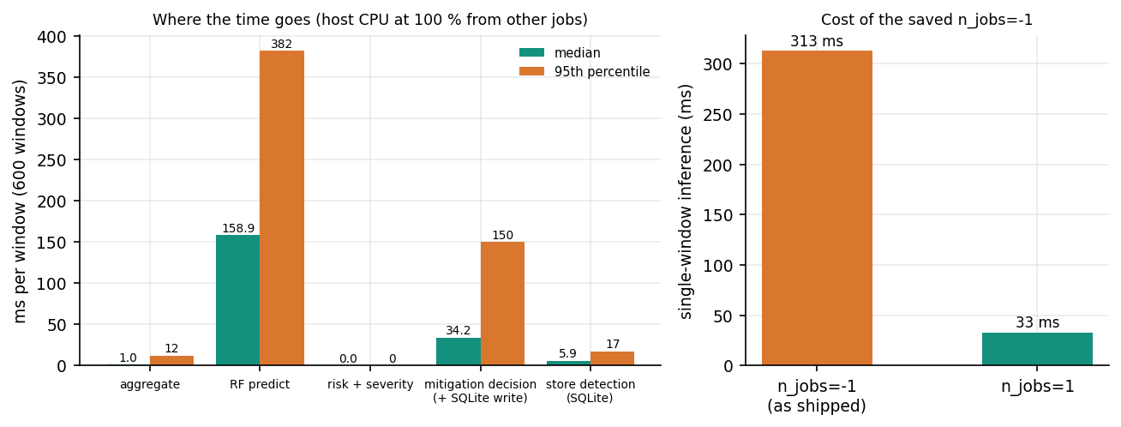
Figure 13: Where the time goes in one window, and the cost of the saved n_jobs=-1.
The forest dominates: its median is 159 ms of a 231 ms window, while aggregation takes about 1 ms and the rule layer well under a millisecond. The cause is a configuration detail, not the model: the saved forest has n_jobs=-1, so even a single-row prediction pays for a thread pool. With n_jobs=1 the median single-window inference drops from 313 ms to 33 ms (309 ms and 32 ms means). The decision from the finished feature vector to the mitigation decision took a median of 217 ms (95th percentile 489 ms, maximum 742 ms) on this loaded machine. Both numbers are far smaller than the monitoring window itself, which is the real delay of the design: a window must close (10 s by default, 2 s at the shortest setting of the demo) before it can be classified. Loading the model takes 0.113 s and the file is 2.74 MB.
Table 34: REST API latency over HTTP on 127.0.0.1 (milliseconds).
Method | Endpoint | Status | Calls | Median | 95th pct | Max
GET | /api/status | 200 | 100 | 3.5 | 19.9 | 27
GET | /api/health | 200 | 100 | 12.9 | 28.0 | 134
GET | /api/interfaces | 200 | 100 | 35.7 | 55.5 | 193
GET | /api/settings | 200 | 100 | 3.7 | 23.6 | 28
GET | /api/mitigations | 200 | 100 | 8.7 | 24.7 | 214
GET | /api/model/metrics | 200 | 100 | 4.3 | 20.8 | 31
GET | /api/detections/latest | 200 | 100 | 6.6 | 24.8 | 28
GET | / | 200 | 30 | 12.4 | 18.8 | 27
GET | /static/results/confusion_matrix.png | 200 | 30 | 13.2 | 20.2 | 45
POST | /api/settings | 200 | 50 | 13.7 | 16.6 | 27
GET | /api/detections?limit=50 | 200 | 60 | 6.9 | 25.2 | 28
GET | /api/detections?limit=500 | 200 | 60 | 5.9 | 25.3 | 30
GET | /api/detections/latest | 200 | 60 | 3.0 | 23.5 | 35
GET | /api/mitigations | 200 | 60 | 3.9 | 18.5 | 24
GET | /api/status | 200 | 60 | 3.3 | 22.3 | 29

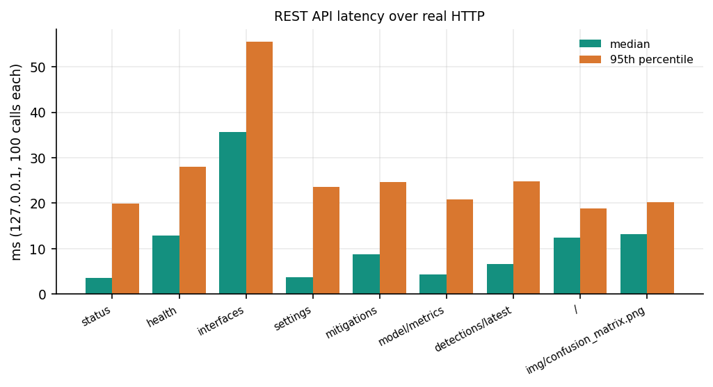
Figure 14: Median and 95th-percentile latency of the GET endpoints.
Every endpoint answers in a median of 36 ms or less, including the 500-row detection list, which is dominated by JSON encoding. The slowest is the interface listing (Scapy and psutil are queried on every call); the maxima of 134-214 ms are single outliers on the loaded host. No load test was run: the API was exercised by one client at a time, so nothing is known about concurrent users, and the throughput of live capture under a real flood (Scapy's sniff() is a pure-Python capture loop) was not measured.

7.8 User acceptance
No user study was run: the project team and its guide used the console, but there were no external users and no structured feedback, so nothing here is a measured acceptance result. What can be said is how the verified behaviour maps to the six objectives of the batch and to the user stories listed in the batch's 19.USER_STORIES.xlsx (which describe an administrator who registers, submits flows, runs detection and mitigation, views results and exports reports).
Table 35: Objectives against what was verified by testing.
# | Objective | Verified by | Status
1 | Acquire a benchmark dataset and extract flow features | Preprocessing tests; real CICIDS2017 DDoS-day file mapped and scored (Chapter 8) | Partly: shipped model not trained on it
2 | Capture live traffic and compute the same features | Aggregator tests; simulator; capture error path | Implemented; not run live
3 | Train a classifier for DDoS versus legitimate traffic | Model tests; experiments of Chapter 8 | Done; shipped model synthetic-trained
4 | Adaptive mitigation that rate-limits or blocks sources | Mitigation tests (quarantine, expiry, protection) | Partly: application-level only
5 | Dashboard of traffic, detections and mitigation | Smoke test; 12 screenshots | Done
6 | Evaluate accuracy, false positives, detection-to-mitigation time | Experiments and timings of Chapters 7-8 | Done; no real attack timeline

Several user stories describe features that the product does not have: registration and password reset (the console has a demo gate only), roles, file submission of flows, notifications and export of reports. They were not tested because they do not exist. The stories that match built functionality (a results dashboard, a view of detections and their history with filtering, an explanation of why a window was flagged, an API for detection and mitigation) pass the checks above.

7.9 Limits of the testing done
• No live capture. Npcap is not installed, so no real packet was captured and the capture engine's success path was never executed; the simulator drives the same downstream code.
• No real attack. No attack traffic was generated or captured; the attack windows come from the product's simulator, and the real-data evidence is offline flow data (Chapter 8). Time from the first attack packet to a quarantine was therefore not measured.
• No load or concurrency test. One client at a time; no long soak run (the longest simulation observed was a few hundred windows); no memory-growth measurement of the in-memory baseline and detection buffers beyond what the screenshots show.
• One machine, a loaded one. All timings were taken with other jobs holding the CPU at 100 %; they are upper bounds and shift from run to run.
• Scratch data. Tests and probes ran on scratch databases; the 12 screenshots were captured earlier from the product's own database.
• Front end. There are no automated front-end tests; the React pages were checked through the Playwright screenshot run and by eye. The three proxy checks of the smoke script were not executed in the final run.
• Statistical validity. Model quality was measured on one real attack day of one dataset with a random flow split and a block split; both splits share capture conditions with the training data.

8. RESULTS AND OUTPUT SCREENS

8.1 What was measured and how
Four sets of measurements are reported, and they must be read together because they answer different questions. (1) The model the product shipped with, as it displays itself on its Model page: it was trained on a labelled synthetic fallback dataset, because CICIDS2017 was unreachable when the product was built. (2) The same model, and the same forest retrained with the product's own settings, on real CICIDS2017 flows: the Friday-afternoon DDoS capture, 225,745 labelled flows (97,718 benign, 128,027 DDoS), obtained from the Hugging Face mirror c01dsnap/CIC-IDS2017 of the original MachineLearningCSV file and mapped to the ten-feature schema with the product's own ml/preprocessing.py (licence 'other'; the file is not part of the repository). (3) The shipped model inside the real window pipeline (aggregation, distributed risk, severity) on windows of 2, 5 and 10 seconds from the product's own traffic simulator. (4) Timings and behaviour of the running software (Chapter 7).
All numbers come from results/metrics.json and results/experiments/*.json, written by scripts/run_experiments.py and scripts/measure_api.py, and are copied in docs/REPORT_FACTS.md. The hardware was an Intel Core i5-12500 with 15.7 GB of RAM and no GPU; no packet was captured from a real interface because Npcap is not installed.

8.2 The shipped model on its own test split
The shipped Random Forest (200 trees, balanced class weights, seed 42) was trained in 22.2 s on 19,200 rows and tested on 4,800 held-out rows. The 24,000 rows are 9,000 benign and 9,000 attack synthetic flows plus 6,000 aggregated simulator windows (3,000 of each class). The table below reproduces what the console shows.
Table 36: Shipped model on its own held-out split (synthetic fallback data plus simulator windows).
Measure | Value
Accuracy | 99.71 %
Precision (attack) | 99.96 %
Recall (attack) | 99.46 %
F1 | 99.71 %
ROC-AUC | 99.99 %
False-positive rate | 0.042 % (1 of 2,400 benign rows)
False negatives | 13 of 2,400 attack rows
Confusion matrix [[TN, FP], [FN, TP]] | [[2399, 1], [13, 2387]]

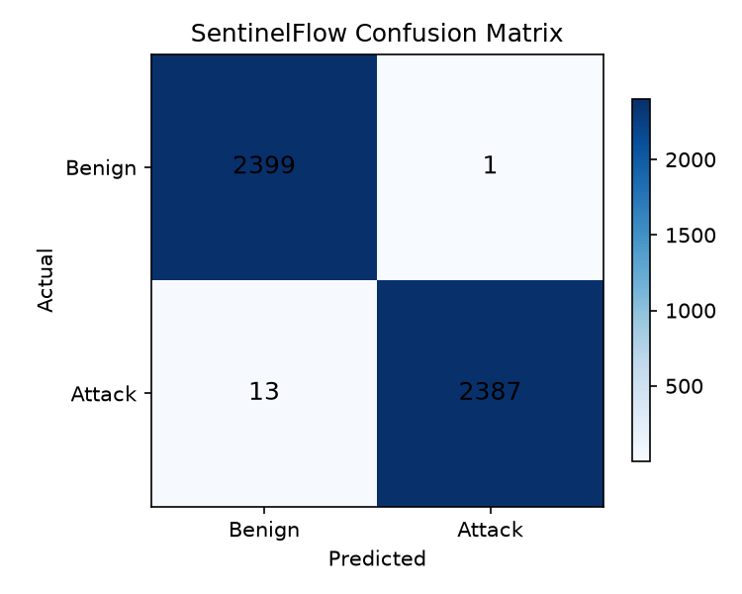  Figure 15: Confusion matrix of the shipped model (results/confusion_matrix.png). | 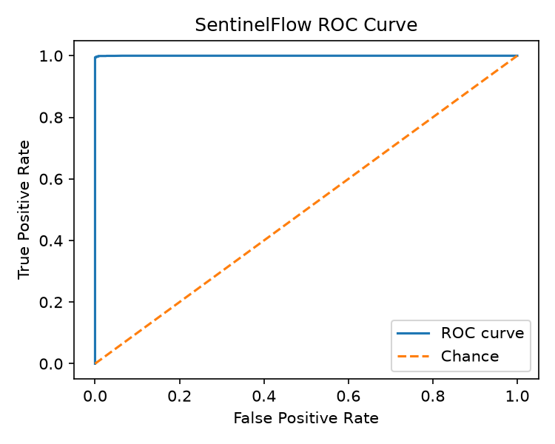  Figure 16: ROC curve of the shipped model (results/roc_curve.png).

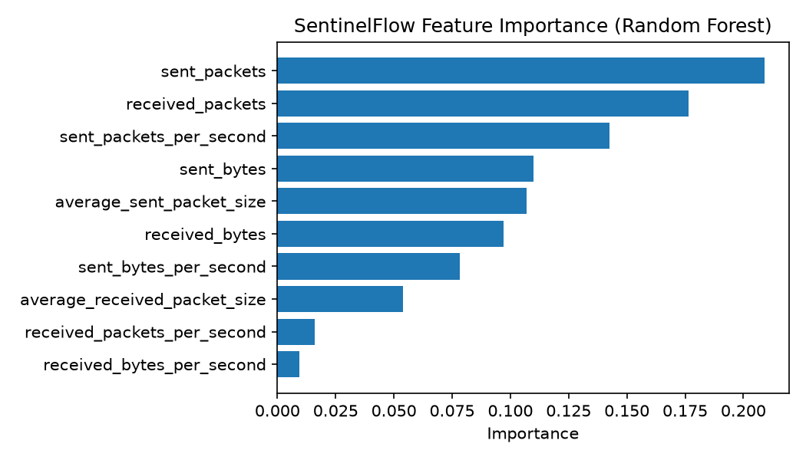
Figure 17: Feature importance of the shipped forest (results/feature_importance.png).
These figures are real measurements of the shipped file, but they describe how well the forest separates two synthetic generators, not how well it detects DDoS traffic. The synthetic flows are drawn from simple distributions (an attack flow has many forward packets and few backward ones), and the window rows come from the generator that Simulation Mode later uses. A near-perfect score on such data is expected and says little about real traffic. The shipped forest leans on the sent-side counts: sent_packets (0.209), received_packets (0.176) and sent_packets_per_second (0.142) carry 53 % of the importance.

8.3 Real-data check on CICIDS2017

8.3.1 The shipped model does not transfer
Applied to all 225,745 real flows without any retraining, the shipped model scores 71.8 % accuracy, 82.8 % precision, 63.4 % recall, 71.8 % F1 and a 17.2 % false-positive rate (ROC-AUC 86.1 %). Of 97,718 benign flows, 16,813 are flagged as attacks; of 128,027 DDoS flows, 46,860 are missed. A 20 % stratified sample gives the same picture (71.8 % accuracy), so the result is not an artefact of sample size. The ROC-AUC of 86.1 % shows that the forest's scores still rank attacks above benign flows better than chance, but the 0.5 threshold learnt from synthetic data is wrong for real flows.

8.3.2 The same forest retrained on real flows
The product's training script would have produced a different model if the CICIDS2017 CSV had been present in data/raw/. To measure that, the same forest (ten features, 200 trees, balanced class weights) was trained on the real flows, with a stratified 80/20 split repeated for five seeds, and with a chronological block split (the first 70 % of the file for training, the last 30 % for testing, since row order in these files follows capture order).
Table 37: Real CICIDS2017 Friday-DDoS flows: shipped model versus a forest retrained on real flows.
Experiment | Accuracy | Precision | Recall | F1 | FPR | Rows tested
Shipped (synthetic) model, all real flows | 71.79 % | 82.84 % | 63.40 % | 71.83 % | 17.21 % | 225,745
Retrained RF, seed 42, 20 % test | 99.94 % | 99.96 % | 99.94 % | 99.95 % | 0.05 % | 45,149
Retrained RF, block split (70 % / 30 %) | 99.74 % | 99.57 % | 99.77 % | 99.67 % | 0.28 % | 67,724
Retrained RF, five seeds, mean ± std | 99.94 ± 0.01 % | 99.96 ± 0.00 % | 99.93 ± 0.01 % | 99.94 ± 0.01 % | 0.058 ± 0.006 % | 45,149 each

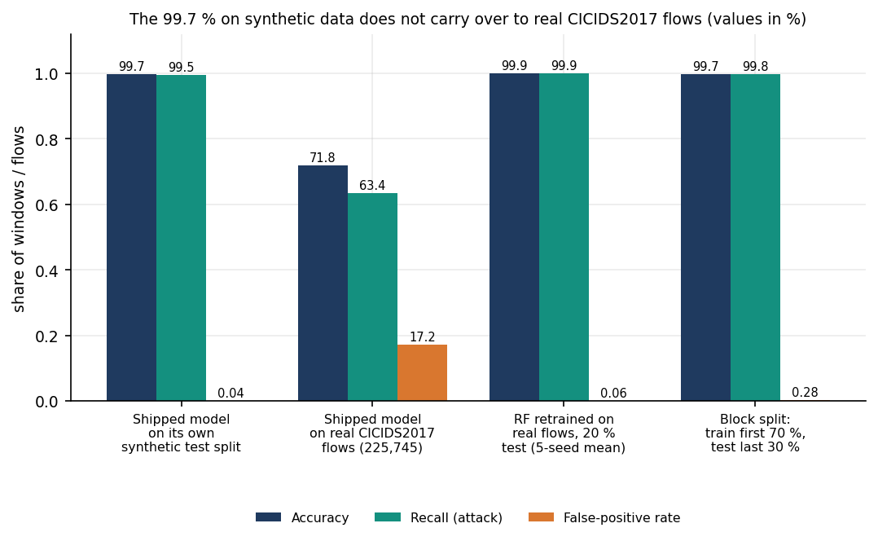
Figure 18: Accuracy, recall and false-positive rate: the shipped model on its own synthetic split, on real flows, and a forest retrained on real flows.
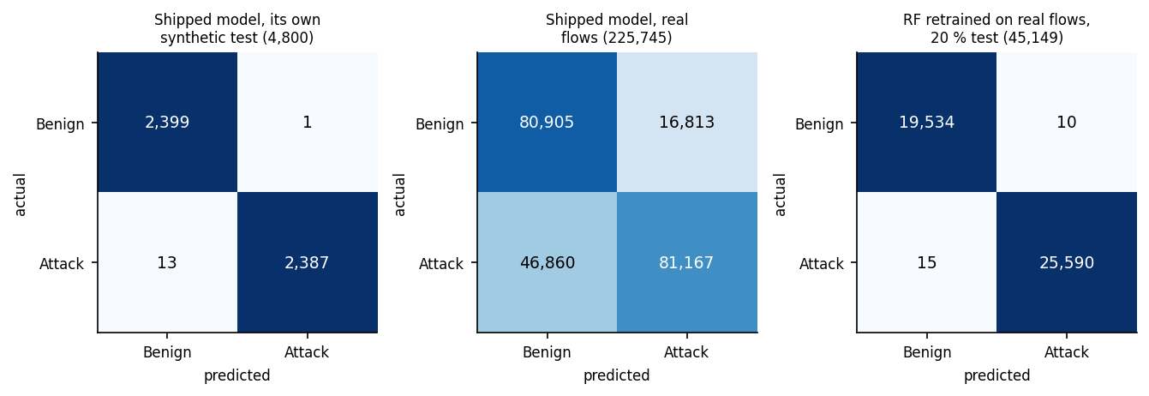
Figure 19: Confusion matrices: shipped model on its synthetic test, shipped model on real flows, retrained forest on real flows.
Retrained on real flows, the forest reaches 99.94 ± 0.01 % accuracy (the standard deviation over five seeds is 0.01 points) with a false-positive rate of 0.058 ± 0.006 %, in 6.92 s of training and a 1.24 MB model file. The chronological split gives 99.74 % accuracy and 0.28 % false positives; its test part is 60.4 % benign. That the block split is slightly worse than the random split is expected: neighbouring flows of one attack burst are near-duplicates, so a random split leaks. Even so, both splits come from one capture day with one attack type, and CICIDS2017 is known to contain labelling and flow-construction errors [9]; these numbers show that the ten features separate this day's DDoS from this day's benign traffic, not that they would separate any DDoS from any benign traffic.

8.3.3 Classifier comparison and feature ablation
The base paper compares seven classifiers before building voting ensembles. The same style of comparison was made here on the real split (seed 42), using classifiers from scikit-learn with their default or stated settings.
Table 38: Classifiers on real CICIDS2017 flows (same split, seed 42; training and prediction times on a CPU-saturated host).
Classifier | Accuracy | F1 | FPR | Train (s) | Predict 45,149 rows (s)
DecisionTree | 99.94 % | 99.95 % | 0.06 % | 0.59 | 0.003
RandomForest(200) | 99.94 % | 99.95 % | 0.05 % | 6.77 | 0.071
HistGradientBoosting | 99.95 % | 99.95 % | 0.04 % | 0.81 | 0.037
GaussianNB | 72.91 % | 80.71 % | 62.56 % | 0.04 | 0.009
LogisticRegression(scaled) | 98.59 % | 98.77 % | 3.10 % | 0.42 | 0.000

Figure 20: Classifier comparison on real flows: accuracy, F1, false-positive rate and training time.
The three tree-based learners are indistinguishable at 99.94-99.95 % accuracy; the Random Forest the product uses gives up nothing against gradient boosting, but it is the slowest of the three to train (6.8 s against 0.8 s for boosting and 0.6 s for one tree). A single decision tree scores the same as the forest on this data. Gaussian Naive Bayes fails (72.9 % accuracy, 62.6 % false positives): its independence and normality assumptions do not fit heavy-tailed packet counts. Scaled logistic regression is respectable (98.6 %) but has a 3.1 % false-positive rate. For comparison, the reference paper in the batch folder reports 0.971 for an SVM, 0.827 for a decision tree and 0.593 for logistic regression on a different, small CIC sample [7]; the datasets differ, so the ordering of the tree against the SVM there says nothing about this data.
Table 39: Feature-group ablation: Random Forest on real flows (seed 42).
Feature group | Features | Accuracy | Recall | FPR
all 10 | 10 | 99.94 % | 99.94 % | 0.05 %
sent only | 5 | 99.89 % | 99.88 % | 0.09 %
received only | 5 | 95.83 % | 99.95 % | 9.56 %
counts and bytes only | 4 | 99.91 % | 99.85 % | 0.02 %
rates only | 4 | 99.33 % | 99.38 % | 0.74 %
no rates | 6 | 99.91 % | 99.85 % | 0.02 %

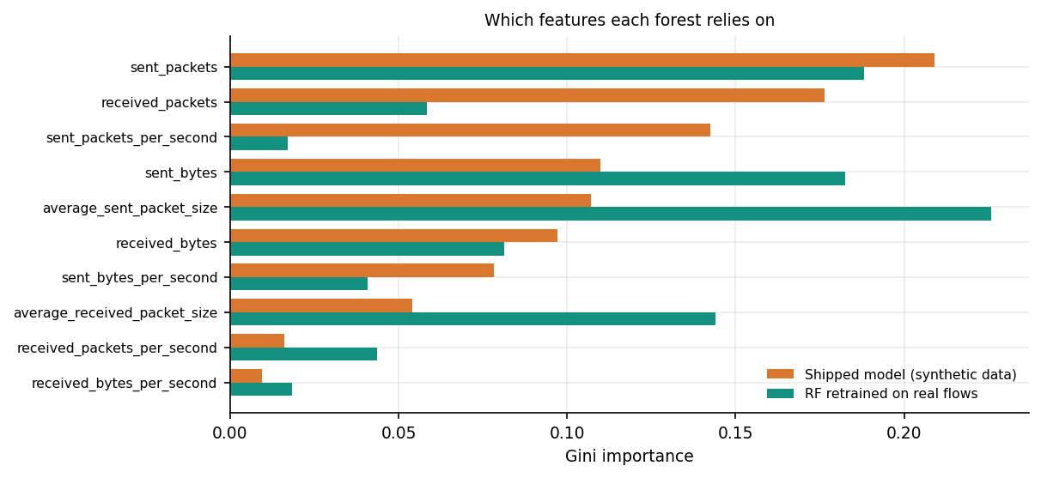
Figure 21: Feature importance of the shipped forest and of the forest retrained on real flows.
Dropping the four rate features changes nothing (99.91 % accuracy, the lowest false-positive rate of any group at 0.02 %), and the four count and byte features alone do just as well. The received-side features alone are clearly worse (95.83 % accuracy, 9.56 % false positives): on this capture the attacker's forward direction carries the signal. The retrained forest relies on the average sent packet size (0.226), sent_packets (0.188) and sent_bytes (0.183), whereas the shipped forest relied mostly on counts. The ablation also shows a weakness of the design: because rates are counts divided by the window length, they add no information on top of the counts, and the model is only calibrated to the window length it was trained on (Section 8.5).
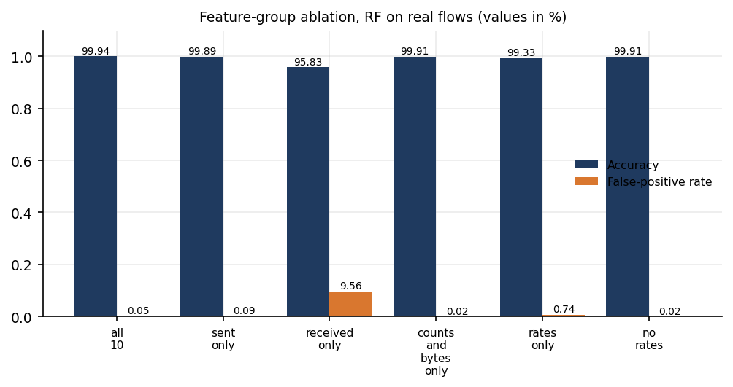
Figure 22: Feature-group ablation on real flows.

8.4 The product's training recipe on real flows
ml/train_model.py combines flow rows with 6,000 aggregated simulator windows so that window-scale feature values are represented. Run on the real file instead of the synthetic fallback (the flows plus the windows, capped at 120,000 rows: 51,912 benign and 68,088 attack), the recipe gives 99.93 % accuracy, 99.94 % F1 and 0.039 % false positives on its own mixed 24,000-row test set, and 99.95 % accuracy on all real flows (about 80 % of the sampled flows were seen in training, so this second figure is optimistic). On fresh simulator windows of 2, 5 and 10 seconds it classifies every window correctly (100 %, 100 %, 100 %), but this is not evidence: those windows come from the same generator that produced the augmentation rows.
The contrast with the forest trained on real flows alone is instructive. That forest labels every one of 1,500 simulator windows of 10 s as benign (attack recall 0 %), although its ROC-AUC on them is 100 %: a flow-scale model sees a window with thousands of packets as unlike anything it has learnt, and the scores rank correctly while the threshold is wrong. A forest needs training rows at the scale it will be applied to; the window rows are what supplies that, and they are synthetic.
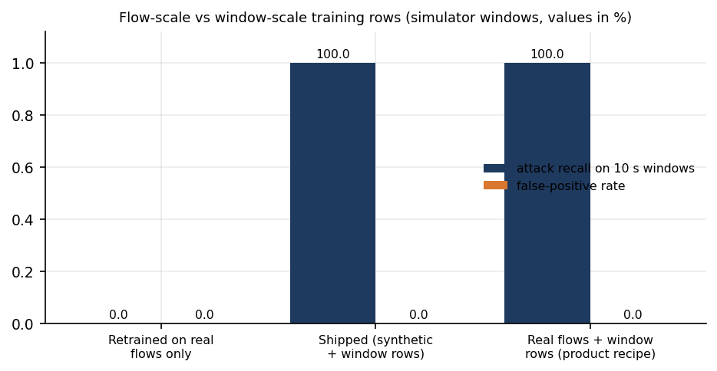
Figure 23: Attack recall and false-positive rate on 10 s simulator windows for three training sets.

8.5 The window pipeline: model, risk and severity together
The most informative experiment for the product as a whole feeds the shipped model through the pipeline as app.py runs it: simulator packets, traffic_aggregator, Random Forest, distributed risk against a rolling twelve-window baseline, persistence and severity. For each window length, 4,000 windows were generated with the simulator's own settings (1,445 attack windows of three styles, 2,555 benign). The table below compares three possible decision rules: the forest's label alone, the severity layer (a window acts only at High or Critical, which is what triggers a quarantine), and the distributed-risk score alone at two thresholds.
Table 40: Shipped model through the pipeline at three window lengths (4,000 simulated windows each).
Window | RF label: accuracy | RF label: FPR | High/Critical: accuracy | High/Critical: FPR | High/Critical: recall | Risk >= 0.7: recall | Risk >= 0.4: recall
2 s | 70.6 % | 46.0 % | 95.7 % | 6.77 % | 100.0 % | 31.9 % | 74.9 %
5 s | 91.3 % | 13.6 % | 99.8 % | 0.27 % | 100.0 % | 19.2 % | 61.4 %
10 s | 100.0 % | 0.0 % | 98.9 % | 0.00 % | 97.0 % | 9.0 % | 53.6 %

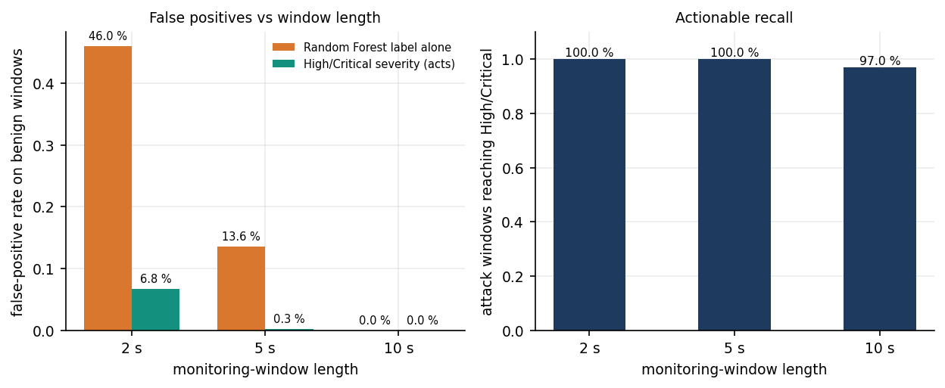
Figure 24: False-positive rate of the forest's label and of High/Critical severity, and the recall of High/Critical, at three window lengths.
Three results stand out. First, window length matters a great deal. The forest was calibrated on 10-second windows. At 10 s its label is perfect on these simulated windows (a result that, as Section 8.4 explains, only reflects the shared generator); at 5 s it flags 13.6 % of benign windows as attacks, and at 2 s, the window length used for the screenshots, 46.0 %. Shorter windows contain fewer packets, the count features fall, and benign traffic starts to look like the lower end of the attack classes. The Simulation Mode default is 5 s and the live default 10 s, so the product's own demo setting is not the setting its model was calibrated for. Second, the severity layer removes most of the damage. Requiring High or Critical lowers the benign-window false-positive rate to 0.27 % at 5 s (7 of 2,555 windows) and 6.77 % at 2 s (173 windows), at no cost in recall at those lengths (100 %). A false positive here is a quarantine of a source, which is the harm the batch's problem statement warns about, so this is the number that matters operationally. Third, the layer misses some real attacks at the length it was designed for. At 10 s, 44 of 1,445 attack windows (3.04 %) stay at Medium, because the severity thresholds were tuned against a different packet-rate scale; none of them is quarantined, though each is flagged and a rate limit is recommended.
The distributed-risk score alone is precise but nearly blind: it has no false positives at either threshold (precision 100 %), yet at the 0.7 threshold it recovers only 31.9 %, 19.2 % and 9.0 % of attack windows at 2, 5 and 10 s, and 74.9 %, 61.4 % and 53.6 % at 0.4. It is therefore used as one input of the severity score, not as a detector, and the carpet-bombing signal it carries is only as good as the spread of destinations in the window. The second table shows how the severity layer treats each traffic style at 5 s.
Table 41: Severity by traffic style, 5 s windows (counts of windows).
Style | Windows | Mean packets/s | RF flags Attack | Low | Medium | High | Critical | Reaches High/Critical
benign | 2555 | 65 | 13.6 % | 2208 | 340 | 7 | 0 | 0.3 %
flood | 453 | 1136 | 100.0 % | 0 | 0 | 245 | 208 | 100.0 %
carpet | 492 | 780 | 100.0 % | 0 | 0 | 176 | 316 | 100.0 %
slow | 500 | 149 | 100.0 % | 0 | 0 | 499 | 1 | 100.0 %

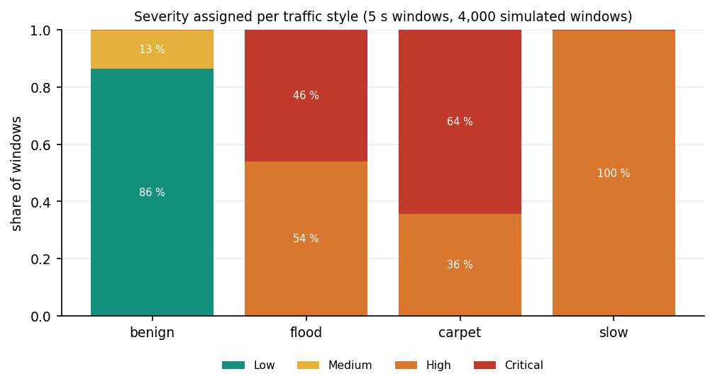
Figure 25: Share of windows at each severity level for each simulated traffic style (5 s windows).

8.6 Mitigation behaviour in the running system
In the live simulation run on a scratch copy of the backend (2 s windows), the first detection was stored 4.6 s after pressing Start. In the observation period 13 windows were scored: 10 Attack and 3 Benign, with severities 4 Critical, 3 High, 3 Medium, 3 Low. The 7 High and Critical windows produced 21 quarantine rows (three sources each), and 21 quarantines were active at the time of the status call. Medium windows produced only a rate-limit recommendation, and Low windows were monitored. Each quarantine lasts 40 s (80 s for Critical) and then lapses; the Mitigation page counts the seconds down and the history row changes from active to recovered.
The decision itself is quick: from the finished feature vector to the mitigation decision took a median of 217 ms (95th percentile 489 ms) on a CPU-saturated machine, almost all of it forest inference (Chapter 7). What the quarantine does is limited, however: it adds the address to a list inside SentinelFlow. The operating-system firewall is never modified (apply_os_firewall_block() returns applied: False), no packet is dropped, and rate limiting is advised, not applied. The mitigation therefore demonstrates the policy, its timing and its recovery, not an actual reduction of attack traffic. The time between the first attack packet and the quarantine is at least the window length (10 s by default) plus the decision time; it was not measured against a real attack.

8.7 Comparison with the base paper
The base paper [1] reports 100 % accuracy, precision, recall and F1 for all four of its voting ensembles on both of its datasets. The comparison with SentinelFlow can only be indicative: the datasets, the features, the classifiers and the evaluation protocols differ, and the base paper measures resource use that SentinelFlow measures only coarsely. The like-for-like fact is that the same family of tree learners reaches 99.94 ± 0.01 % on a real DDoS capture here, close to the paper's figure, and that this requires training on real data, which the shipped model did not.
Table 42: Base paper and SentinelFlow, side by side (datasets and protocols differ).
Aspect | Base paper (IEEE Access 2026) | SentinelFlow (this project)
Data | SDN flow dataset (104,345 records, 23 features); CIC-DDoS2023 subset (1,754,109 rows, 47 features) | CICIDS2017 Friday-DDoS flows (225,745 rows), mapped to 10 features; shipped model: synthetic fallback
Features | RF importance combined with the Banzhaf Power Index to select a subset | Ten fixed count, byte, rate and size features shared by training and live windows; no feature selection
Classifiers | XGBoost, RF, Gradient Boosting, SVM, kNN, AdaBoost, Naive Bayes; four hard-voting ensembles | Random Forest (200 trees); single-classifier comparison on real flows (Section 8.3.3)
Headline result | 100 % accuracy, precision, recall, F1 on both datasets | 99.94 ± 0.01 % (5 seeds, real flows); 99.71 % on the synthetic split; 71.8 % for the shipped model on real flows
Resource profile | Training time, inference time, memory, model size per ensemble; SVM-based ensembles over 4,000 s to train, kNN over 150 s to classify the SDN test set | RF trains in 6.92 s (real flows); model 1.24 MB (real) or 2.74 MB (shipped); window cost 231 ms median on a loaded host; no memory profile
Mitigation | Proposed as future work (throttling or blackholing; sidecar next to the controller) | Implemented as application-level quarantine with automatic recovery; not enforced on the network
False positives | Reported through precision and F1 (all 1.0) | Measured per benign window: 0.058 % on real flows; 0.27 % (5 s) after the severity layer
Deployment test | Offline datasets; live and testbed evaluation listed as future work | Simulated windows through the real pipeline; live capture untested here (no Npcap)

Two further points of context. The carpet-bombing paper in the batch folder (Swileh et al. [6]) reports 99.94 % accuracy for an LLM-based detector at about two seconds per request on a Mininet and Ryu testbed, and the survey item of Raghavendran and Robinson [3] reports 97 % for KNN and 100 % for XGBoost on a testbed dataset; neither measurement is comparable with the figures above, and neither reports the effect of the false-positive rate on legitimate users that the severity layer addresses here.

8.8 Sample input and output
The excerpt below is a real detection record. It was produced by starting Simulation Mode on a scratch copy of the backend (window 2 s) and reading GET /api/detections; it was not edited except for omitting the unrelated top-destination list and rounding. The input is the ten-feature vector of one window of 7,504 packets from 20 sources to one destination; the output is the verdict, the risk breakdown, the severity score with its factors and the three quarantines.
{ "id": 17, "source": "simulation", "prediction": "Attack", "confidence": 1.0, "severity": "Critical",
"packet_rate": 3752.0, "byte_rate": 708363.5, "source_count": 20, "destination_count": 1,
"distributed_risk": 0.6199, "mitigation_status": "quarantine",
"detail": {
"features": { "received_packets": 7504, "received_bytes": 1416727, "received_packets_per_second": 3752.0,
"received_bytes_per_second": 708363.5, "average_received_packet_size": 188.8,
"sent_packets": 0, "sent_bytes": 0, "sent_packets_per_second": 0.0,
"sent_bytes_per_second": 0.0, "average_sent_packet_size": 0.0 },
"distributed": { "distributed_risk_score": 0.6199, "distributed_risk_level": "Medium",
"components": { "source_diversity": 0.667, "destination_diversity": 0.067,
"packet_rate_pressure": 1.0, "baseline_deviation": 0.999 },
"explanation": "Observed 20 unique sources and 1 unique destinations at 3752 packets/sec
(708364 bytes/sec); traffic is spread across many sources (possible distributed flood)." },
"severity": { "severity": "Critical", "severity_score": 75.0,
"factors": [ "Random Forest classified the window as Attack (100.0% confidence)",
"High model confidence (>= 90%)", "Very high packet rate (3752 pkt/s)",
"Medium distributed-traffic risk (0.62)" ],
"recommendation": "Quarantine top sources in SentinelFlow immediately and rate-limit the affected interface." },
"actions": [ {"action": "quarantine", "target": "10.66.4.87", "duration": 80},
{"action": "quarantine", "target": "10.66.0.104", "duration": 80},
{"action": "quarantine", "target": "10.66.7.204", "duration": 80} ] } }

The severity score of 75 is the sum of 30 points for the Attack label, 15 for a confidence of at least 90 %, 20 for a rate of at least 3,000 packets per second and 10 for a medium distributed-risk score; it crosses the Critical threshold of 70, so the three busiest non-protected sources are quarantined for twice the base 40 s. The distributed-risk level is only Medium (0.62) because this is a single-destination flood: destination diversity contributes 0.067. A carpet-bombing window would score much higher on that component.

8.9 Output screens
The twelve screens below were captured from the running React console at 1440 x 900 with the Playwright browser driver. The console was in Simulation Mode: windows are generated by the product's simulator and scored by the real model, and the interface labels this state; nothing on these screens is live network traffic. The simulation ran with 2-second windows, so the screens show the short-window behaviour discussed in Section 8.5, including benign-looking windows labelled Attack. The shipped database held about 250 scored windows at capture time.
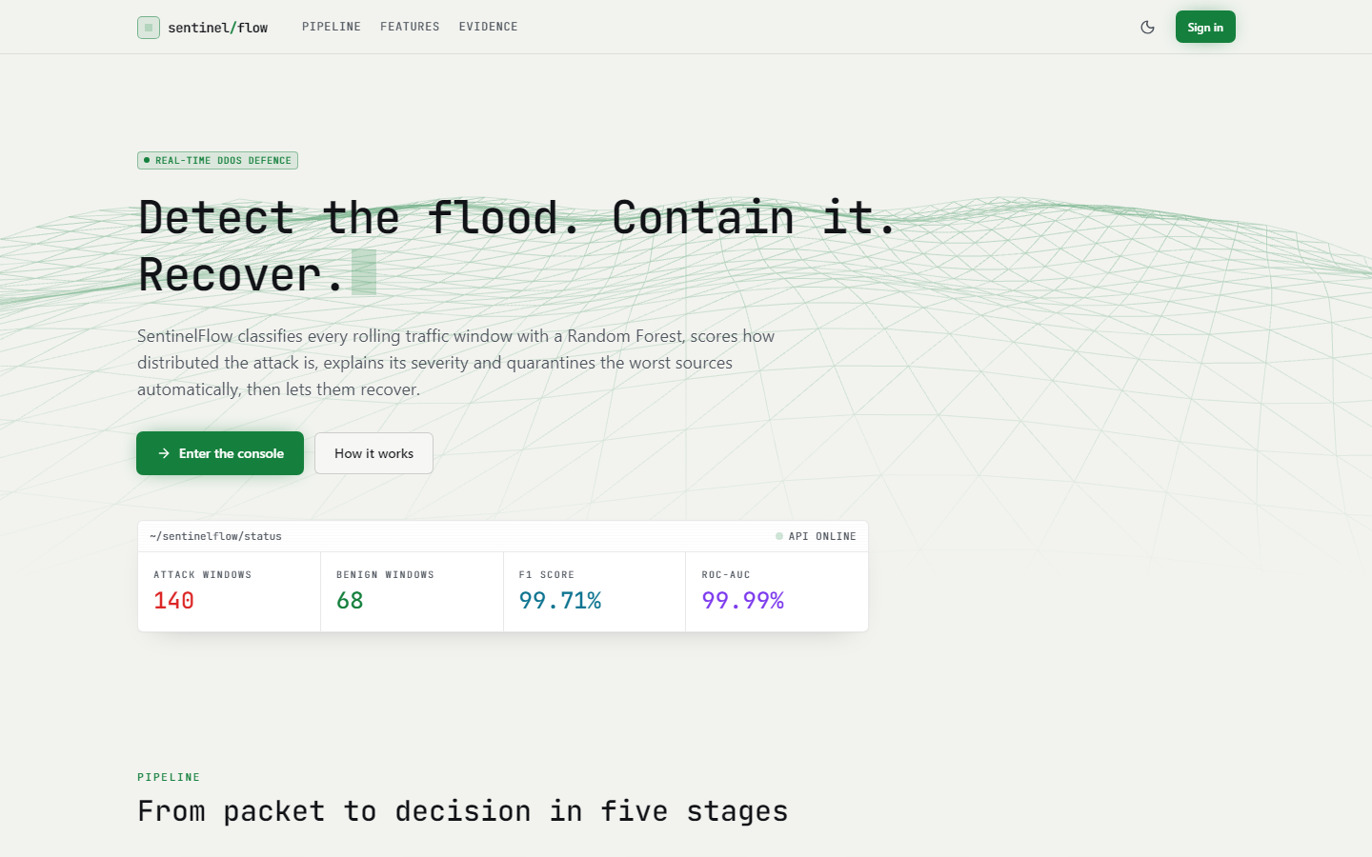  Figure 26: Landing page, light theme. A status card read from the API shows 140 attack windows, 68 benign windows, F1 99.71 % and ROC-AUC 99.99 %; these last two are the synthetic-split figures, shown here without a synthetic caveat. | 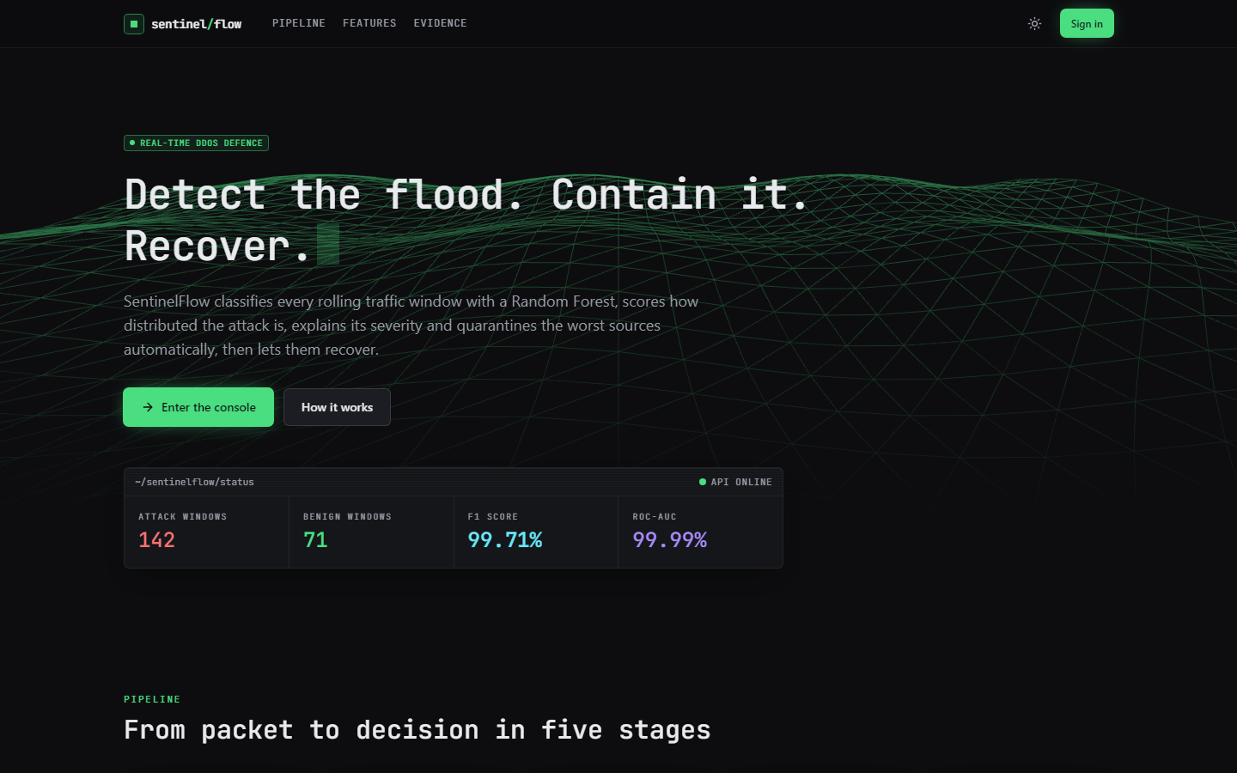  Figure 27: Landing page, dark theme: 142 attack and 71 benign windows scored so far, same F1 and ROC-AUC. The counters update live from /api/detections.

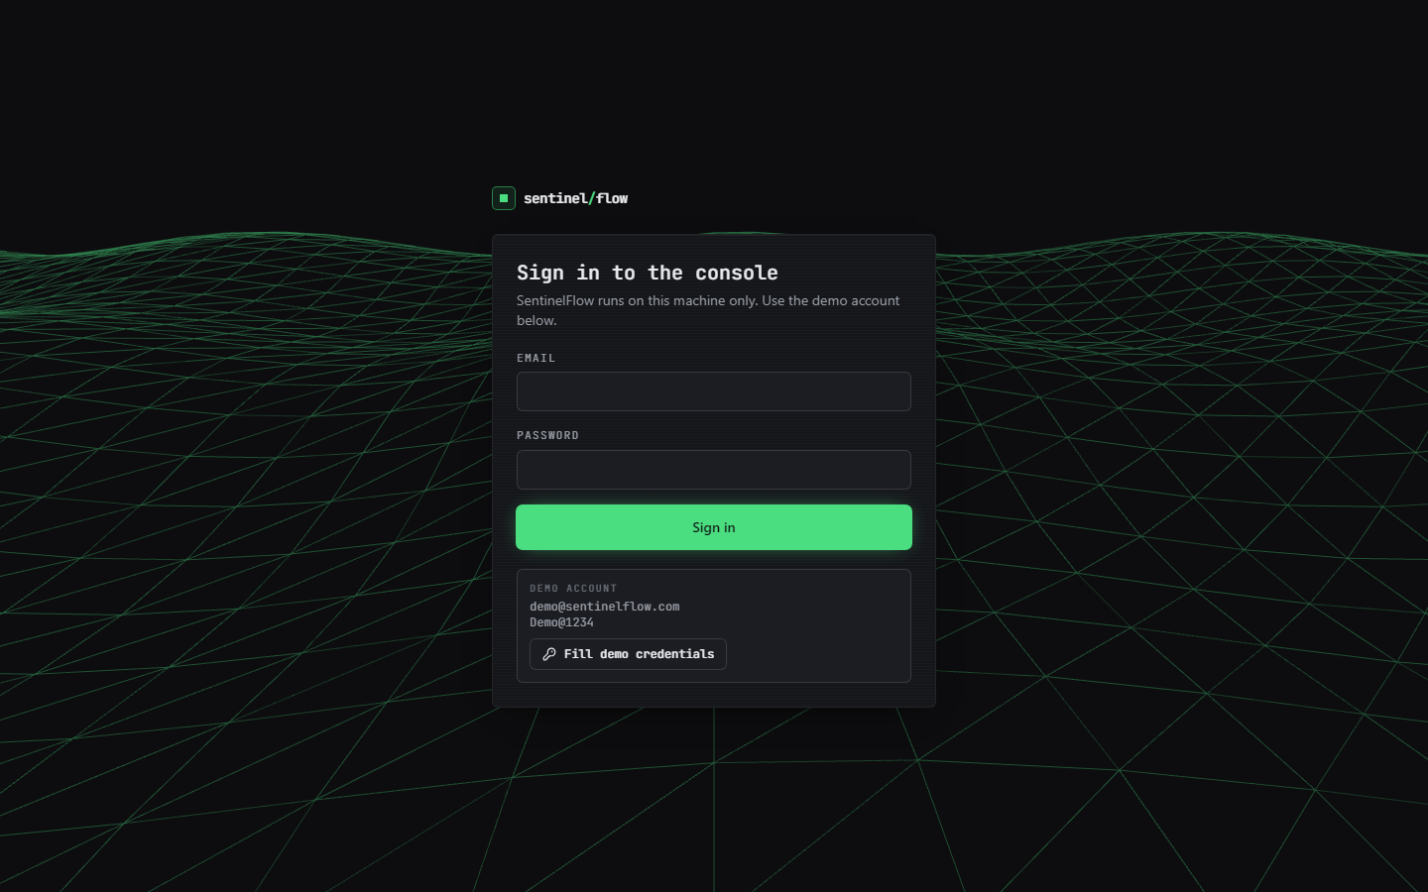  Figure 28: Sign-in page. Email and password fields, the demo account (demo@sentinelflow.com, Demo@1234) and a Fill demo credentials button; the gate is browser-side only. | 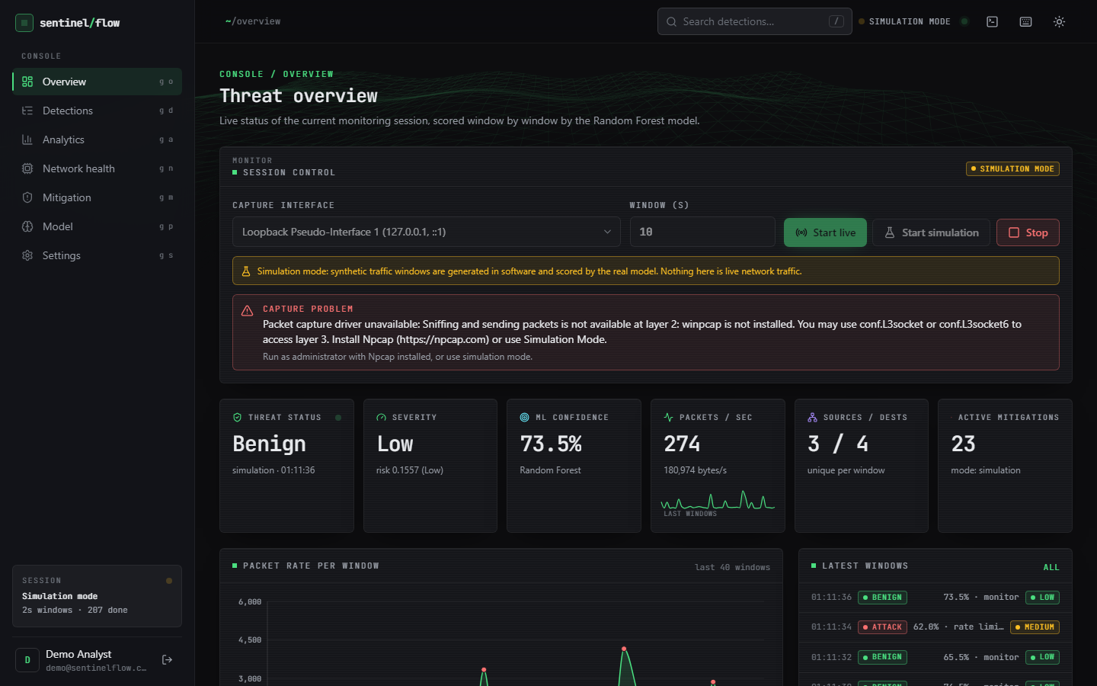  Figure 29: Overview page. The amber banner says simulation mode; the red capture-problem banner reports the real error (winpcap not installed). Cards: Benign, severity Low (risk 0.1557), model confidence 73.5 %, 274 packets/s, 3 sources / 4 destinations, 23 active mitigations; session 207 windows done.

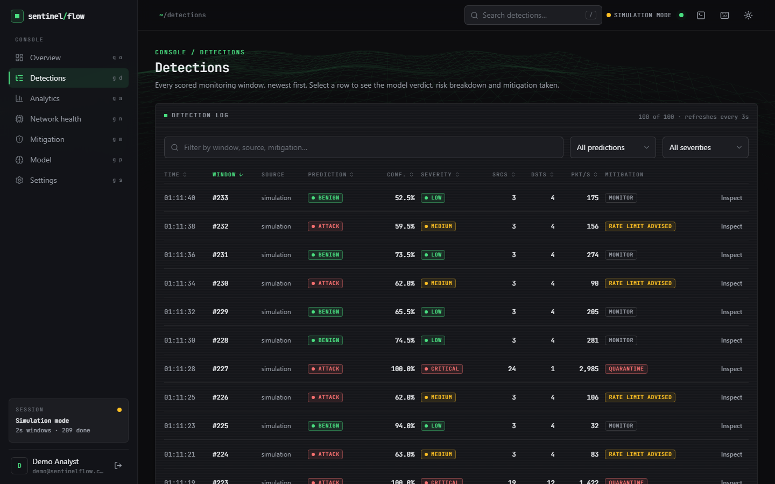  Figure 30: Detections page, newest first, 100 rows with filters. Windows #232, #230, #226 and #224 are labelled Attack at 59-63 % confidence with only 3 sources, 4 destinations and 83-156 packets/s: benign-looking windows flagged by the forest at 2 s, held at Medium (rate limit advised). #227 (24 sources, 1 destination, 2,985 packets/s, 100 %) is Critical with a quarantine. | 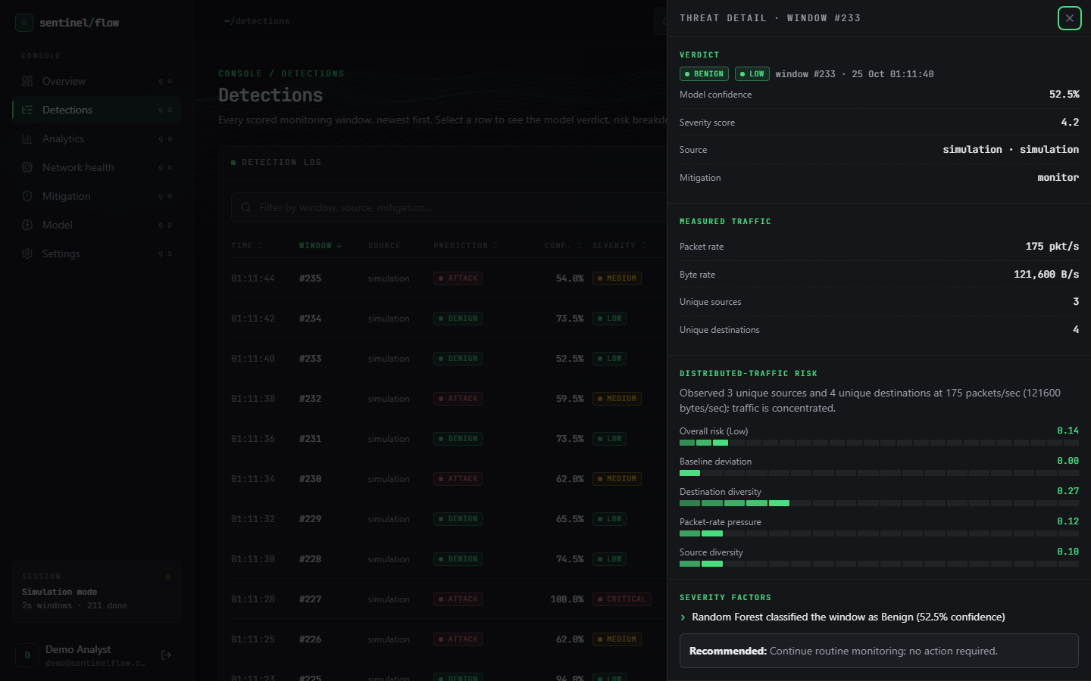  Figure 31: Threat-detail drawer for window #233: Benign at 52.5 % confidence, severity Low (score 4.2), 175 packets/s, 121,600 bytes/s, 3 sources, 4 destinations, distributed risk 0.14 with its four components, the first severity factor and the recommendation 'Continue routine monitoring'.

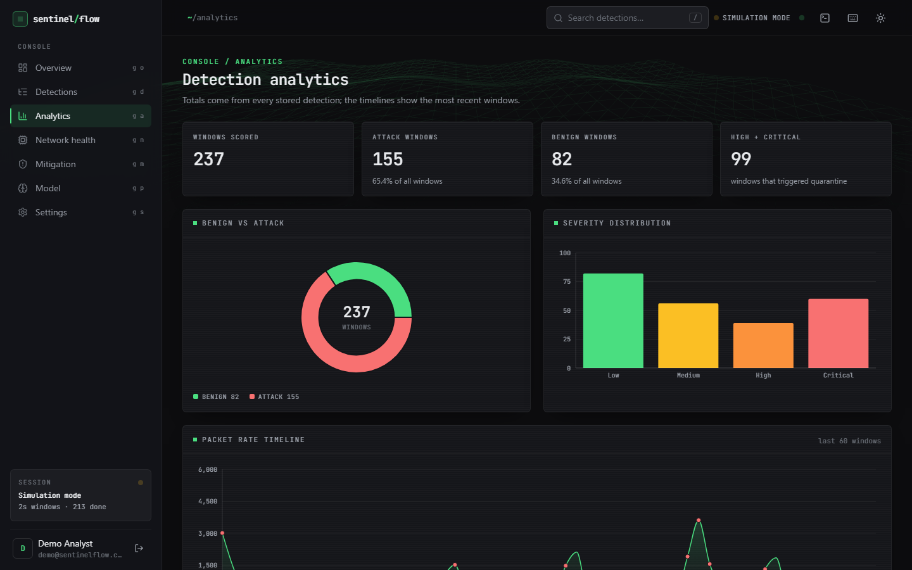  Figure 32: Analytics page: 237 windows scored, 155 Attack (65.4 %), 82 Benign, 99 High or Critical; donut chart, severity bar chart and the start of the packet-rate timeline. The simulator intends 35 % attack windows, so the 65.4 % reflects the short-window false alarms of Section 8.5. | 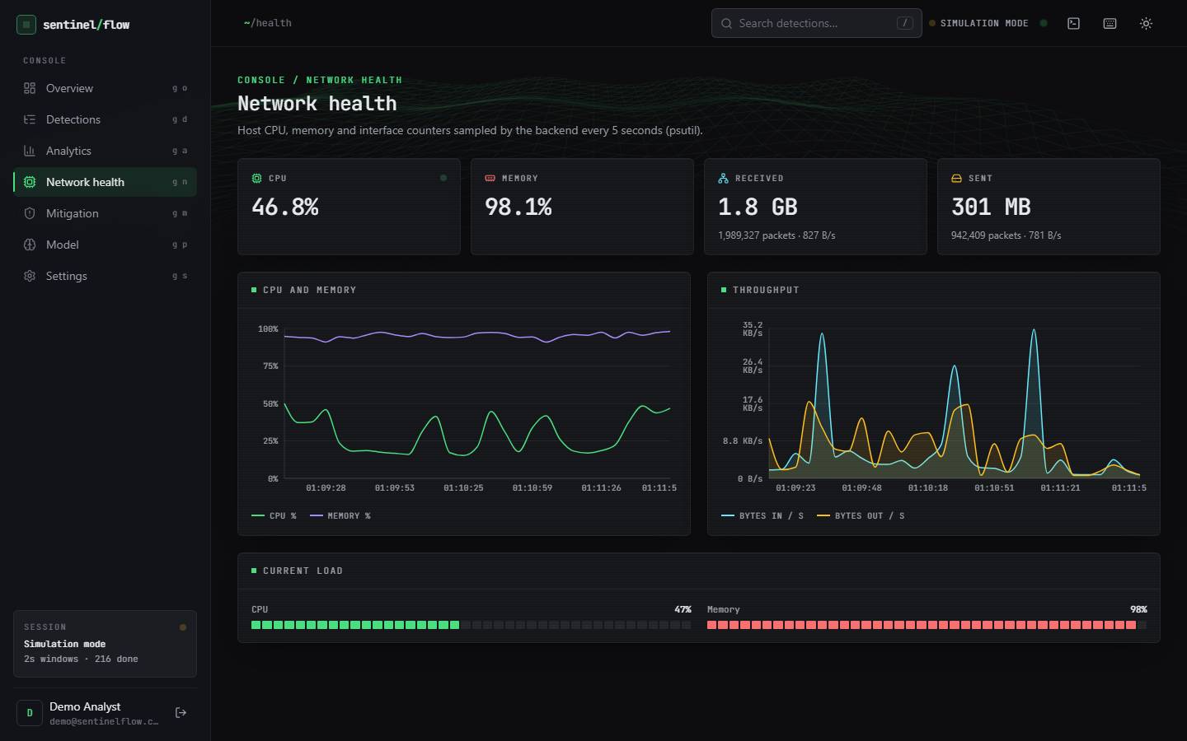  Figure 33: Network health page, psutil counters sampled every 5 s: CPU 46.8 %, memory 98.1 % (the machine was heavily loaded), 1.8 GB received in 1,989,327 packets, 301 MB sent in 942,409 packets, with CPU/memory and throughput charts.

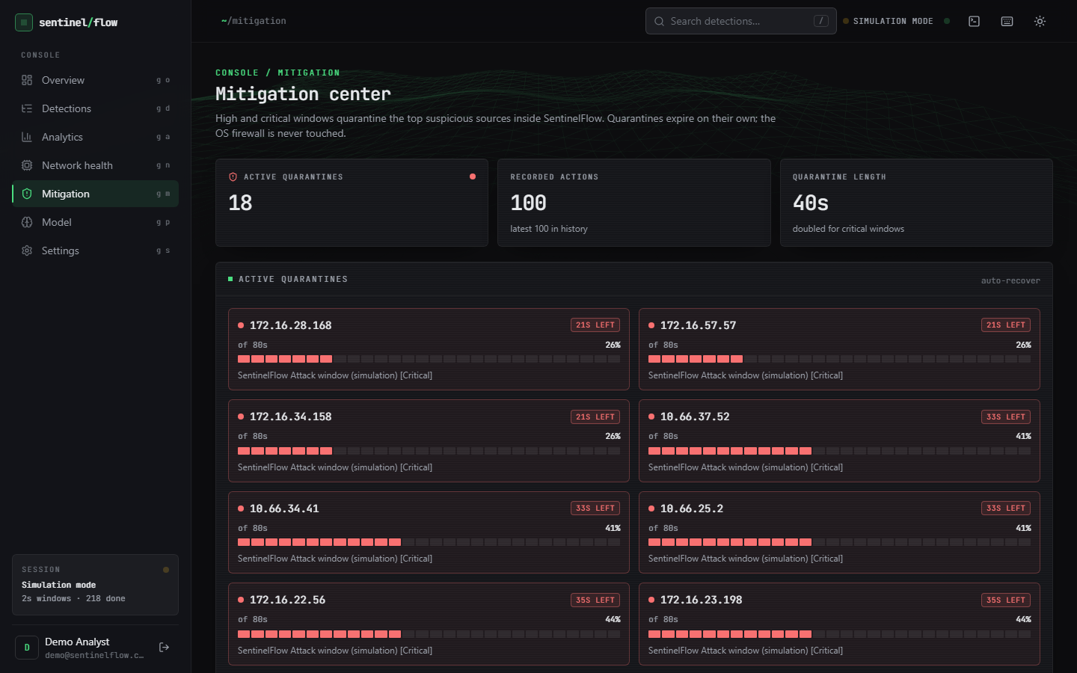  Figure 34: Mitigation page: 18 active quarantines, 100 recorded actions, quarantine length 40 s (doubled for Critical). Each card shows the address, seconds left of 80 s, a progress bar and the reason, for example 172.16.28.168, 21 s left, 'Attack window (simulation) [Critical]'. | 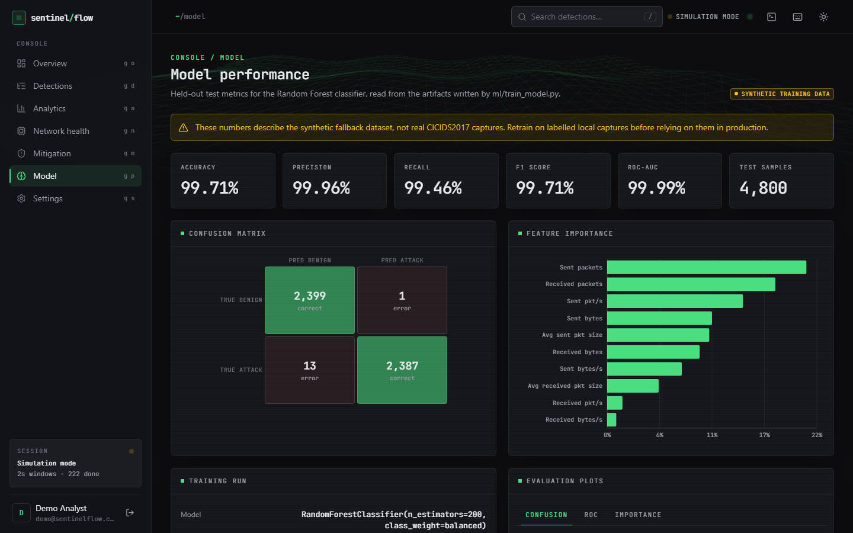  Figure 35: Model page: banner 'SYNTHETIC TRAINING DATA' with the warning that the numbers describe the synthetic fallback; accuracy 99.71 %, precision 99.96 %, recall 99.46 %, F1 99.71 %, ROC-AUC 99.99 %, 4,800 test samples, confusion matrix 2,399 / 1 / 13 / 2,387 and the feature-importance bars.

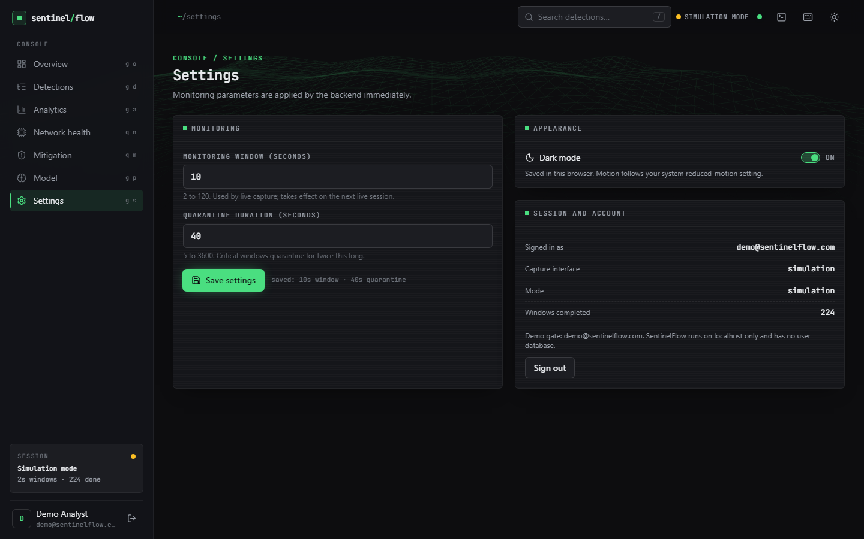  Figure 36: Settings page: monitoring window 10 s (2-120), quarantine 40 s (5-3600, doubled for Critical), saved confirmation, dark-mode switch, and a session panel (signed in as the demo user, interface simulation, 224 windows completed, demo-gate note). | 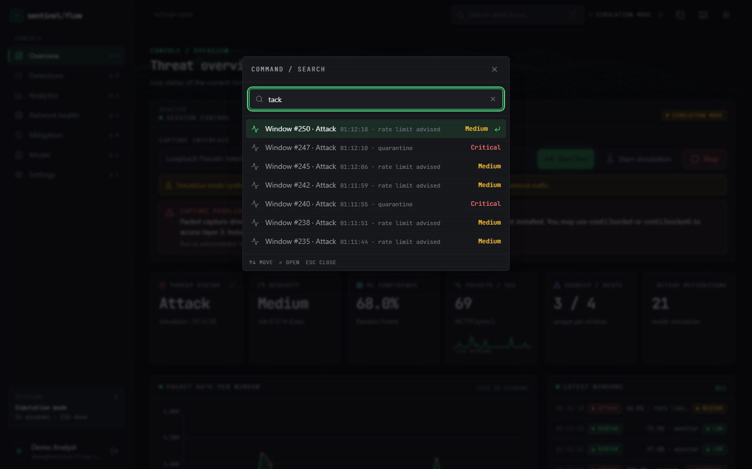  Figure 37: Command palette opened over the Overview page with the query 'tack': the matching detections (Windows #250, #245, #242, #238 and #235 Attack at Medium, #247 and #240 Critical with quarantine), with keyboard hints.

8.10 Success and failure analysis

Where the system succeeded
• The loop closes. A window goes from packets to a stored, explained detection and, when severe, to a temporary quarantine that recovers on its own, in a fraction of a second of compute per window (Chapter 7); 95 automated tests and 25 smoke checks pass.
• The severity layer works as a false-positive filter. It lowers benign-window false positives from 13.6 % to 0.27 % at 5 s and from 46.0 % to 6.8 % at 2 s while keeping recall at 100 %, and it lists the reasons for every verdict.
• The feature set is adequate for real DDoS flows. Retrained on the real capture the forest reaches 99.94 ± 0.01 % accuracy over five seeds and 99.74 % on a chronological split; a single tree does as well.
• The failure paths are handled. Missing Npcap, a missing model, invalid features, out-of-range settings and a second start all produce a clear message or status code instead of a crash.

Where it failed or fell short
• The shipped model does not transfer to real flows: 71.8 % accuracy, 63.4 % recall and 17.2 % false positives on 225,745 real CICIDS2017 flows, against 99.71 % on its own synthetic split. The Model page warns about the synthetic data; the landing page does not.
• Window length breaks calibration. At the Simulation Mode default of 5 s the forest alone flags 13.6 % of benign windows; the screenshots, taken at 2 s, show Attack labels on windows with 3 sources and under 160 packets/s.
• The severity layer misses weaker attacks at 10 s: 44 of 1,445 attack windows stay at Medium and are not quarantined.
• The 10 s synthetic result is circular. Perfect accuracy on simulator windows follows from training on rows from the same generator; it is not detection performance.
• The distributed-risk score is a weak detector (recall 9-32 % at 0.7), and the carpet-bombing case was only tested with the simulator's own carpet style.
• Mitigation is not enforcement. Quarantine is a list inside the application; the firewall is untouched, nothing is dropped, rate limiting is only recommended.
• Inference is slower than it needs to be: the saved n_jobs=-1 makes single-window prediction about 9 times slower than n_jobs=1 (313 ms against 33 ms median on the loaded host).
• Live capture was never run: Npcap is not installed on the test machine.

8.11 Limitations of the results
• One real dataset, one attack day (the DDoS capture of CICIDS2017), one attack family; no other attack types, no other datasets, no cross-dataset test. The mirror's copy of the file was not independently checked against the original archive.
• CICIDS2017 has documented labelling and flow-construction problems [9]; flows adjacent in time are near-duplicates, so random splits overstate generalisation. The block split reduces but does not remove that.
• The window experiments use the product's own simulator, whose traffic styles were written by the same team that wrote the detector; they test the pipeline logic, not its behaviour on real mixtures of traffic.
• No real-time, live or testbed measurement: no real attack timeline, no throughput under load, no recovery of a real service. Timings come from a CPU-saturated machine and are upper bounds.
• The base-paper comparison is indicative only: different data, features, classifiers and protocol (Section 8.7).
• Seeds: the five-seed result varies only the split and the forest seed; the severity thresholds and the simulator settings were not tuned or varied in this study.

8.12 Objectives against outcomes
Table 43: The six objectives of the batch against what was achieved.
# | Objective | Outcome
1 | Acquire a benchmark dataset and extract flow features | Partly. The training script looks for CICIDS2017 CSVs in data/raw and otherwise builds a synthetic fallback, which is what shipped. In this documentation run the real Friday-DDoS file (225,745 flows) was obtained and mapped with the product's own preprocessing; the shipped model was not retrained on it.
2 | Capture live traffic and compute the same features in real time | Implemented (Scapy sniff, traffic_aggregator, the same ten-feature schema as training). Not verified on live traffic because Npcap is not installed; verified through the simulator, the aggregator tests and the error path.
3 | Train a classifier to distinguish DDoS from legitimate traffic | Achieved as code and, after retraining, as a result on real flows (99.94 ± 0.01 %). The shipped artefact is synthetic-trained and scores 71.8 % on real flows.
4 | Implement adaptive mitigation that rate-limits or blocks sources | Partly. Temporary quarantine of the top three sources with automatic recovery, doubled for Critical; rate limiting only recommended; no enforcement outside the application.
5 | Build a dashboard of live traffic, detections and mitigation actions | Achieved: nine-page React console plus the original dashboard, refreshed by polling every two seconds; screens in Section 8.9.
6 | Evaluate accuracy, false positive rate and time from detection to mitigation | Achieved for accuracy and false positives (synthetic split, real flows, three window lengths) and for decision latency (median 217 ms on a loaded host). Not measured against a real attack timeline.

9. CONCLUSION

9.1 Summary of the work
The batch asked for a framework that detects DDoS traffic in real time and applies adaptive mitigation without blocking legitimate users. The project delivered SentinelFlow: Scapy or simulated traffic windows, ten flow features, a 200-tree Random Forest, an explainable distributed-risk and severity layer, temporary quarantine with automatic recovery, a SQLite history, twelve REST endpoints and a nine-page React console, backed by 95 passing tests and 25 passing smoke checks. It follows the base paper [1] and adds the closed detection-to-mitigation loop that the paper leaves as future work.
In the documentation phase the product was evaluated more strictly than it had been built. The shipped model, trained on a synthetic fallback, scores 99.71 % on its own split but 71.8 % on 225,745 real CICIDS2017 DDoS-day flows; the same forest retrained on real flows reaches 99.94 ± 0.01 %. The two layers must be read separately: the engineering (pipeline, API, console, tests) works as designed; the shipped model's headline figure does not describe real traffic.

9.2 Objectives achieved and not achieved
Table 44: Batch objectives against the outcome
Objective | Status | Evidence
1. Acquire a benchmark dataset and extract flow features | Partly | The training script reads CICIDS2017 CSVs from data/raw and otherwise builds a labelled synthetic fallback, which is what shipped. During documentation the real Friday-DDoS file (225,745 flows) was obtained and mapped with the product's own preprocessing; the shipped model was not retrained on it.
2. Capture live traffic and compute the same features in real time | Implemented, not verified live | Scapy capture, rolling windows and the aggregator use the training schema. Npcap is not installed on the test machine, so only the error path was exercised; the simulator drives the identical pipeline.
3. Train a classifier to separate DDoS from legitimate traffic | Achieved after retraining | Shipped synthetic-trained forest: 99.71 % on its own split but 71.8 % on real flows. Same forest retrained on real flows: 99.94 ± 0.01 % over five seeds.
4. Adaptive mitigation that rate-limits or blocks sources | Partly | High and Critical windows quarantine the top three non-protected sources for 40 s (80 s for Critical) with automatic recovery, inside the application. Rate limiting is only recommended; the OS firewall is never touched.
5. Dashboard of live traffic, detections and mitigation | Achieved | Nine-page React console plus the original Flask dashboard; polling every 2 s; every screen captured with data.
6. Evaluate accuracy, false-positive rate and time from detection to mitigation | Achieved for offline evaluation | Accuracy and false-positive rate on a synthetic split, on real flows and through the window pipeline at three window lengths; decision latency median 217 ms on a saturated host. No real attack timeline was measured.

The statuses are strict. 'Partly' means a simpler version of the step exists; 'Implemented, not verified live' means the code exists and its failure path was tested but live capture was not possible; nothing is claimed beyond the table.

9.3 Key findings
1. The synthetic-trained model does not transfer. The shipped forest scores 99.71 % accuracy and 0.04 % false positives on its own 4,800-row split, but on the 225,745 real CICIDS2017 DDoS-day flows it scores 71.8 % accuracy, 63.4 % recall and 17.2 % false positives (ROC-AUC 86.1 %: the ranking is informative, the 0.5 threshold is not).
2. The same forest trained on real flows is accurate. With identical features and hyper-parameters, five seeds give 99.94 ± 0.01 % accuracy and 0.058 ± 0.006 % false positives; a chronological block split (first 70 % train, last 30 % test) gives 99.74 %. This is the same order as the 100 % reported by the base paper [1], on different data and with a different protocol.
3. Simple tree models are enough on this data. On the same real split a decision tree (99.94 %), the 200-tree forest (99.94 %) and histogram gradient boosting (99.95 %) are indistinguishable; logistic regression reaches 98.59 % and Gaussian Naive Bayes only 72.9 %. The forest takes 6.9 s to train and its file is 1.24 MB.
4. Packet and byte counts carry the signal. Four count-and-byte features alone give 99.91 %; sent-direction features alone 99.89 %; received-direction features alone fall to 95.8 % with 9.6 % false positives. The rate features add nothing on flows.
5. Window length decides the false-alarm rate. The model was calibrated on 10-second windows. On 4,000 simulator windows the forest label alone raises false positives on benign windows of 46.0 % at 2 s, 13.6 % at 5 s and 0.0 % at 10 s (the last figure is flattering, because the simulator generated the training windows).
6. The severity layer removes most false alarms. Acting only on High or Critical severity cuts those false positives to 6.77 % at 2 s and 0.27 % at 5 s while 100 % of attack windows still reach High or Critical at both lengths; at 10 s recall is 96.96 % because 44 weaker attack windows stay at Medium. The distributed-risk score alone is precise but weak: at threshold 0.7 it has 100 % precision and only 31.9 %, 19.2 % and 9.0 % recall at 2, 5 and 10 s.
7. Flow-scale and window-scale rows are different populations. A forest trained on real flows only labels every simulator window Benign (recall 0 at all three window lengths) although its ROC-AUC on those windows is 100.0 %. The product's recipe of adding 6,000 window rows fixes this on windows (100.0 % on fresh windows from the same generator) while keeping 99.93 % on the mixed test split.
8. Decision latency is small next to the window. On a host whose CPU was saturated by other jobs, the time from the finished feature vector to the mitigation decision had a median of 217 ms (95th percentile 489 ms), dominated by forest inference: the saved forest has n_jobs=-1, which costs 313 ms per single window against 33 ms with n_jobs=1. The real delay to a decision is the window length, 10 s by default.
9. The software is tested. 95 pytest tests and 25 smoke checks pass; 25 of 25 malformed-input probes were handled as intended; the REST endpoints answer in a median of 3 to 36 ms on 127.0.0.1.
The two figures below summarise the findings that most change how the system should be read: the gap between synthetic and real data, and the effect of window length with and without the severity layer.
Figure 38: Accuracy, recall and false-positive rate: shipped model on synthetic data and on real flows, and the forest retrained on real flows.
Figure 39: False-positive rate on benign windows and attack recall at 2, 5 and 10 s windows.

9.4 Practical applications
SentinelFlow is a teaching and prototyping tool for network-security courses and small labs: it shows the whole path from packets to a verdict, an explanation and a reversible action; it provides a safe simulator for demonstrations; and it is a test bed for the evaluation mistakes the report exposes (synthetic data, window-length calibration, forests saved with a parallel setting). It is not a replacement for a firewall, a scrubbing service or a commercial intrusion-prevention system, and it must be retrained on real captures before any operational use.

9.5 Known limitations
The limitations are listed in full in Chapter 1, Chapter 8 and the Scope and Limitations document. The ones that matter most for reading the results are:
• Synthetic training data in the shipped model.
• Real-data result covers one attack day.
• Ten features describe a flow, not an attack.
• Window length sensitivity.
• Mitigation is an application-level denylist.
• Live capture was not run end to end.

10. FUTURE SCOPE

10.1 Improvements to the existing system
The improvements below follow directly from the measurements; the first three would change the headline results.
1. Retrain on real data and ship that model. Place the CICIDS2017 CSVs in data/raw (the training script already uses them) and add CIC-DDoS2023 and an SDN flow dataset as the base paper does, so that the shipped forest is not synthetic. The real-flow result (99.94 ± 0.01 %) shows the pipeline is ready; what is missing is the artefact and a split that respects time.
2. Calibrate for the window length. Train with window rows built at the configured length (or at several lengths), store the length in the model metadata and refuse or warn when the console runs with a different one; at 2 s the forest label alone gave 46.0 % false positives on benign windows.
3. Fix the inference setting. Save the forest with n_jobs=1 (or set it at load time): single-window inference falls from 313 ms to 33 ms on the loaded test host, which removes the largest part of the decision time.
4. Make the landing page honest. Show the synthetic warning wherever the headline metric appears, and show the real-data figures once the model is retrained.
5. Persist settings and validate every field. Use the existing settings table for window length and quarantine duration, and reject over-long interface values.
6. Learn the severity thresholds. Replace the hand-set weights and cut-offs by values tuned on labelled windows, keeping the factor list so that every verdict stays explainable.

10.2 Additional features
• Richer features: entropy of destination and source addresses per window, TCP flag rates (SYN, ACK, RST), protocol shares, inter-arrival statistics and per-destination packet counts for a sharper carpet-bombing signal. The aggregator already collects protocol and top-destination context that the model does not yet use.
• Multi-class typing: classify SYN flood, UDP flood, HTTP flood and carpet bombing so that the recommended action can differ (the base paper lists multi-class detection as future work as well).
• Ensembles and feature selection from the base paper [1]: voting ensembles and Banzhaf-index selection become useful once the feature set is larger than ten.
• Online learning: update the model from confirmed windows, with a guard against an attacker poisoning the training stream.
• Notifications and export: e-mail or chat alerts on High and Critical windows and a CSV or PDF export of the detection history.
• Authentication and roles: replace the browser-side demo gate by server-side accounts and protect the REST API before it is bound to anything other than 127.0.0.1.

10.3 Scalability and deployment
• Live testing: install Npcap, run SentinelFlow as administrator against a lab network with a traffic generator under the supervision of the department, and measure time from the first attack packet to the first quarantine.
• OS-level enforcement with explicit opt-in: implement apply_os_firewall_block() for Windows Firewall or iptables behind a confirmation setting, a protected-address list and an automatic rollback, so that the safe default stays unchanged.
• SDN integration: feed flow statistics from an SDN controller instead of Scapy windows and install throttling or blackhole rules through the controller, as the base paper [1] proposes for a sidecar.
• Deployment: package the API and the console in the existing Docker image with a production server, add rotation of the SQLite history or a server database, and move polling to server-sent events.
• Scale: measure capture throughput at line rate, move aggregation to a compiled or kernel-assisted capture path, and run several sensors that report to one console.

10.4 Further research
• Transfer between datasets and window lengths: the flow-to-window gap measured here suggests studying domain adaptation between flow-level training data and window-level sensors, and testing on CIC-DDoS2023 and SDN data as in the base paper.
• Retrieval and language-model detection: the carpet-bombing paper [6] avoids retraining by retrieval; comparing its accuracy, cost (about 2 s per request) and robustness with a calibrated forest on the same traffic is an open question.
• Dataset quality: repeat the evaluation on a relabelled CICIDS2017 [9] and on captures made by the team.
• False-positive cost: quantify the harm of quarantining a legitimate source, for example by replaying benign traffic with known senders and counting wrongly quarantined addresses.
• Adversarial behaviour: test evasion by low-rate or slowly ramping floods and by spoofed sources, against which a source-based quarantine is weak (see the taxonomy of Mirkovic and Reiher [11]).

REFERENCES
[1] M. M. Trigui, M. S. Islam, M. D. Gambo, M. S. Alam and T. Helmy, "Resource-aware ensemble framework for DDoS detection in SDN via novel game-theoretic feature selection," IEEE Access, vol. 14, pp. 1666-1676, 2026, doi: 10.1109/ACCESS.2025.3618519.
[2] S. Areef and G. Vijayasri, "DDoS attack detection and mitigation," Int. J. Eng. Sci. Adv. Technol., vol. 26, no. 4, pp. 115-120, 2026, doi: 10.64771/ijesat.2026.v26.i6.3198 (record as given by Crossref; abstract not available).
[3] N. Raghavendran and Y. H. Robinson, "IoT-based WISNE-SDN detection and DDoS attack mitigation using machine learning techniques," PeerJ Comput. Sci., vol. 12, Art. no. e3572, Feb. 2026, doi: 10.7717/peerj-cs.3572.
[4] M. Jadric and S. Mladenovic, "DDoS attack detection and mitigation using double deep Q-networks," in Proc. 2025 Int. Conf. Software, Telecommun. Comput. Netw. (SoftCOM), Split, Croatia, Sep. 2025, pp. 1-6, doi: 10.23919/SoftCOM66362.2025.11197364.
[5] "AI-driven DDoS attack detection and mitigation in SDN," IJARCCE, vol. 14, no. 4, 2025, doi: 10.17148/IJARCCE.2025.144107 (authors not listed in Crossref; abstract not available).
[6] M. N. Swileh, S. Zhang and K. Lei, "Intelligent detection and mitigation of carpet-bombing DDoS attacks in SDN using retrieval-augmented generation and large language models," arXiv:2605.26307, May 2026.
[7] M. A. Rahman, "Detection of distributed denial of service attacks based on machine learning algorithms," arXiv:2502.00975, Feb. 2025.
[8] I. Sharafaldin, A. Habibi Lashkari and A. A. Ghorbani, "Toward generating a new intrusion detection dataset and intrusion traffic characterization," in Proc. 4th Int. Conf. Inf. Syst. Secur. Privacy (ICISSP), Funchal, Portugal, Jan. 2018, pp. 108-116, doi: 10.5220/0006639801080116.
[9] G. Engelen, V. Rimmer and W. Joosen, "Troubleshooting an intrusion detection dataset: The CICIDS2017 case study," in Proc. 2021 IEEE Secur. Privacy Workshops (SPW), May 2021, pp. 7-12, doi: 10.1109/SPW53761.2021.00009.
[10] R. Sommer and V. Paxson, "Outside the closed world: On using machine learning for network intrusion detection," in Proc. 2010 IEEE Symp. Secur. Privacy, 2010, pp. 305-316, doi: 10.1109/SP.2010.25.
[11] J. Mirkovic and P. Reiher, "A taxonomy of DDoS attack and DDoS defense mechanisms," ACM SIGCOMM Comput. Commun. Rev., vol. 34, no. 2, pp. 39-53, Apr. 2004, doi: 10.1145/997150.997156.
[12] L. Breiman, "Random forests," Mach. Learn., vol. 45, no. 1, pp. 5-32, Oct. 2001, doi: 10.1023/A:1010933404324.
[13] F. Pedregosa et al., "Scikit-learn: Machine learning in Python," J. Mach. Learn. Res., vol. 12, pp. 2825-2830, 2011.
[14] A. A. Alashhab, M. S. Zahid, B. Isyaku, A. A. Elnour, W. Nagmeldin, A. Abdelmaboud, T. A. A. Abdullah and U. D. Maiwada, "Enhancing DDoS attack detection and mitigation in SDN using an ensemble online machine learning model," IEEE Access, vol. 12, pp. 51630-51649, 2024, doi: 10.1109/ACCESS.2024.3384398.
[15] A. Zaman, S. A. Khan, N. Mohammad, A. A. Ateya, S. Ahmad and M. A. ElAffendi, "Distributed denial of service attack detection in software-defined networks using decision tree algorithms," Future Internet, vol. 17, no. 4, p. 136, Mar. 2025, doi: 10.3390/fi17040136.
[16] M. Alduailij, Q. W. Khan, M. Tahir, M. Sardaraz, M. Alduailij and F. Malik, "Machine-learning-based DDoS attack detection using mutual information and random forest feature importance method," Symmetry, vol. 14, no. 6, p. 1095, May 2022, doi: 10.3390/sym14061095.
[17] Y. Su, D. Xiong, K. Qian and Y. Wang, "A comprehensive survey of distributed denial of service detection and mitigation technologies in software-defined network," Electronics, vol. 13, no. 4, p. 807, Feb. 2024, doi: 10.3390/electronics13040807.
[18] F. L. Becerra-Suarez, I. Fernandez-Roman and M. G. Forero, "Improvement of distributed denial of service attack detection through machine learning and data processing," Mathematics, vol. 12, no. 9, p. 1294, Apr. 2024, doi: 10.3390/math12091294.
[19] M. A. Hossain and M. S. Islam, "Enhancing DDoS attack detection with hybrid feature selection and ensemble-based classifier: A promising solution for robust cybersecurity," Meas.: Sensors, vol. 32, Art. no. 101037, Apr. 2024, doi: 10.1016/j.measen.2024.101037.
[20] K. S. Sahoo, B. K. Tripathy, K. Naik, S. Ramasubbareddy, B. Balusamy, M. Khari and D. Burgos, "An evolutionary SVM model for DDoS attack detection in software defined networks," IEEE Access, vol. 8, pp. 132502-132513, 2020, doi: 10.1109/ACCESS.2020.3009733.
[21] J. E. Varghese and B. Muniyal, "An efficient IDS framework for DDoS attacks in SDN environment," IEEE Access, vol. 9, pp. 69680-69699, 2021, doi: 10.1109/ACCESS.2021.3078065.
[22] F. Musumeci, A. C. Fidanci, F. Paolucci, F. Cugini and M. Tornatore, "Machine-learning-enabled DDoS attacks detection in P4 programmable networks," J. Netw. Syst. Manage., vol. 30, no. 1, Art. no. 21, 2022, doi: 10.1007/s10922-021-09633-5.
[23] R. Braga, E. Mota and A. Passito, "Lightweight DDoS flooding attack detection using NOX/OpenFlow," in Proc. IEEE 35th Conf. Local Comput. Netw. (LCN), Oct. 2010, pp. 408-415, doi: 10.1109/LCN.2010.5735752.
[24] A. J. Akroma and E. O. K. Mohamed, "Analysis of DDoS attacks and development of software solutions using machine learning for detection and mitigation," Bani Waleed Univ. J. Humanities Appl. Sci., vol. 10, no. 2, pp. 39-50, Apr. 2025, doi: 10.58916/jhas.v10i2.720.
[25] P. Biondi et al., "Scapy: Interactive packet manipulation program," software documentation. [Online]. Available: https://scapy.net
[26] Pallets Projects, "Flask: A lightweight WSGI web application framework," documentation. [Online]. Available: https://flask.palletsprojects.com
[27] G. Rodola, "psutil: Cross-platform library for retrieving information on running processes and system utilisation," software documentation. [Online]. Available: https://github.com/giampaolo/psutil
[28] W. Eddy, "TCP SYN flooding attacks and common mitigations," IETF, RFC 4987, Aug. 2007.
[29] P. Ferguson and D. Senie, "Network ingress filtering: Defeating denial of service attacks which employ IP source address spoofing," IETF, RFC 2827 (BCP 38), May 2000.

APPENDIX A: IMPORTANT CODE
The key functions are copied from 8.ProjectCode in the state in which the results were measured (whole statements; the full files are in the repository).

A.1 The per-window pipeline (`app.py`)
def process_window(features: dict, context: dict, source: str, interface: str) -> dict:
"""Shared inference pipeline for live and simulated windows."""
global consecutive_suspicious, latest_detection
if context.get("error"):
return {"error": context["error"]}
try:
ml_result = detector.detect(features)
except FileNotFoundError as exc:
return {"error": str(exc)}
except ValueError as exc:
return {"error": "Feature validation failed: %s" % exc}

packet_rate = float(features.get("received_packets_per_second", 0.0)) + float(
features.get("sent_packets_per_second", 0.0))
dist = distributed_analysis.compute_distributed_risk(features, context, _baseline())
baseline_rates.append(packet_rate)

with state_lock:
if ml_result["label"] == 1 or dist["distributed_risk_score"] >= 0.7:
consecutive_suspicious += 1
else:
consecutive_suspicious = 0
persistence = consecutive_suspicious

sev = severity.assess_severity(ml_result["prediction"], ml_result["confidence"],
features, dist, persistence)
actions = mitigation.decide(sev["severity"], context,
"SentinelFlow %s window (%s)" % (ml_result["prediction"], source))
mitigation_status = actions[0]["action"] if actions else "monitor"

record = {
"timestamp": time.time(),
"interface": interface,
"source": source,
"prediction": ml_result["prediction"],
"confidence": ml_result["confidence"],
"severity": sev["severity"],
"packet_rate": dist["packet_rate"],
"byte_rate": dist["byte_rate"],
"source_count": dist["unique_sources"],
"destination_count": dist["unique_destinations"],
"distributed_risk": dist["distributed_risk_score"],
"mitigation_status": mitigation_status,
"detail": {
"features": features,
"context": {k: v for k, v in context.items() if k != "simulated_attack_intended"},
"distributed": dist,
"severity": sev,
"actions": actions,
},
}
try:
record_id = db.add_detection(record)
record["id"] = record_id
except Exception:
record["id"] = None
with state_lock:
latest_detection = record
return record

A.2 Severity assessment (`security/severity.py`)
def assess_severity(prediction: str, confidence: float, features: dict,
distributed: dict, persistence: int = 0) -> dict:
packet_rate = float(distributed.get("packet_rate", 0.0))
risk = float(distributed.get("distributed_risk_score", 0.0))
n_src = int(distributed.get("unique_sources", 0))
n_dst = int(distributed.get("unique_destinations", 0))
is_attack = (prediction == "Attack")

score = 0.0
factors = []

if is_attack:
score += 30
factors.append("Random Forest classified the window as Attack (%.1f%% confidence)" % (confidence * 100))
else:
factors.append("Random Forest classified the window as Benign (%.1f%% confidence)" % (confidence * 100))
score += 8 * confidence # small residual for uncertain benign windows

if confidence >= 0.9:
score += 15
factors.append("High model confidence (>= 90%)")
elif confidence >= 0.75:
score += 8
factors.append("Moderate model confidence (>= 75%)")

if packet_rate >= 3000:
score += 20
factors.append("Very high packet rate (%.0f pkt/s)" % packet_rate)
elif packet_rate >= 1200:
score += 12
factors.append("Elevated packet rate (%.0f pkt/s)" % packet_rate)
elif packet_rate >= 400:
score += 5
factors.append("Above-normal packet rate (%.0f pkt/s)" % packet_rate)

if risk >= 0.7:
score += 20
factors.append("High distributed-traffic risk (%.2f): %s" % (risk, distributed.get("explanation", "")))
elif risk >= 0.4:
score += 10
factors.append("Medium distributed-traffic risk (%.2f)" % risk)

if n_src >= 25 or n_dst >= 12:
score += 8
factors.append("Wide traffic spread (%d sources, %d destinations)" % (n_src, n_dst))

if persistence >= 3:
score += 10
factors.append("Persistent suspicious activity across %d consecutive windows" % persistence)
elif persistence == 2:
score += 5
factors.append("Repeated suspicious activity across 2 consecutive windows")

if not is_attack:
score = min(score, 45) # benign windows cannot exceed Medium

if score >= 70:
severity = "Critical"
recommendation = "Quarantine top sources in SentinelFlow immediately and rate-limit the affected interface."
elif score >= 50:
severity = "High"
recommendation = "Quarantine the most active suspicious sources and recommend rate limiting."
elif score >= 28:
severity = "Medium"
recommendation = "Recommend rate limiting and keep the sources under heightened monitoring."
else:
severity = "Low"
recommendation = "Continue routine monitoring; no action required."

return {
"severity": severity,
"severity_score": round(score, 1),
"factors": factors,
"recommendation": recommendation,
}

A.3 Distributed-risk score (`security/distributed_analysis.py`)
def compute_distributed_risk(features: dict, context: dict, baseline: dict | None = None) -> dict:
packet_rate = float(features.get("received_packets_per_second", 0.0)) + float(
features.get("sent_packets_per_second", 0.0))
byte_rate = float(features.get("received_bytes_per_second", 0.0)) + float(
features.get("sent_bytes_per_second", 0.0))
n_src = int(context.get("unique_sources", 0) or 0)
n_dst = int(context.get("unique_destinations", 0) or 0)

# Component 1: source diversity (many distinct sources).
src_component = min(n_src / 30.0, 1.0)
# Component 2: destination diversity (carpet-bombing signal).
dst_component = min(n_dst / 15.0, 1.0)
# Component 3: absolute packet-rate pressure.
rate_component = min(packet_rate / 1500.0, 1.0)
# Component 4: deviation from rolling baseline.
if baseline and baseline.get("packet_rate", 0) > 1:
deviation = packet_rate / max(baseline["packet_rate"], 1.0)
baseline_component = min(max(deviation - 1.0, 0.0) / 4.0, 1.0)
else:
baseline_component = 0.0 if packet_rate < 300 else 0.4

score = round(
0.30 * src_component
+ 0.30 * dst_component
+ 0.25 * rate_component
+ 0.15 * baseline_component,
4,
)
if score >= 0.7:
level = "High"
elif score >= 0.4:
level = "Medium"
else:
level = "Low"

A.4 Mitigation policy and quarantine (`security/mitigation.py`)
def decide(self, severity: str, context: dict, reason: str) -> list:
"""Apply policy for one window. Returns list of actions taken."""
actions = []
self.expire_due()
protected = {"unknown", "127.0.0.1", "::1", "192.168.1.20"} | _local_ips_safe()
if severity in ("High", "Critical"):
targets = [t["ip"] for t in (context.get("top_sources") or [])[:3]
if t["ip"] not in protected]
duration = self.quarantine_seconds * (2 if severity == "Critical" else 1)
for ip in targets:
if self.quarantine(ip, reason + " [%s]" % severity, duration):
actions.append({"action": "quarantine", "target": ip, "duration": duration})
if not targets:
actions.append({"action": "rate_limit_recommended", "target": "interface", "duration": 0})
elif severity == "Medium":
actions.append({"action": "rate_limit_recommended", "target": "interface", "duration": 0})
else:
actions.append({"action": "monitor", "target": "interface", "duration": 0})
return actions

def quarantine(self, ip: str, reason: str, duration: int | None = None) -> bool:
duration = int(duration or self.quarantine_seconds)
now = time.time()
with self._lock:
existing = self.active.get(ip)
if existing and existing["expires_at"] > now:
return False
record = {
"ip": ip,
"reason": reason,
"quarantined_at": now,
"expires_at": now + duration,
"duration": duration,
"status": "active",
}
self.active[ip] = record
try:
self.db.add_mitigation(ip, reason, duration, "active")
except Exception as exc:
print("SentinelFlow mitigation history write failed: %s" % exc)
return True

A.5 Packet aggregation into the ten features (`monitoring/traffic_aggregator.py`)
def aggregate_packets(packets: list, window_seconds: float, local_ips: set) -> tuple:
"""Aggregate packet summaries into (features, context).

packets: list of dicts {src, dst, proto, length}
Returns (feature_dict, context_dict) using the 10-feature schema.
"""
window_seconds = max(float(window_seconds), 1e-6)
received_packets = 0
received_bytes = 0
sent_packets = 0
sent_bytes = 0
srcs = []
dsts = []
protos = []
per_src = Counter()
per_dst = Counter()

for pkt in packets:
try:
src = str(pkt.get("src", "unknown"))
dst = str(pkt.get("dst", "unknown"))
length = max(int(pkt.get("length", 0)), 0)
proto = str(pkt.get("proto", "other"))
except Exception:
continue
srcs.append(src)
dsts.append(dst)
protos.append(proto)
per_src[src] += 1
per_dst[dst] += 1
src_local = src in local_ips
dst_local = dst in local_ips
if src_local and not dst_local:
sent_packets += 1
sent_bytes += length
else:
# dst local, both local (loopback), or external transit
received_packets += 1
received_bytes += length

features = {
"received_packets": float(received_packets),
"received_bytes": float(received_bytes),
"received_packets_per_second": float(received_packets / window_seconds),
"received_bytes_per_second": float(received_bytes / window_seconds),
"average_received_packet_size": float(received_bytes / received_packets) if received_packets else 0.0,
"sent_packets": float(sent_packets),
"sent_bytes": float(sent_bytes),
"sent_packets_per_second": float(sent_packets / window_seconds),
"sent_bytes_per_second": float(sent_bytes / window_seconds),
"average_sent_packet_size": float(sent_bytes / sent_packets) if sent_packets else 0.0,
}

A.6 Feature validation (`ml/features.py`)
def validate_feature_dict(features: dict) -> list:
"""Validate a feature dict and return ordered value list.

Raises ValueError when a required feature is missing or invalid.
"""
missing = [c for c in FEATURE_COLUMNS if c not in features]
if missing:
raise ValueError("Missing features for prediction: %s" % ", ".join(missing))
ordered = []
for col in FEATURE_COLUMNS:
try:
value = float(features[col])
except (TypeError, ValueError):
raise ValueError("Invalid (non-numeric) value for feature '%s': %r" % (col, features[col]))
if value != value or value in (float("inf"), float("-inf")): # NaN / inf guard
raise ValueError("Invalid (NaN/inf) value for feature '%s'" % col)
if value < 0:
raise ValueError("Negative value for feature '%s'" % col)
ordered.append(value)
return ordered

A.7 Window augmentation and model fit (`ml/train_model.py`)
from monitoring.interface_manager import local_ip_set
from monitoring.simulator import TrafficSimulator
from monitoring.traffic_aggregator import aggregate_packets

sim = TrafficSimulator(seed=seed)
local_ips = set(local_ip_set()) | {"192.168.1.20"}
rows, labels = [], []
for _ in range(n_benign):
packets = sim._make_window(False)
features, _ = aggregate_packets(packets, 10.0, local_ips)
rows.append([features[c] for c in FEATURE_COLUMNS])
labels.append(0)
for _ in range(n_attack):
packets = sim._make_window(True)
features, _ = aggregate_packets(packets, 10.0, local_ips)
rows.append([features[c] for c in FEATURE_COLUMNS])
labels.append(1)
X_aug = pd.DataFrame(rows, columns=FEATURE_COLUMNS)
y_aug = pd.Series(labels, dtype=int)
return X_aug, y_aug
...
from sklearn.model_selection import train_test_split

X_train, X_test, y_train, y_test = train_test_split(
X, y, test_size=TEST_SIZE, random_state=RANDOM_SEED, stratify=y
)
clf = RandomForestClassifier(
n_estimators=200,
max_depth=None,
min_samples_split=2,
class_weight="balanced",
random_state=RANDOM_SEED,
n_jobs=-1,
)
clf.fit(X_train, y_train)
y_pred = clf.predict(X_test)

APPENDIX B: INSTALLATION AND USER GUIDE

B.1 Requirements
Windows 10 or 11 (or a modern Linux distribution), Python 3.11 or 3.12 on PATH, Node.js 20 or newer for the React console, and a modern browser. About 1 GB of disk is enough; no GPU is needed. Live capture additionally needs Npcap (https://npcap.com) on Windows and an Administrator (or root) terminal; Simulation Mode needs neither. No dataset download is required: if CICIDS2017 files are absent, training uses the labelled synthetic fallback.

B.2 One-click start
1. Open the 8.ProjectCode folder and double-click run.bat; a command window opens and stays open.
2. The script creates .env (ports) if missing, creates .venv and installs requirements.txt, trains the model only if models/sentinelflow_rf.joblib is missing (about 22 seconds for the shipped configuration), runs npm install on the first start, starts the API in a minimised window and the console in the main window.
3. The browser opens http://127.0.0.1:5415. Sign in with demo@sentinelflow.com / Demo@1234 (the login page has a Fill demo credentials button). To stop, press Ctrl+C in the main window and close the SentinelFlow API window.
4. The original server-rendered dashboard remains available at http://127.0.0.1:8415/.

B.3 Manual start
python -m venv .venv
.venv\Scripts\activate
pip install -r requirements.txt
python ml\train_model.py # only if models\ is empty
python app.py # terminal 1: API on 8415

cd frontend
npm install
npm run dev # terminal 2: console on 5415

# production-style build
cd frontend && npm run build && npm run preview

B.4 Using the console
Table 45: Screens and how to use them
Screen | What to do | What to look for
Overview | Choose an interface and a window length; press Start simulation (works everywhere) or Start live (needs Npcap and Administrator); press Stop to end | Mode pill and Simulation banner; capture-problem banner if live capture cannot start; six cards; packet-rate sparkline; latest windows
Detections | Filter, sort, click a row | Prediction, confidence, severity, sources, destinations, mitigation; the drawer lists the severity factors and the recommendation
Analytics | Watch the donut and bars grow | Benign versus attack counts, severity distribution, packet-rate timeline
Network health | Leave it open | CPU, memory, bytes and packets in and out
Mitigation | Watch countdown bars | Active quarantines with seconds left, history, quarantine length
Model | Read the metrics | Accuracy, precision, recall, F1, ROC-AUC; the SYNTHETIC TRAINING DATA warning; confusion matrix, importance, plots
Settings | Change window (2-120 s) or quarantine length (5-3600 s) and save | Validation messages for out-of-range values

Keyboard: / opens search, g then o, d, a, n, m, p or s jumps between screens, ? lists the shortcuts, Esc closes an overlay; the sun and moon button toggles the dark theme.

B.5 Retraining on real CICIDS2017 files
1. Download the MachineLearningCSV files of CICIDS2017 (for example the Friday-WorkingHours-Afternoon-DDos CSV) and place them in 8.ProjectCode/data/raw/.
2. Run python ml/train_model.py. The script reads every CSV in data/raw, maps it to the ten features, adds the 6,000 window-scale rows, trains the Random Forest and rewrites models/ and results/; the provenance in metadata.json then names CICIDS2017 and the Model screen no longer shows the synthetic warning.
3. Restart the API so that the new model is loaded. Rows are capped at 120,000 for practical training time.

B.6 Checks
python -m pytest tests # 95 tests on a scratch SQLite file
python scripts\smoke_test.py # 25 backend checks (+3 proxy checks if the console runs)
python scripts\run_experiments.py all # the measurements in this report (needs the CICIDS2017 file; CICIDS_CSV)
python scripts\measure_api.py http://127.0.0.1:8415 # use a scratch copy of the backend

B.7 Troubleshooting
Table 46: Common problems
Symptom | Fix
Live start fails with a driver message mentioning winpcap or Npcap | Install Npcap, run the terminal as Administrator, or use Simulation Mode
Capture permission denied | Run as Administrator (Windows) or root (Linux)
Port already in use | Change BACKEND_PORT or FRONTEND_PORT in .env and start again
Model not trained message | Run python ml/train_model.py
Many Attack labels on quiet benign windows with short windows | Use the default 10-second window; the model was calibrated on it
sklearn InconsistentVersionWarning when loading the model | The model was saved with scikit-learn 1.9.0 and is loaded with 1.9.1; it is only a warning. Retrain to remove it
Console shows no data | Press Start simulation; check that the API window is running on the configured port

APPENDIX C: ADDITIONAL SCREENS
The captures below are of the original server-rendered dashboard that the Flask application still serves at / (the screens of the React console are in Chapter 8). They were taken in Simulation Mode with the real model scoring simulated windows. Three further captures (01, 02 and 03) are not shown: the full-page capture has the sticky header drawn in the middle of the page and the network-health and analytics crops are cut by the header; the same information is on the console screens of Chapter 8. The file names of captures 05, 06 and 07 do not match their content (for example the file called model_performance shows the Mitigation Center), so the captions below describe what each image shows.
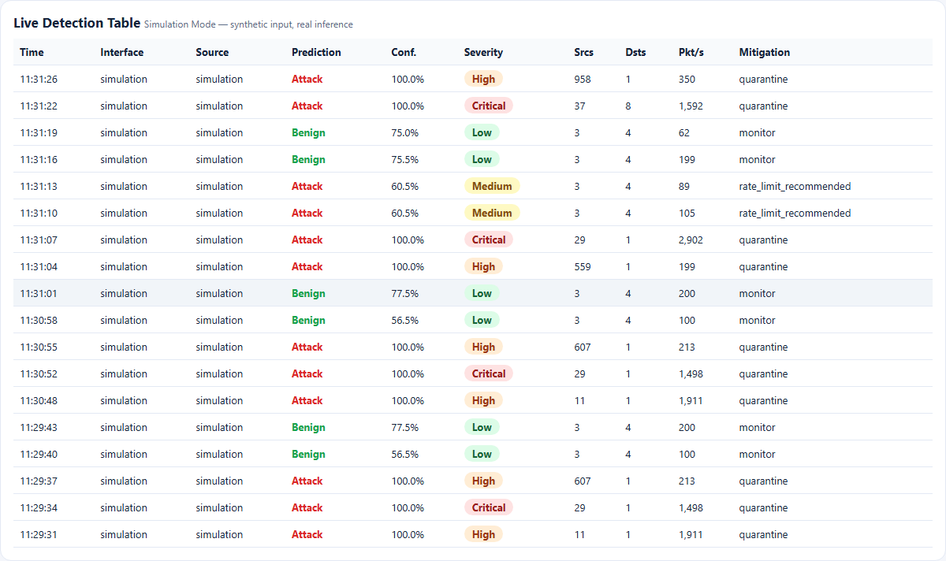  Figure 40: Original dashboard: live detection table (simulation, real inference). | 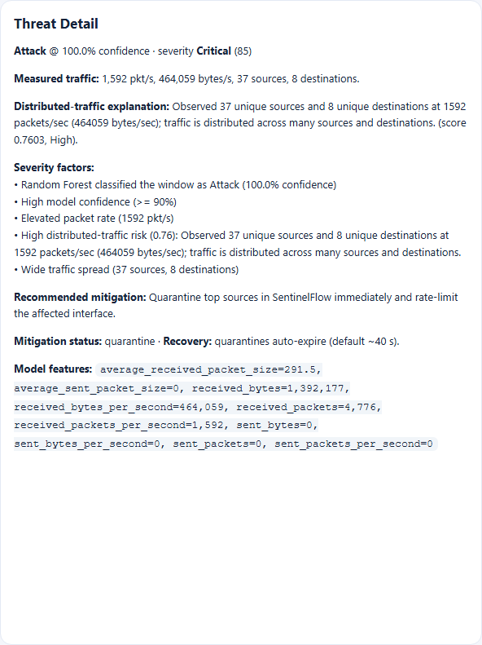  Figure 41: Original dashboard: Threat Detail of a Critical window with its factors and recommendation.

The live table shows the same columns as the console's Detections screen: time, interface, source, prediction, confidence, severity, sources, destinations, packets per second and mitigation. Weak benign windows have confidences of 56 to 78 %, Medium windows carry the rate-limit recommendation, and High and Critical windows carry a quarantine. The Threat Detail shows 1,592 packets per second from 37 sources to 8 destinations scored Critical (85) with five severity factors, and states that quarantines auto-expire.
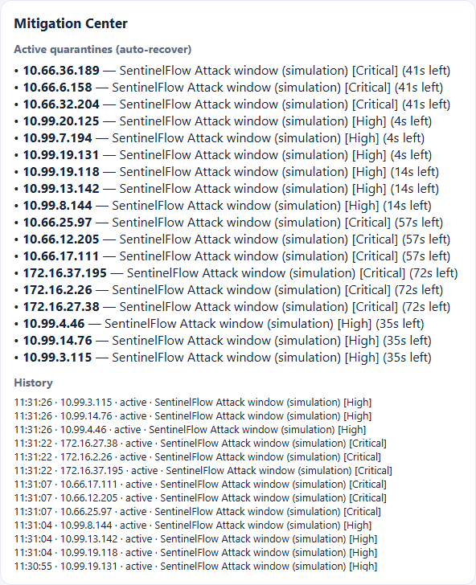  Figure 42: Original dashboard: Mitigation Center with active quarantines (seconds left) and history. | 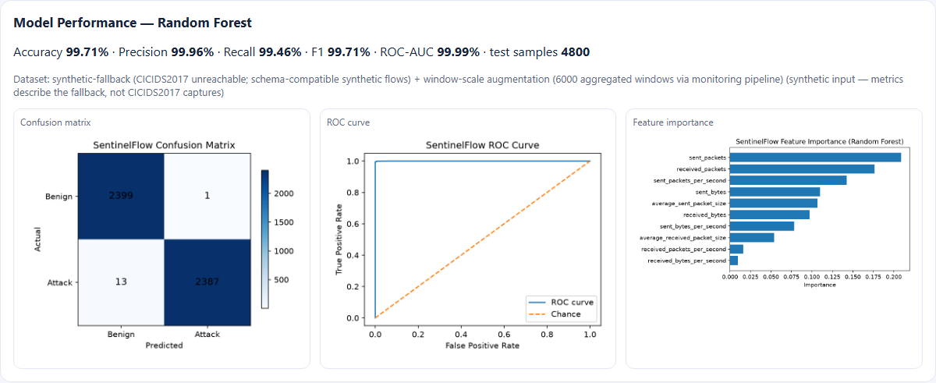  Figure 43: Original dashboard: Model Performance with the dataset-provenance note, confusion matrix, ROC curve and feature importance.

The Mitigation Center lists active quarantines with the seconds left (4 to 72 in the capture) and a history of the latest actions. The Model Performance panel shows the synthetic-fallback provenance sentence directly under the headline figures, which is why the original dashboard, unlike the React landing page, never presents 99.71 % without its caveat.
Figure 44: Original dashboard: header with the Simulation Mode pill, interface selector and Start live, Start simulation and Stop buttons.
The header shows the Simulation Mode pill and the interface list; in this capture the first interface is a Bluetooth network connection, showing that interface names come from the operating system rather than from the application.

